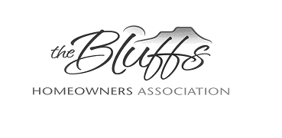
The Bluffs HOA Board Meeting: October 12, 2021

Members present: Bill Mager, Imi Mager, Sally Maddocks, Vivian Patton, Lynne Stefonik

The meeting was called to order at 6:30 pm at Sally Maddock’s house.
The September Minutes were approved. The Treasurer’s report did not change from September.
The Annual Meeting went well. Attendance was good and food was excellent. The meeting was productive and a full slate of officers were elected. Residents participated in “Covenants Trivia,” the 2022 Budget was presented, and an update was given on the Cell Tower.
Several campers and boats are not in storage and are still parked in the neighborhood. The owners will receive reminder letters to move them.
The CCC Committee will contact a resident on Winding Circle. The ACC Committee is discussing requirements for fences in the area.
A newsletter with announcements will be sent out in the near future.
HOA Dues will be due in January, 2022. Some dues from this past year are still being collected.
The meeting was adjourned at 7:00 pm.
The next meeting will be on Tuesday, November 9, at 6:00 pm, at Sally’s house, 4807 Avondale Circle. New members are encouraged to attend.

