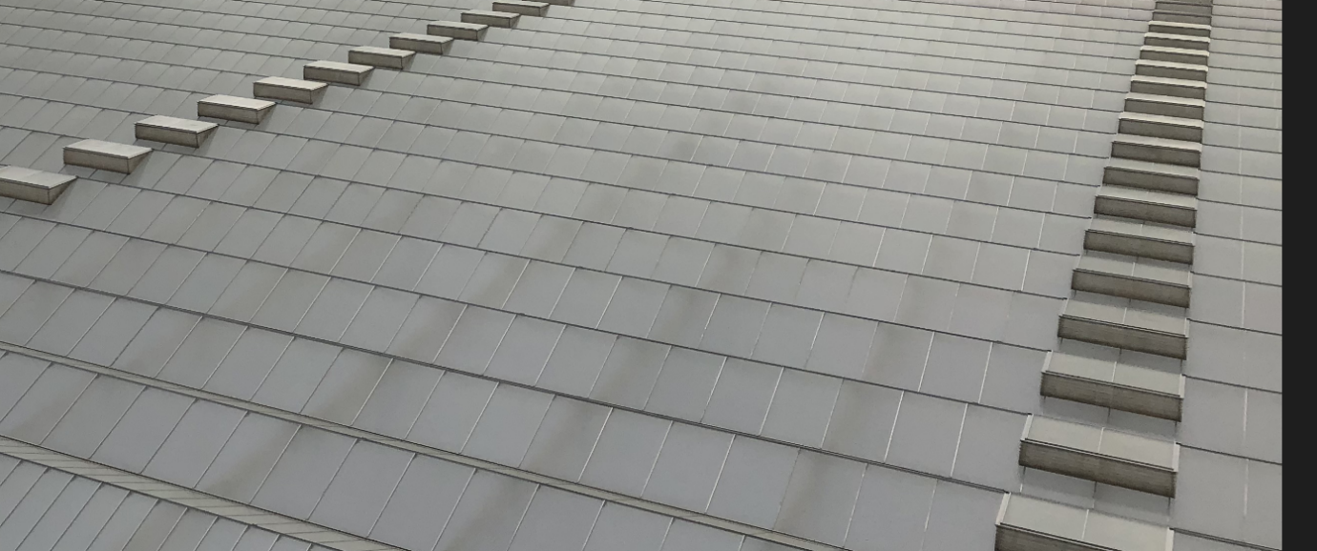
Things You Should Never Do in a Semi-Closed Glasshouse!

In this post I share my experiences with the semi closed glasshouses. There is much confusion on how best to grow crops in a semi closed glasshouse, and this series of articles tries to clear up confusion, inspire new discussion and educate.
One of the main attractions for retailers and consumers alike to choose glasshouse produce, is the reliability with which quality, quantity and food safety are maintained. The semi-closed glasshouse has extended that reliability in the way it manages summer heat, pest and disease and produces safe food. Why then, are there self-imposed limitations on what a grower can and cannot do with this fantastic new technology? In this, and upcoming articles I will discuss the do’s and don’ts of the semi-closed glasshouse.
Fan Speed
It may surprise many that the first “do not”, is to put the fan speed at 100%. Intuitively, growers who convert to semi-closed, feel that fan speed is the same tool as vent opening in a conventional glasshouse. If the temperature in the glasshouse is warm, the vents open further. So, it should be the same in a semi-closed glasshouse where increased fan speed increases the air exchange. This is true, but at high fan speeds there are other dynamics that come into play. I will discuss just a few of them.
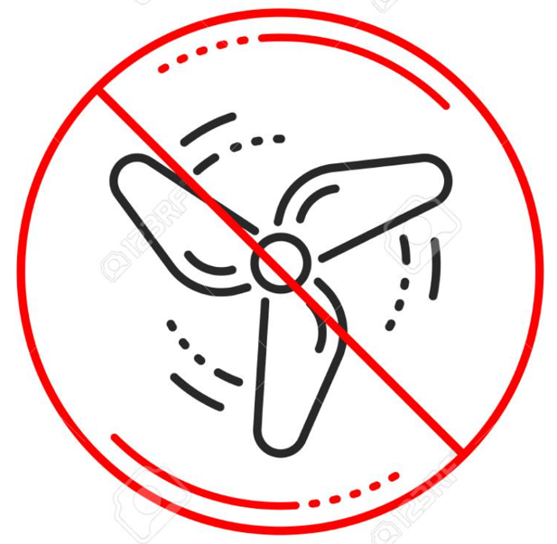
The glasshouse is a heat storage tank?
In a semi-closed glasshouse, the pre-cooled air is brought in from the bottom of the glasshouse and rises slowly to the top. A semi-closed glasshouse has far fewer roof vents. They are not meant to let air in, rather they allow the air to leave the glasshouse. As such they act as a low-pressure relief valve. As the air rises, it warms up. It is not unusual to have an air temperature of 45 degrees Celsius (or more!) in the roof of the glasshouse while at plant level, the temperature is 25 degrees Celsius. Increasing the fan speed to 100% creates enough turbulence in the glasshouse to bring hot air from the top back down to the tops of the plants. An analogy can be drawn with a heat storage tank where hot and cold layers maintain separation if the water enters the tank slowly. When the water travels to quickly into the tank, the separation is broken, and the water is mixed. The same is true for the air in a semi-closed glasshouse at high fan speed.
Momentum
Another serious side effect of high fan speed is that it creates a circular motion in the glasshouse. This phenomenon is called Momentum and in a future post, I am planning to discuss this in more detail. For now, it suffices to say that the circular motion pulls hot, upper level air down to the tops of the plants near the climate chamber creating a very hot climate for the plants in that area. If the speed of the fans is higher, the circular motion increases in speed and the area affected by the hot air coming down will be larger.
Another important reason for slowing down the fans is cost. For instance, increasing fan speed from 75% to 100%, increases the electricity cost by 50%.
Please note that glasshouse manufacturers use different fans and fan speeds. It is better to talk in air exchanges per hour. Most of the problems described above, are avoided if the fan speed does not exchange the air in the glasshouse more than 8.5 times per hour.
Questions
Most growers will ask how a semi closed glasshouse can be kept cool if the fan speed is significantly reduced. This will be discussed in another post.
If you like to be copied in on future articles or would like to know more and have questions, follow me on LinkedIn Godfrey Dol, or email Godfrey@glasshouse-consultancy.com.

