APPLICANT INFORMATION
Last Name |  | First |  |  |  |  | M.I. |  |  | Date
Street Address |  |  |  |  |  |  | Apartment/Unit #
City |  | State |  |  |  |  | ZIP
Phone |  | E-mail Address
Date Available | Current School Year (Grade): |  |  |  |  | Desired Salary
Position Applied for : ___ DAY Time ___ Evening ___ Both
Location Applied for (check all that applies) | 1. Glendale/Phoenix  (67th Ave/Happy Valley) |  |  |  | 2. Peoria  (Lake Pleasant/Happy Valley) |  |  |  |  | 3. Westgate Glendale
Are you a citizen of the United States? | YES NO If no, are you authorized to work in the U.S.? YES NO
Have you ever worked for this company? | YES NO If so, when?
Have you ever been convicted of a felony? | YES NO If yes, explain

EDUCATION
High School |  |  | Address
From | To | Did you graduate? | YES | NO | Degree
College |  |  | Address
From | To | Did you graduate? | YES | NO | Degree
Other |  |  | Address
From | To | Did you graduate? | YES | NO | Degree

REFERENCES
Please list three professional references.
Full Name | Relationship
Company | Phone ( )
Address
Full Name | Relationship
Company | Phone ( )
Address

PREVIOUS EMPLOYMENT
Company |  |  | Phone ( )
Address |  |  | Supervisor
Job Title |  | Starting Salary | $ | Ending Salary | $
Responsibilities
From To | Reason for Leaving
May we contact your previous supervisor for a reference? |  | YES | NO
Company |  |  | Phone ( )
Address |  |  | Supervisor
Job Title |  | Starting Salary | $ | Ending Salary | $
Responsibilities
From To | Reason for Leaving
May we contact your previous supervisor for a reference? |  | YES | NO
Company |  |  | Phone ( )
Address |  |  | Supervisor
Job Title |  | Starting Salary | $ | Ending Salary | $
Responsibilities
From To | Reason for Leaving
May we contact your previous supervisor for a reference? |  | YES | NO

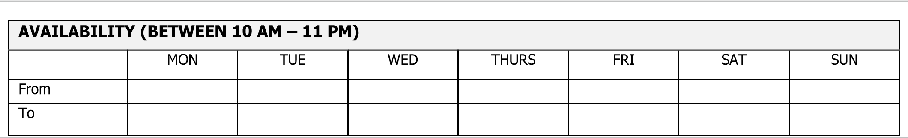

WHY DO YOU WANT TO WORK AT RAZZLEBERRIEZ YOGURT

DISCLAIMER AND SIGNATURE

- I certify that I have read and fully completed all pages of this application and that the information contained in this application is correct to the best of my knowledge.
- I understand that any omission or erroneous information in this application or furnished during interview is grounds for dismissal in accordance with RazzleberrieZ Yogurt’s employment policies.
- I authorize all references listed in this application to provide any and all information concerning my previous employment as well as pertinent information they may have. I release all parties from all liabilities for any damages that may result from furnishing the aforementioned information.
- I acknowledge that RazzleberrieZ Yogurt reserves the right to amend or modify the policies in its Employee Handbook as well as other policies at any time, without prior notice.
- I certify that I meet all requirements and qualifications required to perform this job.
- At Razzleberriez Yogurt, my employment is at‐will.
- If this application leads to employment, I understand that the employer may require me to obtain Food Handling Certificate from appropriate government authorities.
- I understand that I may be asked to go for Drug Test before being hired or during the course of employment with RazzleberrieZ Yogurt.

_______________________________ _____________________
SIGNATURE DATE

RazzleberrieZ Yogurt is an Equal Opportunity Employer.
The information requested in this application will not be used for any purpose prohibited by the law.

