KEEP SAFE CONNECTIONS
AVAILABLE ONLINE AT WWW.GRIEFRELIEFCOACHING.CA/HELP
911
Crisis Services Canada
CALL TOLL FREE 1.833.456.4566 - Available 24/7
http://www.crisisservicescanada.ca/
Nova Scotia Mental Health Mobile Crisis Team
(902) 429-8167 or 1 (888) 429-8167 (Toll Free)

National Suicide Prevention Line (USA & Canada)
https://suicidepreventionlifeline.org/
1-800-273-8255 / Crisis Text Line by texting TALK to 741741
Kids Help Phone
www.kidshelpphone.ca
1 (800) 668-6868 (Toll Free 24/7)

Grief Relief for Survivors of Suicide Loss
https://www.facebook.com/groups/griefreliefforsurvivors/
(on-line private Facebook group providing support to family and friends who have lost a loved one to suicide)
CASP (Canadian Association for Suicide Prevention)
https://www.suicideprevention.ca/

211 Nova Scotia
www.ns.211.ca
Phone: 211 (Provides confidential information and referral services for community and social services available across Nova Scotia & most provinces of Canada)
811 Nova Scotia
www.811.novascotia.ca
Phone: 811 (Provides support regarding non-urgent health-related issues and questions)
Avalon Sexual Assault Centre
www.avaloncentre.ca
(902) 422-4240 (Provides support, counselling, education and forensic evaluation for those who have experienced sexualized violence)

Bryony House
https://www.bryonyhouse.ca/
Distress Line: (902) 422-7650; Shelter Main Number (902)423-7183
(provides 24 hour emergency services for women, with or without children, escaping intimate partner abuse.)
Canadian Mental Health Association Halifax Dartmouth Branch
(902) 455-5445. (Provides various social support programs and initiatives to improve mental health)
Early Psychosis Program of Nova Scotia
http://www.cdha.nshealth.ca/programs-services/e
(902)-473-2976 . Promote early detection and optimal, timely healthcare for persons at risk for, or experiencing, a first episode of psychosis.
ISANS Mumford | main office
http://www.isans.ca/
Phone: 902-423-3607/ Toll free in Nova Scotia: 1-866-431-6472 (We help immigrants to settle and give orientation to living in Nova Scotia)
Phoenix Youth
https://phoenixyouth.ca/services
(902) 420.0676; 24 hr intake 902.446.4663 Toll free: 1.888.878.5088
(dedicated to supporting youth between the ages of 11 and 24, and their families)
Shelter Nova Scotia
www.shelternovascotia.com
(902)406-3631 (Provides a home for people who need somewhere to stay. We offer care to people who can find it nowhere else)
Vets Canada
https://vetscanada.org/
1 (888)228-3871 (committed to helping homeless and at-risk veterans reintegrate into civilian life)
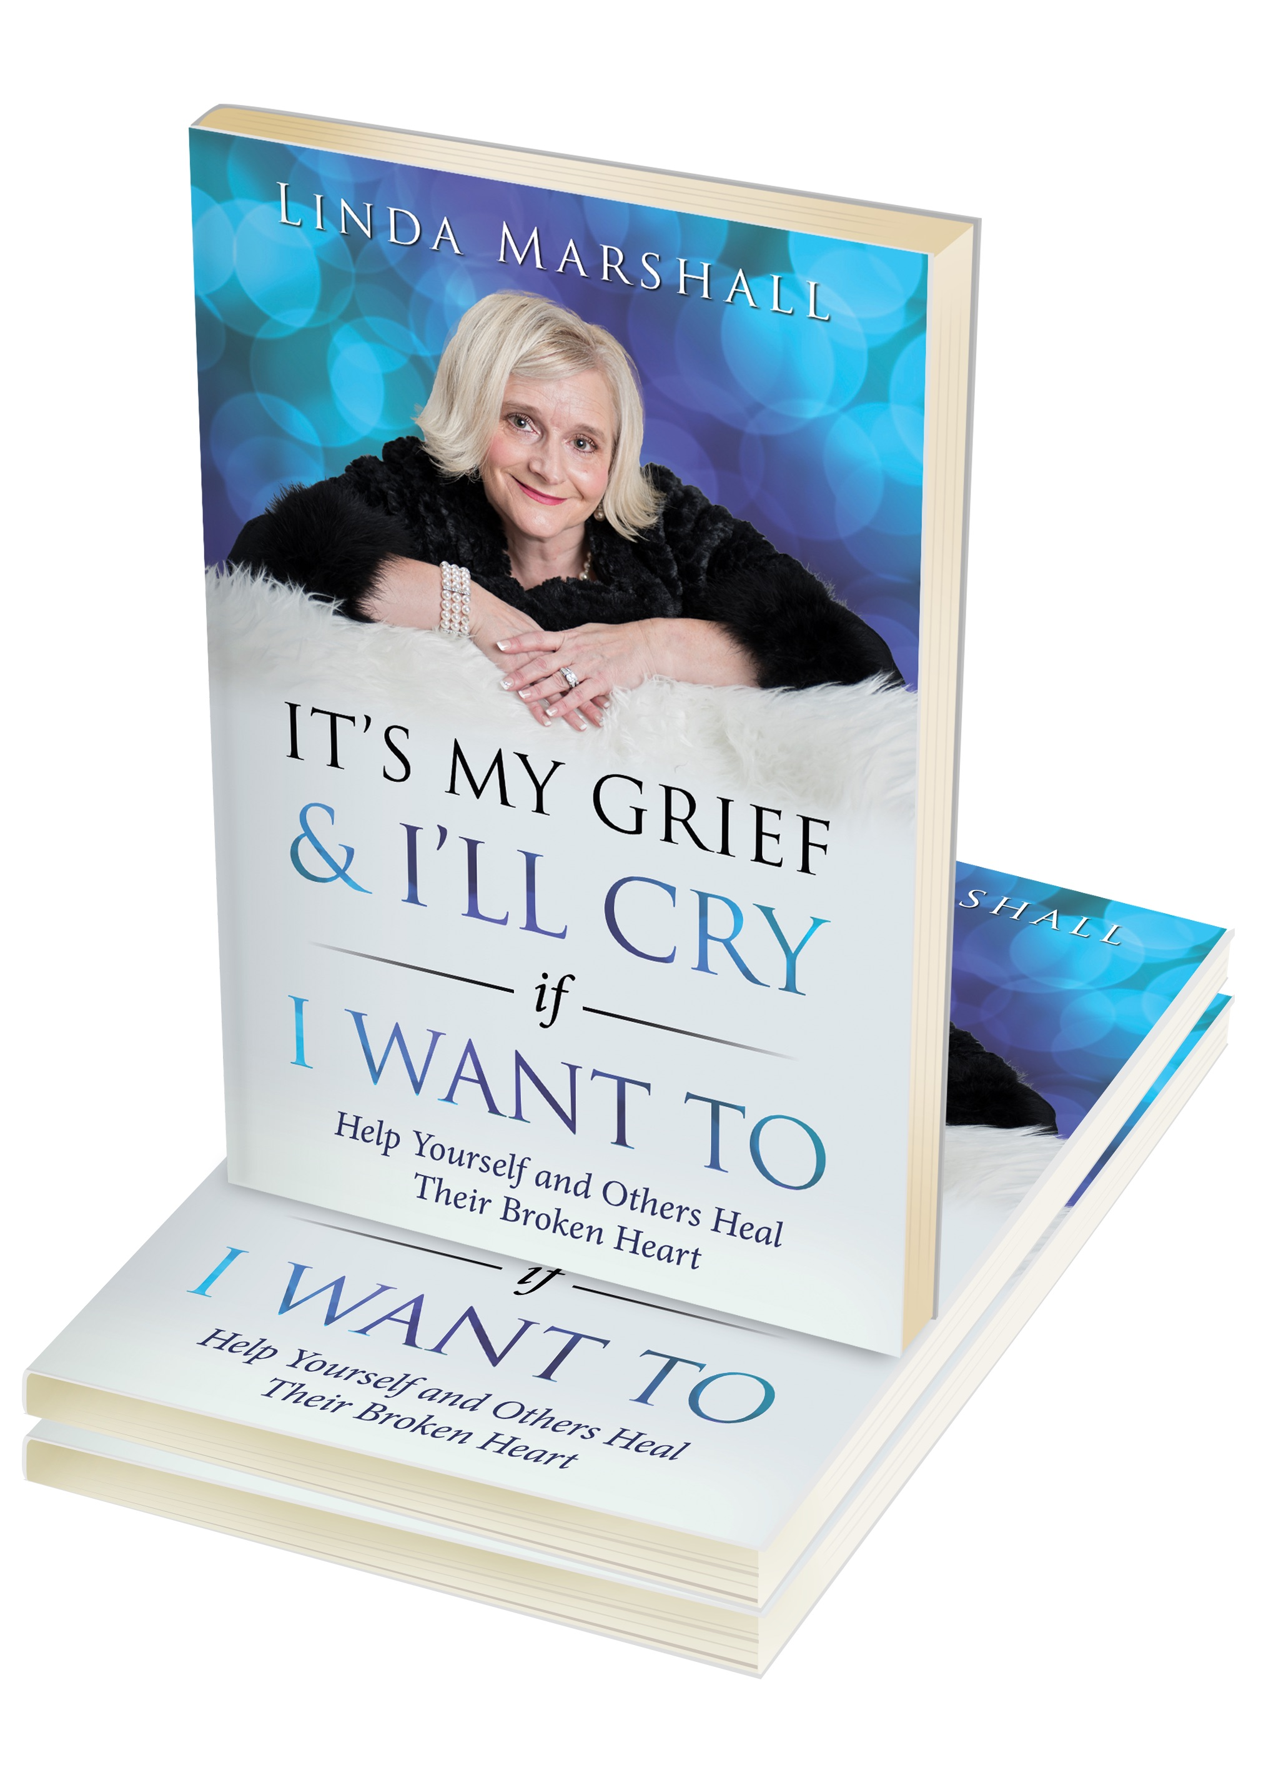
GRIEF RELIEF COACHING
Releasing “It’s My Grief & I’ll Cry if I Want To” Help Yourself & Others Heal Their Broken Heart.
Pre-Order Special - $25 ($5 for each pre-order will go towards Mental Health & Suicide Prevention).
To Pre-Order: http://www.griefreliefcoaching.ca/book

www.griefreliefcoaching.ca www.facebook.com/griefreliefcoaching/
www.griefreliefcoaching.ca & www.facebook.com/griefreliefcoaching/

