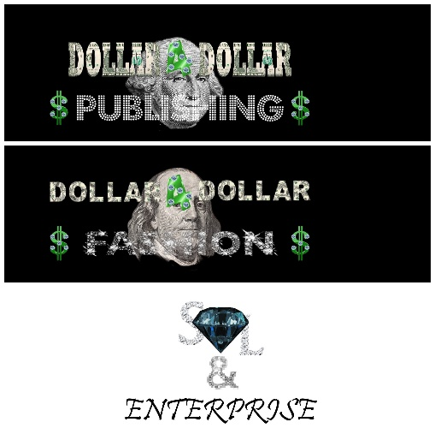 MARKETING AND MEDIA

Photo/Video Release Form

I, ___________________________________________________________(please print), grant permission to Shawn L. Bailey, S.L Enterprise and its agents and emloyees the irrevocable and unrestricted right to reproduce the photographs and/or video images taken of me, or members of my family, for the purpose of publication, promotion, illustration, advertising, or trade, in any manner or in any medium. I hereby release Shawn L. Bailey, S.L Enterprise and its legal representatives for all claims and liability relating to said images or video. Furthermore, I grant permission to use said photographs and/or video images with or without my name, for the purpose of advertising and publicity without restriction. I waive my right to any compensation.

I acknowledge that I am ☐ over the age of 18
☐ proof of identification

Name(s): __________________________________________________________
Signature:_______________________________Date:Click or tap to enter a date.
Address: __________________________________________________________
__________________________________________________________

