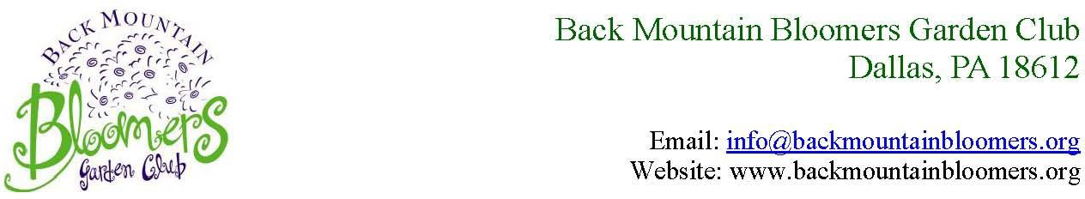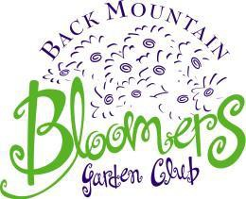

BACK MOUNTAIN BLOOMERS GARDEN CLUB COMMUNITY GRANT APPLICATION
Back Mountain Bloomers Garden Club
Dallas, PA 18612

NAME OF APPLICANT: □ INDIVIDUAL OR □ GROUP ADDRESS: CITY: ST: ZIPCODE:
PHONE: (home) (cell)
EMAIL:
ORGANIZATION AFFILIATION: CONTACT INFORMATION OF TROOP OR CLUB LEADER:

NAME OF PROJECT:

THIS PROJECT WILL □ Improve the scenic beauty throughout the Back Mountain and Wyoming Valley
□ Foster preservation of this area’s natural resources

FUNDING AND RESOURCES NEEDED:

ESTIMATED PROJECT START DATE: COMPLETION DATE:

COMPLETE AND ATTACH THE COMMUNITY GRANT APPLICATION and COMMUNITY GRANT APPLICATION PROJECT DESCRIPTION FORM (Note: If you would like to submit this request form electronically, download the word document (docx) and make necessary entries. Submit saved document in pdf format and attach to an email sent to: info@backmountainbloomers.org with Subject: Community Outreach Project.)

Decision about our club’s sponsorship will be made after careful review. Recipients of funds will be required to complete a brief follow-up report when the project is completed.

Please send completed Application, Application Project Description Form, and Budget Sheet to:

Back Mountain Bloomers Garden Club
P.O. Box 210
Dallas, PA 18612
ATTN: Community Outreach Committee

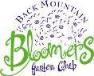
Community Grant Application Project Description Form

IDENTIFY CONCERNS (related to improving the scenic beauty throughout Back Mountain or foster preservation of this area’s natural resources)

SET A GOAL (Set specific goals relevant to concerns and identify how those goals will be measured.)

FORM A PLAN (WHO, WHAT, WHEN, WHERE, HOW, COST, RESOURCES, AND
EVALUATION) The “how” should include a timeline as to what will be accomplished, when, and by whom. Identify resources and form a budget for your project. Attach a copy of the BUDGET SHEET to the application form.

ACT (Provide a brief description about main events that will happen and any changes that may be necessary for the plan to succeed.)

FOLLOW UP (Describe how the project will be evaluated. how it will impact others in their community, and how you will grow as an individual through this project.)

