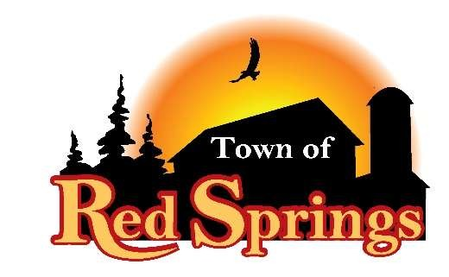
Lonnie Schreiber, Chairman
Gary Olsen & Jennifer Morris, Supervisors
Jackie Schmidt, Treasurer
Gwen Olsen, Clerk

W11019 W. Townhall Road Gresham, WI 54128 715-787-3356

SPRING ELECTION

will be held on Tuesday, APRIL
7, 2026, at the Red Springs Town Hall.

The polls will be open at 7:00
a.m. and will close at 8:00 p.m.

DON’T KNOW WHAT'S ON YOUR INDIVIDUAL BALLOT?
VISIT myvote.wi.gov to find out who you will be voting for in your Ward.

The Red Springs Town Hall is accessible for elderly and disabled voters. If you have any questions concerning your polling place contact the town clerk, Gwen Olsen @ 715-787-3356.

Gwen Olsen, Clerk
Town of Red Springs

