HAM Radio Saga

by Richard Fuller KF5LFI

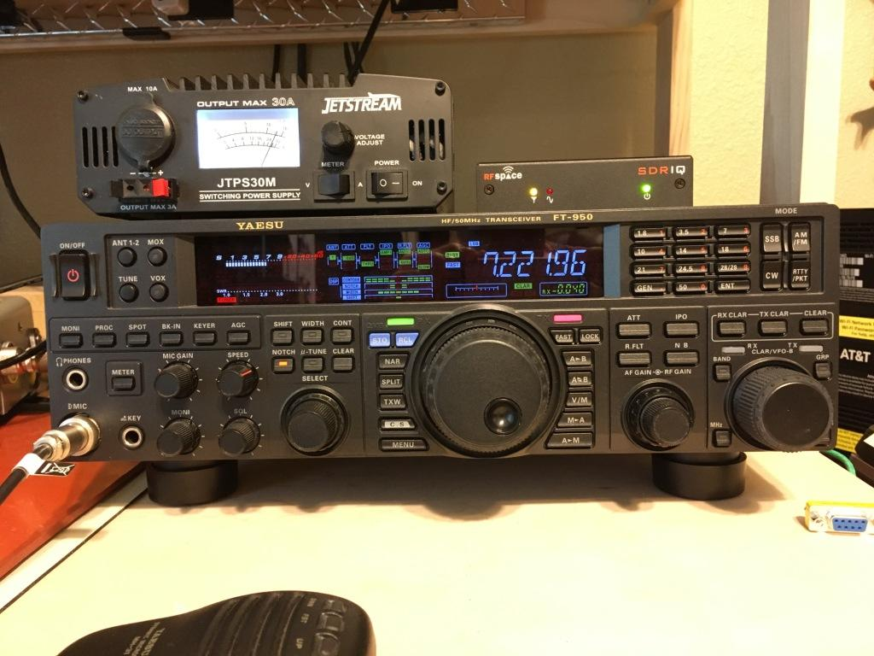

Sunday, March 24 a lightning storm wiped out my PC and AT&T router. This was a drag as the next day was Memorial Day and of course, a holiday. AT&T and the PC had to be on the back burner due to this, so, looking for something to pass the time I turned on the HAM radio. What??? No power??? The HAM, radio that was not even turned on, also perished in the storm!

I was sitting at my PC at the time during the storm feeling confident about my UPS and power strips with transient protection. All of a sudden, below the desk, bellowed out a high transient sounding “SNAP” – and that was it. With no internet or TV, the next three days proved to be a challenge.

The good news, it had been time to replace an aging motherboard, about 11 years old, with a new faster model. With the local computer shop I use closed until Tuesday, I needed to find something else to bide the time.

I bought the HAM radio in 2012 but never really got into it the way I thought I might; but all that is soon to change, right? Wrong! Turned on the power supply, so far so good. Pushed the power button on the radio – nothing! This was weird as the power supply was not turned on plus it was on a different circuit than the router and PC. What I believed happened was the magnetic field from the “SNAP” induced a high voltage on the power cables between the 13.8 Vdc power supply and the radio causing damage to the electronic power on/off switching circuit.

No visual lightening damage was observed during my inspection of the radio internally. Usually lightning damage leaves charcoaled circuit boards, components blow off the board or even evaporate – but nothing visible around the antenna input or power supplies or control circuit board. Now it’s time to pull out the schematics and get to work.

Consider the following power on circuitry (this is my actual unit):

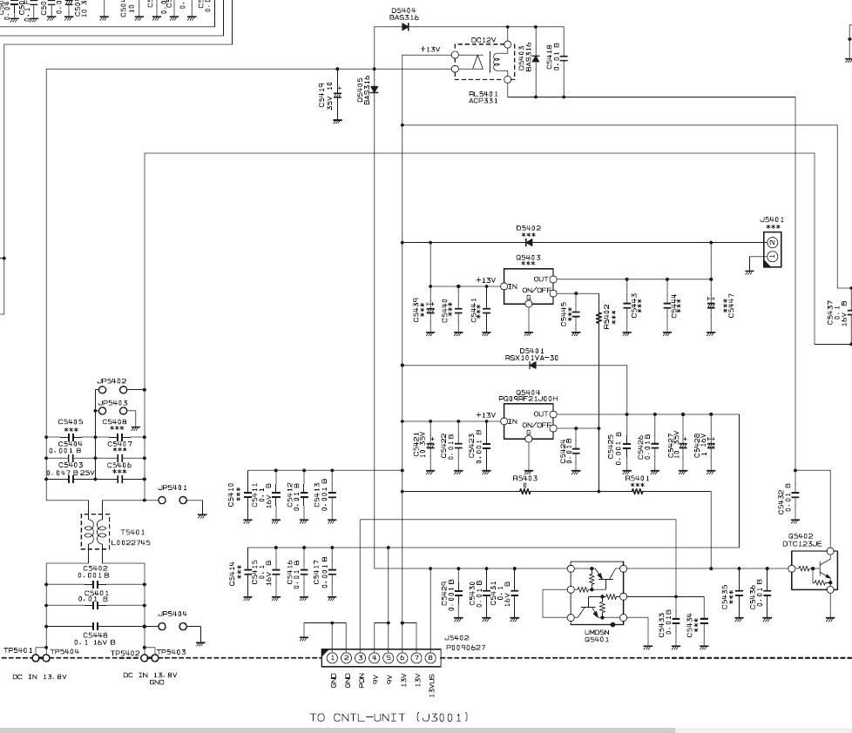

3.3 vdc from the power on/off button on the front of the unit connects to J3001, pin 3 (red arrow). That turns on the relay switch transistor Q5402 (bottom right blue arrow) which provides 13.8Vdc to the radio through the relay at the top of the page.

The following items were tested and replaced accordingly:

Diode D5405 (green arrow) open. Diode D5404 (purple arrow) shorted. Transistor Q5402 breaks down when voltage was applied; specifically, collector to base breakdown. Diode D5403, reverse polarity protection, tested good but replaced as a matter of principle.

After completing the repairs, the radio operated normally. My next project will be to clean up the outside temporary move of antenna components, tuner, junction boxes, grounding and counterpoise system. Whew!

