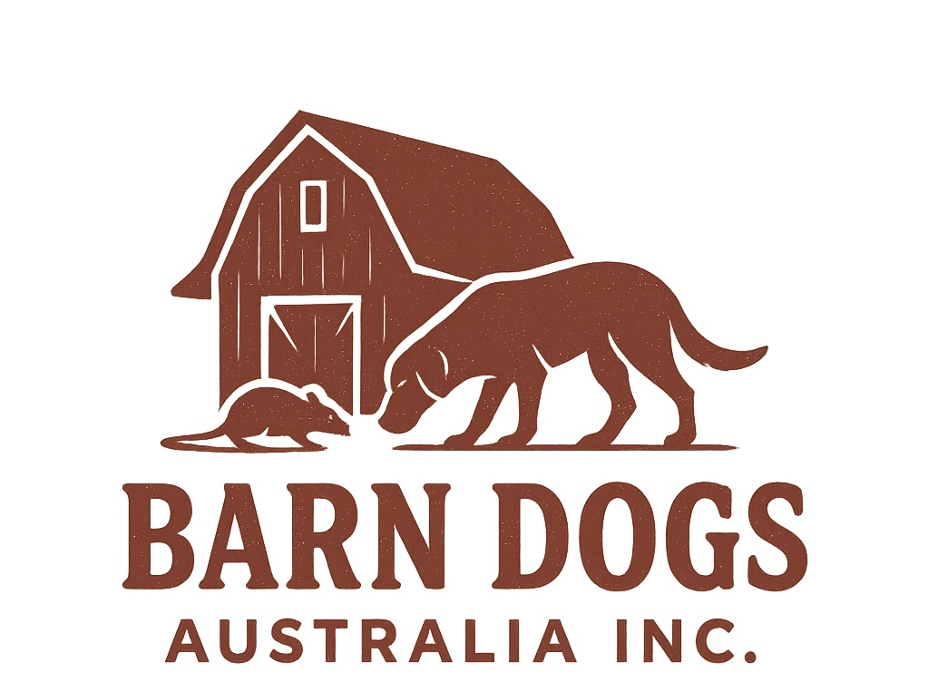

Official Competitors

Rulebook

This rulebook contains all rules and regulations for Barn Search that competitors need to know in order to enter, compete and train.

.

**Purpose of Barn Search**

Barn Search gives dogs the opportunity to tap into their natural hunting instincts by using all their great senses to hunt/ search for a hidden ‘rat’ in a hay barn. To successfully qualify dogs must navigate their way through the hay, jumping on bales, going through tunnels and successfully finding the hide. Dogs and owners must work together, trusting each other to do this correctly. When it is believed the dog has located the ‘rat’ the handler must call out to see if they are correct.

Barn Search is a fun and fulfilling way to test a dog’s work/ hunt drive and also tests the trust and teamwork between dog and handler. This sport challenges dogs to use their natural instincts and problem-solve in a simulated hunt. Not only is it fulfilling for the dog both mentally and physically, but also dramatically strengthens the bond between pooch and handler.

**Good Sportsmanship**

Whilst on the grounds it is vital to treat all participants and spectators respectfully and in a supportive manner as this is a friendly and family orientated sport. Good sportsmanship is essential in building a fun, positive and collaborative environment. Actions which cause unnecessary and inappropriate upset will be managed and discussed by the Barn Dogs Australia INC. committee and may result in disciplinary action.

. **Smoking/Vaping**

Smoking or vaping of any kind is not permitted on the grounds.

**Registering Your Dog**

All dogs must be registered with Barn Dogs Australia INC. prior to competing in any Licensed Trial (see special Fun Test Rules.) The yearly registration fees are non-refundable and non-transferable.

Dogs under 6 months cannot compete in either a Fun Test or a Licensed Trial. This is due to the ongoing physical development of their bodies, particularly their growth plates and the development of their muscles, which are not fully formed until around 12 months. Puppies are still developing their social skills and impulse control and may not be able to handle the environment and demands of a competition.

**Withdrawals and Refunds**

Competitors who withdraw their dog from any Trial or Fun Day before the closing date may apply to receive a refund. If after the closing date the participant wishes to withdraw from the trial, a refund is not valid. If a dog is suffering from a medical condition that is noted by a vet, a refund can be looked in to.

**Entering your dog**

For an entry to be valid, forms must be correct, paid, signed, and legible. Only then a space can be reserved.

* A dog can only be entered in a trial they are eligible to compete in (e.g., cannot enter RATIII if not yet titled in RATII).
* Entries received after the closing date or on the day of the trial, may be turned down or considered invalid.
* Competitors are responsible for checking their Trial confirmations and bringing any errors to attention.
* If trial money is not received or the competitor does not pay the trial fees within a time limit set by Barn Dogs Australia Inc, the entry is not valid.

**Risk and injury**

Barn Dogs Australia Inc and all associates that have planned and are helping manage the event are harmless from any claim for loss or injury which may be alleged to have been caused directly or indirectly to any person or thing by the act of any dog or dogs while in or upon the premises or grounds or near any entrance thereto, and the owner will personally assume all responsibility and liability for such claim, and must agree to hold the aforementioned parties harmless from any claim for damage or injury to the dog or themselves, either physically or mentally, whether such loss, disappearance, theft, damage or injury, be caused or alleged to be caused by negligence while in or upon the premises of where the event is taking place.

Trial, owners must attest that they have read, understand, and will abide by, all Barn Hunt Rules and Regulations.

**Eligibility to Compete**

All dogs competing in Barn Search must be physically able to jump on a hay bale and go through a “tunnel” made of straw. If the judge deems your dog unable it is the judge’s call.

* Dogs allowed to compete include
* Deaf dogs.
* Dogs with partial or limited vision.
* Dogs with physical differences are eligible to participate provided that the judge determines they display no signs of physical discomfort and can safely navigate the course.
* All dogs must be fully vaccinated and up to date with these whilst on our grounds.

**Dogs Ineligible to Compete**

* Dogs with cuts, stitches bandages or open wound are unable to compete. The Judge establishes appropriateness.
* Blind Dogs and Dogs in wheeled carts cannot enter in titled competitions.
* The judge is able to eliminate teams from the ring if any dog appears to show pain or illness, and/or any dog the Judge considers unable to safely complete the course. Veterinary notes are not accepted as evidence of soundness.

**Handler Adjustments and age**

Handlers must be over the age of 16 and able to fully have control of the dog at all times.

Some handlers may have disabilities, stopping them from effectively controlling the dog. If they require any assistance or special accommodations to be made when trialling, they must advise this by email to Barn Dogs Australia INC. before the closing date of trials on their registration forms. All assistants must be capable of handling the dog and have signed the trial registration form.

An owner must be in control of their dog at all times whilst at the event. All dogs need to be leashed or crated whilst at the event. If the dog is nervous or in any way reactive, and needs extra space, handlers must make this visually evident to others by ensuring that their dog is wearing yellow. If this is not enough, email before the event and make sure to note it in the registration form. All dogs whilst at the event must stand at least 2 meters apart whilst waiting for their turn to ensure safety of others.

**Whilst in the ring**

In Barn Search we believe you constantly learn not only from your own dog but also from other people. Every dog indicates and hunts in their own way, being a spectator can help massively as an onlooker will get to see everyone else participate. We keep in mind that not all dogs are people friendly or may be anxious around noises or distractions so make sure that spectators are a fair distance away.

If for any reason something was to happen in the crowd that was visibly off-putting to the dog, it is the judge’s choice whether or not they can redo the run.

No other dogs apart from the one trialling is allowed in the barn at any time.

**In the ring**

**Entering the ring**

Once the participant’s name is called, they must get their dog (walking or carrying them) and enter the ring. Once in the ring they must put their dog down if being carried and walk over to the start square. The dog must have all paws inside the square. As soon as the dog exits this, his/her time will start.

Dogs must not urinate on bales or in arena. This will result in disqualification and a fee may occur to replace damaged bales.

**Tunnel**

A completed tunnel is when the dog enters any entry point of the tunnel and exits out the other end. Owners may verbally cue the dog to do this as well as directing them with hand signals. If the dog completes this task verbal praise may be given along with a pat or stroke. The owner may not touch, pull, or push the dog in any way to get them to do this. If this happens, it is a DQ.

**Bale**

The bale is marked as achieved when all of the dog’s paws are on top of the bale and not on the ground. Owners may verbally cue the dog to do this as well as directing them with hand signals. If the dog completes this task verbal praise may be given along with a pat or stroke. The owner may not touch, pull, or push the dog in any way to get them to do this. If this happens, it is a DQ.

**Rat!**

How the dog indicates that he/she has located the correct rat tube is only relevant to the handler as all dogs do this in different manners. They aren’t required to put their nose to the tube, but the handler must be able to see exactly where their dog is indicating towards and exactly where the tube is. It is therefore the handler’s responsibility to watch and know how their dog indicates and then when they feel he/she has done this, they must then clearly call this to the Judge so that they can note the indication. An owner will usually call ‘Rat’ but this word can be replaced with ‘alert’ or calling another clear and obvious indication.

Once the judge has indicated the participant is correct, they can praise their dog physically and verbally as well as tapping or wiggling the rat tube and showing the dog. As there is no live rat in the tube participants are allowed to roll the tube once on the ground to show the dog. If searching for multiple rats, the dog may be restrained whilst the owner/handler removes the tube from them and gives it to the judge, once the found tube is handed to the judge, all hands have to then be back off of the dog.

**Exiting the trial area**

Once the run has ended the participant must put a collar or lead back on to their dog and exit the ring. If they wish they are more than welcome to carry their dog out. If this is chosen, the dog still needs to have a collar and lead/ slip lead on).

**Appeals procedure**

**Judge’s verdict**

All Judges decisions during a Trial are considered final. No Judge call can be reversed after the Trial is concluded and scores recorded by the Trial Secretary.

If the competitor feels a Judge’s decision was incorrect or unjust, the competitor may take their concern and written explanation to barnhuntdogs94@gmail.com

Once this has been received the board will investigate. Results of that investigation may or may not be reported to the competitor.

**Misconduct or Dog Aggression.**

The competitor who is accused of Misconduct or Dog Aggression may appeal to the board through email; however, final decisions are made by the committee board of Barn Dogs Australia INC. This is a fun event that is open for beginners, all participants must remember that not all dogs will choose to take part as it is based on scent work, prey drive and instincts. Any harsh training methods are unacceptable. Dogs must not be dragged up or off of hay bales. Prong collars, E collars are not allowed at any time whilst on the grounds.

Whilst on the grounds, owners must ensure that they clean up all excrement.