

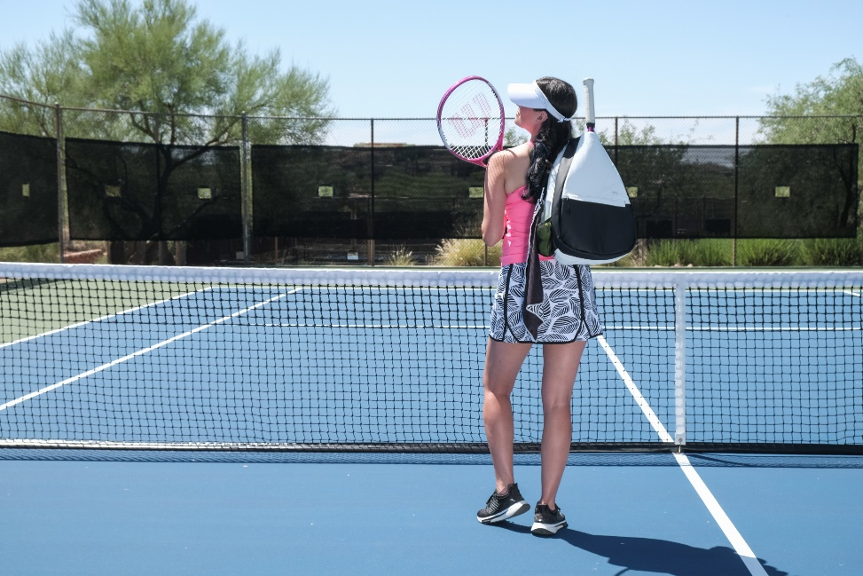

**TENNIS & PICKLEBALL**

**Delivery Date – 10/15/2023**

**Pre-book specials must be place by 9/15/2023**

**Package A**

* **$600 opening order = 5% discount**

**Package B**

* **$1200 opening order = 5% discount + ½ off freight**

**Package C**

* **$2500 opening order = 8% discount + ½ off freight**

[**WWW.GLOVEIT.COM**](http://WWW.GLOVEIT.COM)

**16043 N 82nd St. Scottsdale, AZ 85260**

**PHONE: 480-968-2021 FAX: 480-968-2380**