Irish Festival 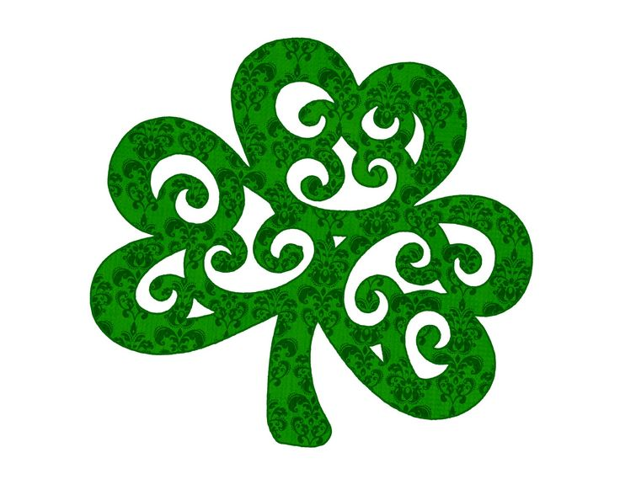March | 2023
Sunday | Monday | Tuesday | Wednesday | Thursday | Friday | Saturday
 |  |  | 1 | 2 | 3 | 4
5 | 6 | 7 | 8 | 9 | 10 | 11
 |  |  |  | Proclamation  /Flag Raising  at  Ottawa City Hall   4:30 – 6 PM | Ottawa 67’s Hockey Game  vs Mississauga  7PM  tickets $25* | St. Patrick’s Parade/Party  With BIG RIG BREWERY  Aberdeen Pavilion  12 – 10 pm **
12 | 13 | 14 | 15 | 16 | 17 | 18
Trivia  at  Brigid’s Well  Hosted by  Ottawa Gaels   |  | Author’s Day  St. Columba Anglican Church Hall  Hosted by  The Irish Seniors Social Group Ottawa (ISSGO)  pot-luck lunch,  11 AM - 2:00 PM |  |  |   Happy ST PATRICK’S  Day  MASS  St. Patrick  Basilica  10 AM
19 | 20 | 21 | 22 | 23 | 24 | 25
26 | 27 | 28 | 29 | 30 | 31
*Hockey tickets send inquires to ottawairishfestival@irishsocietyncr.com

**Party tickets $30 + fees St. Patrick's Parade Party Tickets, Sat, 11 Mar 2023 at 12:00 PM | Eventbrite

