
STEER Collaborative Authorship Guidelines

These guidelines outline the level of participation required for authorship in a STEER collaborative project. They follow the International Committee for Medical Journal Editors guidance for authorship¹ and the ASIT standardised framework for reporting of authorship in collaborative research². It is our intention that all participants will be recognised in the authorship for their contribution, resulting in a Pubmed-citable publication.

In general for any manuscript, collaborative or otherwise, all authors must fulfil the following ICMJE guidance detailed below (Figure 1) and are expected to participate in multiple tasks, in addition to editing and approving the final document.

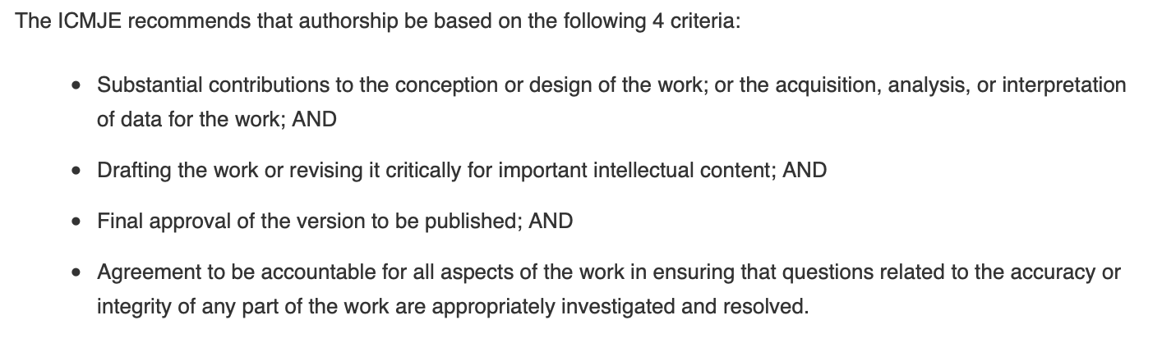
Figure 1: ICMJE contribution guidelines for authorship

Specific to STEER collaborative work, roles may fall into the following categories as detailed in Table 1:
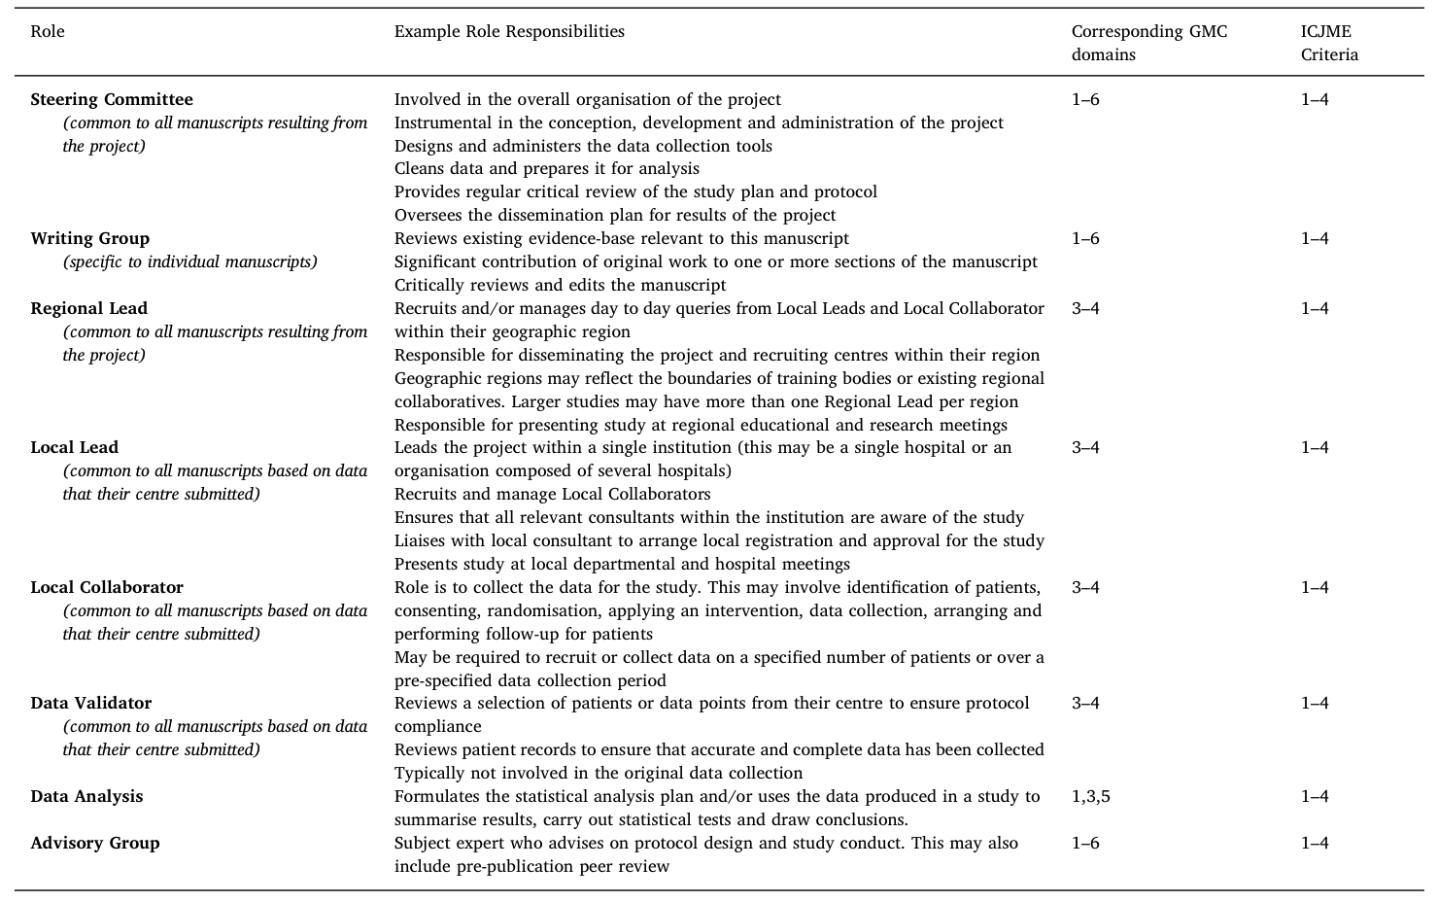
Table 1: Collaborative roles taken from Blencowe et al 2017²

Involvement in any of these roles will result in inclusion in the collaborative authorship. Local collaborators must collect data for a pre-decided minimum number of patients as well as being involved in draft editing and final approval of the manuscript.

Authorship order

Author order will be according to contribution, with joint first authorship considered when appropriate.

Depending on individual journal guidelines, our preferred method will be as follows:

Major contributors (steering committee, data analysers, writing group and regional leads) will be named prior to ‘STEER Collaborative’ as exampled in Figure 2.

The alternatives of only listing ‘STEER Collaborative’ or all authors, will be considered if specified by the journal.

Collaborators will be named individually in the appendix but will be considered authors and Pubmed cited. We will not approach journals who will not accept this aspect of the collaborative authorship.

Figure 2: Example of preferred authorship style

Citing

When citing collaborative work on a CV, the format‘Last name First initial. (Role) Collaborative Group (Year published). Article title. Journal,Volume (Issue), Page(s).’should be used. For example:

Smith, S. (Regional Lead) STEER Collaborative (2021). Recognising Contributions to Work in Research Collaboratives. Journal of Example Surgery, 1(35), 399–406.

References

1. ICMJE | Recommendations | Defining the Role of Authors and Contributors. Available at: http://www.icmje.org/recommendations/browse/roles-and-responsibilities/defining-the-role-of-authors-and-contributors.html#two. (Accessed: 11th January 2021)
2. Blencowe, N. et al. Recognising contributions to work in research collaboratives: Guidelines for standardising reporting of authorship in collaborative research. Int. J. Surg. 52, 355–360 (2018).

