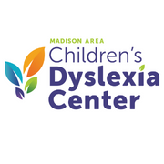

Dear ____________________,

Did you know I am one of over 380 children who have benefitted from the tutoring at the Children’s Dyslexia Center of the Madison Area? Families can get individual and highly effective tutoring for their children. Some of the best news is that there is no cost for our families. It means that nobody is turned away from finding their programs.

Where does the money come from? From you, I hope. I am joining the Walk for Dyslexia on Saturday, May 20, 2023. This walk helps raise awareness of the great tutoring services supporting local kids. The walk also raises income for this nonprofit organization. One year of tutoring for one student costs $6,400, so the community's help is vital. I will walk at the 2023 Walk for Dyslexia so that all students can learn the skills they need to succeed with dyslexia.

Would you consider sponsoring me by donating today?

Sincerely,

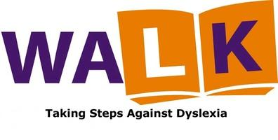

**2023 Walk for Dyslexia-Madison**

***Taking Steps To Support Students with Dyslexia***

**www.walkfordyslexiamadison.org**

Starts and Finishes at Brittingham Park, Madison, WI

Saturday, May 20, 2023 | 8:00 am