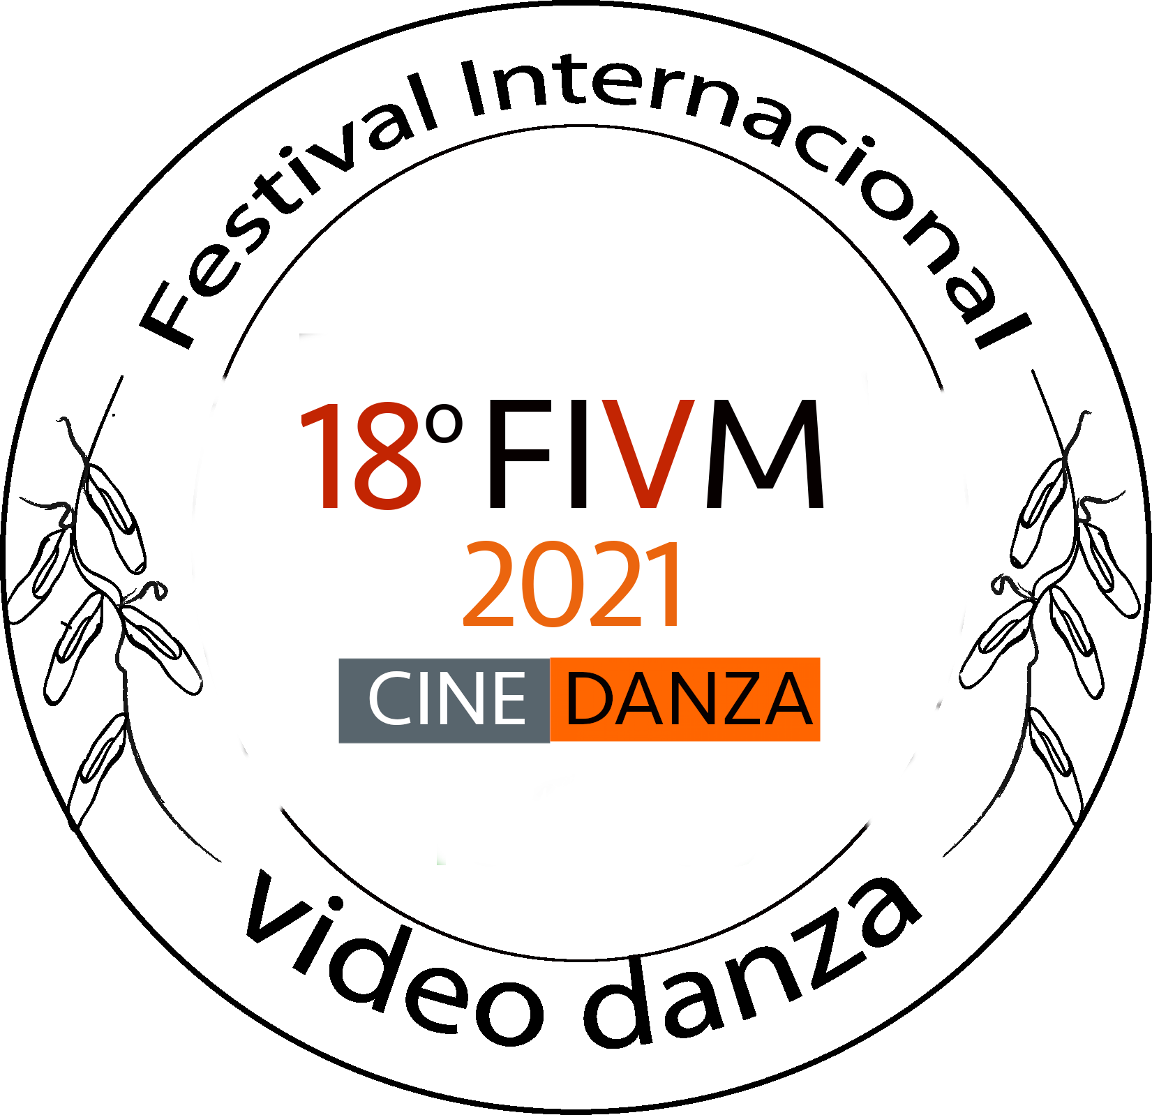
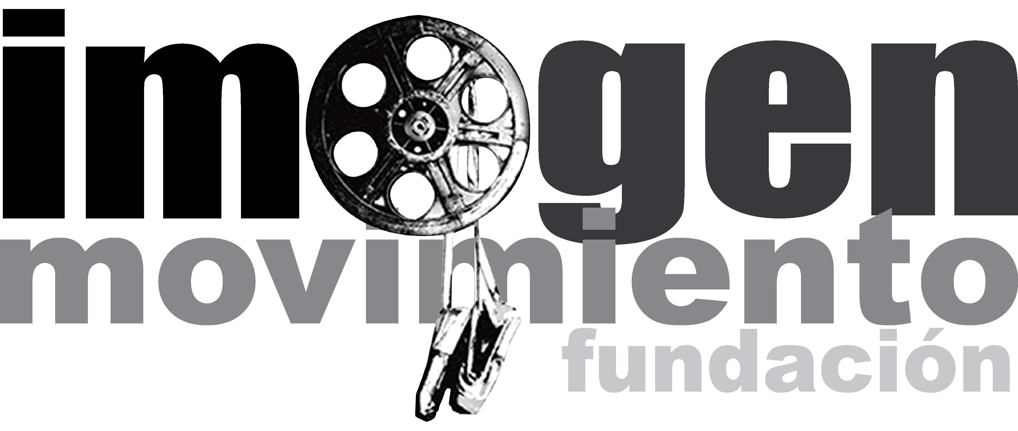

CALL
INTERNATIONAL CONTEST OF VIDEODANCE
VIDEOMOVIMIENTO 2021

The FUNDACIÓN IMAGEN EN MOVIMIENTO, open, the call of preselection for the 18th Version of the “International Festival of Videodance, VIDEOMOVIMIENTO 2021”, that is going to take place between September 27th to the 30th.

We launch the 18th International Contest of Videodance for participants all around the world, inviting filmmakers, artists and all who own plays in videodance format.

Through this call we pretend that the participants explore the different possibilities in movement expressions using has a medium, a camera.
The videodance, is the creation of a choreographic montage made especially for the camera, in which there’s a direct relation between body, movement, choreography and image.

CALL OF THE INTERNATIONAL CONTEST OF VIDEODANCE
VIDEOMOVIMIENTO 2021

Videodance award.

Shall be appointed an amount according to the deliberation of the invited jury and the directors of the Festival, to give it to three winners of the Tent International Contest of Videodance.
The award also can be declared void if it doesn’t meet the expectations of the event.

In the festival can participate, independent persons, companies, groups, organizations, partnerships, academies and schools, residents in any part of the world.

The International Videodance Contest, is sponsored by the Fundación Imagen en Movimiento, director of the festival.

The theme of the contest is open, aspect such as visual treatment, relation body – camera, movement – image, proposal of idea and script will be counted.

The reception of the videos will be between July 20th to September 10th of 2021.

The participant videos in the category “Videodance”, must have a maximum lenght of 10 minutes, credits included.

The particiant videos to the category “Videodance” must have been made after the first of January of 2020.

To participate in the call is required to complete and sign the inscription form:

FORMULARIO DE INSCRIPCIÓN 2021

The participants must send via Internet download link, plus a teaser of the work of one minute long, with the inscription form, attaching four (4) photos of the participant video, in PNG format, to the e-mail: videodanzacolombia@gmail.com

The participants accept that their works and fragments of it, can be diffused in the Eighteenth Videodance Festival VIDEOMOVIMIENTO 2021 and in nonprofit presentations and promos Nationally and Internationally.

Each contestant can participate with a maximum of three works, each one must be filled individually, attaching the previously mention requirements.

The result of the select plays for exhibit, will be published on the website of Fundación Imagen en Movimiento the day 20th of September of 2021.

FORM OF SHIPPING

Digital delivery:

The participants must send the same requirements previously mention, via internet by servers such as dropbox or wetransfer for download, to the e-mail: videodanzacolombia@gmail.com

It’s required the next information if send via internet:

- Video of the participant play or work for download, in formats: .MOV, .AVI or MP4
- Video of the teaser of the play in formats: .MOV, .AVI or MP4
- Four photos of the participant, in PNG format on high definition
- Inscription form duly completed and signed

All the requirement previously mention must be fulfilled, if the contestant doesn’t comply with this condition it will be automatically disqualified of the contest.

Fundación Imagen en Movimiento
18th VIDEOMOVIMIENTO 2021
Eighteenth International Videodance Festival
Bogotá – Colombia
