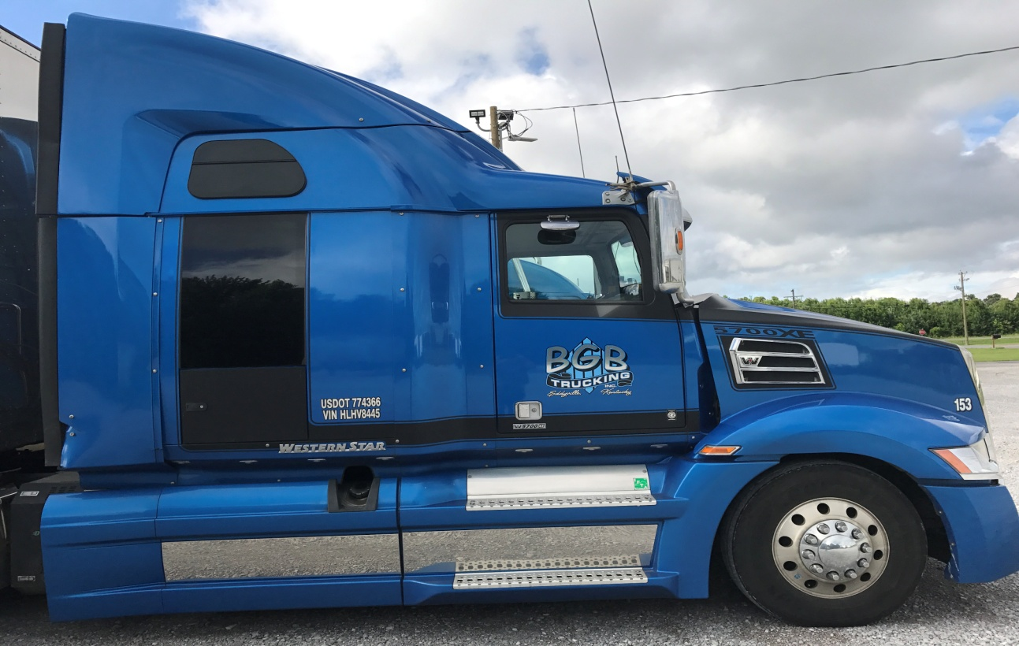

Goals
To create with this program a mirror image of what BGB's vision for our present and future drivers should look like.
- To be the industries model in safety
- 100% DOT compliant
- Safety Culture of Zero (zero accidents & zero injuries)
- Responsible corporate citizen
- Proactive culture
- Forward thinkers
- With a clear message of everyone speaking the same language
- Excellence in service
How we promote it
With 3 - Simple Rules
- Keep an open mind
- Respect others opinions
- Participate in the process
Who is accountable?
- Owner/President
- General Manager
- Safety Director
- Human Resources Director
- Manager(s)/ Supervisor(s)
- Dispatcher(s)
- Service Manager
- Shop Foreman
- Driver Trainer(s)
- Veteran Driver(s)
- Student Driver(s)
The intent of our program
Our Program is designed to leverage the skill sets of our safest and most experienced veteran drivers to help new drivers entering the industry and our team become trained in our said goals to mirror our reflection and vision for this industry and our industries future.
The Commitment to our DSTP (Driver Safety Training Program)
- The driver trainer teaches and prepares the student driver to hold an independent road driving position
- the student driver improves skills and adopts the safety culture and vision of our company
- Safety Director assigns student trainer parings and oversees our driver safety training program
- Human Recourse Director pre-screens new driver candidates and maintains records
Driver Trainer's Role
To be a driver trainer with BGB you must be safe, experienced, on time, a record of excellence in service and mirror our vision as forward thinkers for the industry and our company.
- Three or more years of on-the-road (OTR) experience
- Six months or more of a favorable work record with the company
- zero preventable accidents in the last three years
- No more than two moving violations in the last three years
- No major traffic violation in the last three years (including DUI, illegal possession, reckless/careless/negligent driving, racing, hit and run, eluding office, traffic violation resulting in death, revocation for any reason, vehicle used in a felony, speeding over 15 MPH)
The driver trainer uses the six-week guide included in this document to move the student along in the training process. The driver trainer also uses these weekly plans to evaluate the student driver's progress, providing feedback to both the student and the safety director.
The Student Driver's role
The student driver's mission in this program is to absorb our companies said goals and benefit from the mentorship of the veteran driver trainer. The student driver must be at least 23 years of age or older with less than 36 months of OTR experience. Additionally, the student driver should meet the following qualifications to maintain eligibility for this program through Sentry Transportation's underwriting department:
- Must be a graduate of an accredited truck driving school and hold a valid CDL-A -license
- Should be in the top 25% of their graduation class
- should have a clean motor vehicle (MVR) with no moving violations or at-fault accidents in the last three years, whether in a DOT-regulated commercial motor vehicle (CMV) or non-regulated vehicle
- Must pass a thorough background check
- Must pass a thorough pre-hire road test
- The student driver must ride in the passenger seat (not in the sleeper) for a minimum of 5,000 miles while observing the skills of the driver trainer
- The student driver must then accumulate an additional 10,000 miles or more as a driver while the driver trainer occupies and instructs from the passenger seat (not the sleeper)
Information on any student driver being considered for the program should be submitted to Sentry Transportation for underwriting approval.

The safety Director's role
the safety director is responsible for the implementation and the management of the driver safety training program, including:
- Submitting information on student drivers to Sentry Transportation upon hire
- Promoting the identification and development of traits that make someone a safe driver
- Pairing up driver trainers with students
- Monitoring progress
- terminating training and employment, if necessary
- Administering final student driver road tests
Human Resource Director's role
Provides the conditions needed for the driver safety training program to succeed:
- Hiring only qualified student driver candidates
- Conducting extensive pre-hire road tests prior to hiring
- Fostering a culture of safety reinforced by incentive programs and company-wide behavior
Human Resource Director will retain records of all student driver activity during employment and for a minimum of three years after an employee leaves the company. Include miles driven and details on any traffic citations or accidents.

BGB Trucking, Inc. DSTP 7 Week Training Schedule
Week One
Introduction to BGB's Safety Goals and Orientation with Skills training
- First day classroom training about BGB's goals and vision
- Second day classroom Safety and HOS training
- Third-fifth days in the truck skills training (backing, staging and Pre & Post Trip training)
First week length of training per day
8 hours a day.
Main Goals
- To introduce the new student to the industry and the ways BGB wants to be the industry model
- Train the student in our zero culture (zero accidents and zero injuries)
- Introduce the student to Hours of Service (HOS) and train them in ELD's and paper logs with trip planning and map training.
- Introduce the student to the Compliance Safety Accountability (CSA) what it means and how they are accountable through it
- To learn proper drop and hook techniques
- Master backing techniques for staging and docking trailers safely
- Proper Pre and Post trip Inspections of our equipment

Week Two
Driving Training & Restrictions
- Begin with Interstate driving during daylight hours
- Switch seats when needed so the student driver does not drive through large cities or during rush hour traffic
- Allow the student driver to drive within the driver trainer's comfort level
Length of trips
- First trip: 100 miles
- Second trip: 300 to 400 miles-radius (overnight)
- Third trip: Driver trainer's discretion
Main Goals
- On the first trip, have the student driver observe only on the outbound load. Get to know the student driver. Keep in mind that this is a new experience, and it's up to you to pass on your experience, professionalism and reflection of being the mirror image of the goals and vision set by BGB for our industry in safety and service. The student driver may be seeing the trucking industry for the first time through you. Always have a positive, upbeat attitude about the company and your customers. Make training a good experience remember, the industry's future depends on people like you.
- Have the student driver drive back to the terminal with the inbound load as the student driver's initial road test. Make sure they can properly do a pre-trip and post-trip equipment inspection, coupling & uncoupling, shifting, backing, etc. Be patient and keep in mind the student driver will likely not be well skilled in any area that you're training them in, but will improve with experience.
- At the earliest safe opportunity, let the student driver drive. As they progress, start to work on proper shifting and clutching techniques. Put our Space Cushion Management into practical application from what they learned in our class room portion of the week one training.
- Make sure logs (paper or ELD) are up to date 15 minutes current and completed daily. Inspect their logs and answer any question to help them have a better understanding of the regulations how to be compliant while operating under the hour of service regulations.
- Always stress safety and encourage the student driver in all aspects of driving.
Week Three
Driving restrictions
- Continue interstate or two-lane driving during daylight hours
- Begin driving after dark, but not after midnight
- Begin city driving, but not during rush hour
Length of trips
- As assigned by dispatch
Main Goals
- Start to increase the student driver's driving time within their capabilities.
- Make sure the student driver is involved in all coupling/ uncoupling, with emphasis on proper procedures.
- Have the student driver begin backing up tin simple situations (daylight only), with emphasis on proper procedure.
- Stress safety on turns and the proper use of mirrors.
- Demonstrate and explain the proper method of determining following distance and the importance of maintaining a safe following distance under all conditions.
- Praise the student driver for doing things correctly

Week Four
Driving Restrictions
- None
Length of trips
- As assigned by dispatch
Main Goals
- To continue to increase the student driver's driving time. The student driver should be doing at least 50% of the driving by the end of this week.
- Start teaching routing during this portion of the training. Don't just tell the student how to get there-show them by using the map. Point out how to plan your route by always using the shortest safest destination routing. Explain fuel routing and fuel economy, how to maximize it.
- Continue to express the importance of always keeping your eyes moving and checking your mirrors every 8 to 10 seconds. Explain to them that by checking your mirrors it allows you to see that your are centered in your lane or not, it allows you to know and see all four sides of your vehicle to know at all times what's around you and by doing so it allows you to not have to wait until there is an emergency to find a way out but by knowing your surroundings you will have options to make a decision on how to react to a warning before it becomes an emergency. Continue to express safety on turns and the proper use of mirrors.
- Let the student driver park the vehicle-show and explain where to park and why to park there.
- Start to teach the student driver proper use of the jake brake in all states, making sure that they understand that it's to be used to assist braking only.
- Stress time and space management, and the vehicle's ability to stop and maneuver in traffic.

Week Five
Driving restrictions
- None
Length of trips
- As designed by dispatch
Main Goals
- Continue to increase the student driver's driving time.
- Teach the student driver proper trip logging. So far you and the student driver have had to log your trips as a two-person operation. Explain how you're logging it, and also show the student driver how to log it solo so they can do it when they get their own truck.
- Show the student driver how to fill out trip envelopes and what to do with them when they're completed.
- Explain the bill-of-lading (BOL) and how they should be signed. Also, explain the use of a seal on the trailer. Have them watch piece counts and explain multi-stop seals.
- Let the student driver go with you when you work with shippers and receivers.
- Explain how dispatch work closely together.

Week Six
Driving restrictions
- None
Length of trips
- As assigned by dispatch
Main Goals
- Start role reversal by letting the student driver make the decisions, take orders, and do their own routing.
- Make sure the student driver knows the importance of properly getting all dispatch information-names, addresses and phone numbers-so they know where to pick up and deliver.
- Teach the student driver how to read bills-of-lading (BOL) for phone numbers and addresses
- Work on helping your student driver find their final destinations. Share and explain what resources your student driver can use for directions.
- Show your student driver how to safely and properly load and secure the load in the trailer. Address proper use of the seals, proper weight distribution, how to slide the tandems, and what to do if the load is overweight.
- Teach your student driver about permits, can cards and their importance. Show them the permit book and how to make sure what is in it is up to date and correct.

Week 7
Driving restrictions
- None
Length of trips
- As assigned by dispatch
Main Goals
- The student driver should be doing all of the driving by the end of this week. If the driver trainer is not comfortable with this, the company must decide whether or not to extend the training schedule.
- Instruct your student driver where to buy fuel, and how to use the fuel stop network fuel card.
- Your student driver should handle and complete all paperwork regarding the shipment. They should complete the trip and envelopes for each trip.
- Let your student driver do their own logs, both team and solo. The student driver should log all trips as though they were running them solo, for practice.
- Your student driver should deal with shippers and receivers, handling bills-of-lading (BOL), piece counts, ect.
- Your student driver should work with dispatch to make check calls and take orders.
- Continue to work with the student driver on routing and using the map.

