SEPTEMBER 2024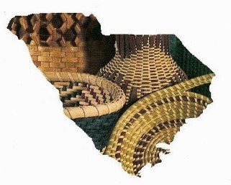 Newsletter

Upper SC Basketmakers Guild

*“Preserving the Art of Basketweaving”*

Meets 2nd Saturday each month (Feb. – Dec.) 9:30-2:30

Lutheran Church of Our Savior, 2600 Wade Hampton Blvd, Greenville, SC

Website: basketweaversofsc.com

Facebook: Upper SC Basketmakers Guild⁹

Contact: [upperscbasketmakers@gmail.com](mailto:upperscbasketmakers@gmail.com)

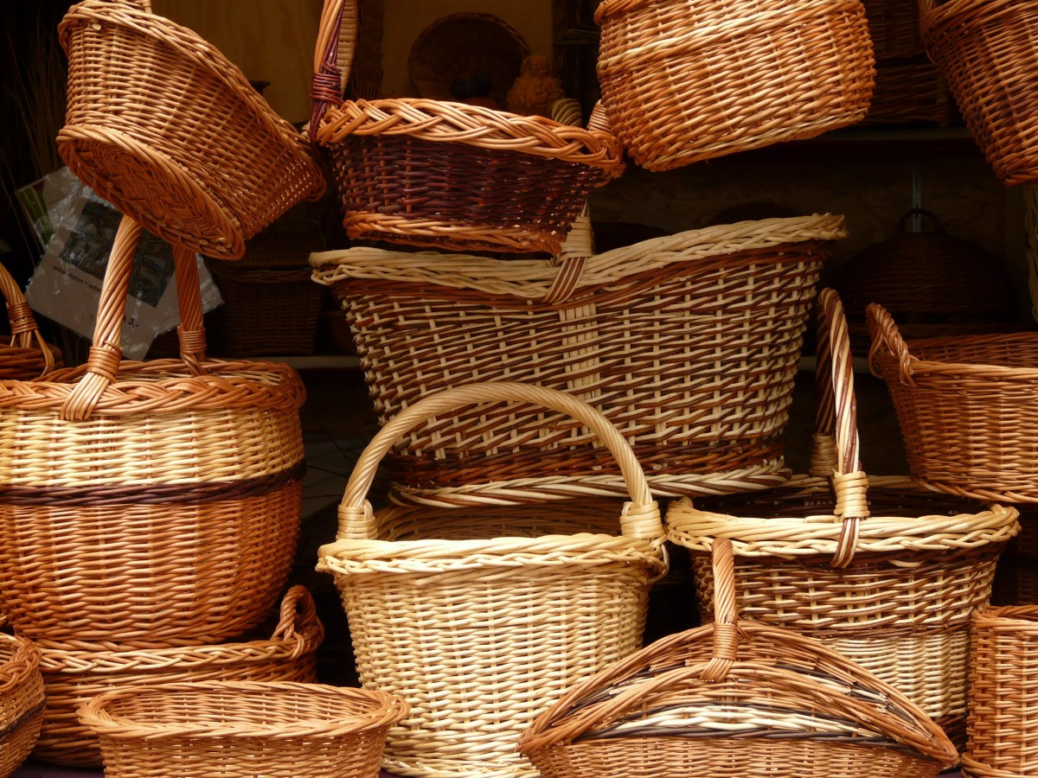

**********************************************************

Other related basket weaving groups you may want to check out:

**Dolores von Rosen Basket Guild**

4th Tuesday per month 10AM-2PM

Silverstreet Community Center (Near Newberry, SC)

**SC Natural Weavers Group currently not meeting but will be again soon stay tuned**

Used to meet 3rd Monday per month 10AM-12PM Rensing Center Library, Pickens, SC

**Your Board:**

Deborah Hill -President [deborahhill54@gmail.com](mailto:deborahhill54@gmail.com)

Judy Brooks -Vice President [jdbrooks0226@gmail.com](mailto:jdbrooks0226@gmail.com)

Denise Gillam -Treasurer [denise.gillam@gmail.com](mailto:denise.gillam@gmail.com)

Michele Hartwell -Newsletter Editor [micheleflgarden@gmail.com](mailto:micheleflgarden@gmail.com)

Janet Lampson -Recording Secretary lampsonjc@reagan.com

Julie Honchar -Web Mistress (+ so much more) [jfhonchar@yahoo.com](mailto:jfhonchar@yahoo.com)

Debbie Wilson -Member-at-large/Past President [artbasgo@gmail.com](mailto:artbasgo@gmail.com)

Pati English -Member-at-large [basketsmyspecialty@yahoo.com](mailto:basketsmyspecialty@yahoo.com)

Tina Few -Member-at-large [kristina.few@gmail.com](mailto:kristina.few@gmail.com)

Minutes from August 10, 2024 meeting

Debbie Hill opened the meeting with thanks to August Moon and Mona for a great weekend workshop.

Denise has a sign- up sheet for the necklace project she will teach at our next meeting. We do not yet know where we will need to meet in September. We will let you know if we cannot meet in our usual venue.

Denise gave the treasurer’s report. We have spent under $500 for the meals for the mini weave-in and will make a donation to the Lee Road Church.

Projects for our next meetings:

September – woven necklace taught by Denise

October – Nantucket basket taught by Judy

November – Josephine basket taught by Patti English

December – Party and basket exchange

Debbie Hill will be away for the rest of the meetings this year so Judy Brooks will be leading the meetings for us.

A vote was taken to determine if we want to have the convention again. The consensus was to hold the convention. Everyone was reminded that we would ALL be expected to help with the required tasks that will need to be done.

Debbie closed the meeting.

Submitted by Janet Lampson

**CALENDAR**

**September 14**: A cane necklace ornament.

**October 12**: the Nantuckets

**November 9**: Patti English will teach her Josephine knot basket. **December 14**: PARTY!!!

**Upper South Carolina Basket Makers Guild News**

The second Saturday of the month is our usual meeting time in Greenville, South Carolina. Recently we enjoyed a mini Weave-In and for two wonderful days more than twenty guild members from around the Upstate, North Carolina, and Georgia had the pleasure of a very patient and talented visiting Instructor, Mona Boykin, of August Moon Basketry. Mona offered a variety of basket designs and so our members selected Double Wall Cathead designs, French Shopping Baskets, Victorian Shopping Baskets, Prairie Baskets, Double Wall Plumes, a Cottage Basket along with several others. We also had a choice of colors, handle wraps, and borders with many weaving the infamous Gretchen border with lots of assistance from Mona!

Check out the August Moon Basketry website at

https://www.augustmoonbasketry.com for all of your weaving needs from reed, to bases, handles, tools, patterns, books, kits and lots more. Watch for the Monthly Specials and new additions.

Instead of our traditional potluck lunch, Judy Brooks, Vice-President, had our Friday supper and Saturday lunch catered by nearby restaurants. Registration for this event was taken care of by Janet Lampson. In addition, Michele Hartwell hosted Mona overnight for a comfortable stay. Thank you to these members and the other volunteers who were helpful in setting up and clean-up. Debbie Hill, President, announced door prize winners and held our short business meeting with preliminary plans for our 2026 Weave-In. Stay tuned for more information on date and location. As always we are looking for Volunteers to take on one of the many positions to make this event a success.

Come weave with us on the 2nd Saturday of the month from 9:30-2 at the Lutheran Church of Our Saviour on Wade Hampton Blvd. in Greenville, SC.

Visit our website at https://basketweaversofsc.com

Submitted by Pati English

***I’m still trying to get folks to submit bios and a picture for the newsletter, in an effort to get to know our members better.***

***ANYONE is welcome to send one to me that is a member.***

***Anything basket related that you would like to submit to the Newsletter is welcome. Special tips in basket making, basket resources or vendors you’d like to share.***

***I would also like to do a recipe feature each month. If there’s a dish that you’ve brought for our potluck* that *month, please email me your recipe. For next month’s Newsletter-please have submissions to me by September 27th Thank you***[***Micheleflgarden@gmail.com***](mailto:Micheleflgarden@gmail.com)

**Never tried caning?  Learn the steps through this example created on a wood ring, made from poplar, with waxed cord.  Use a tapestry needle to "sew" the woven design.  A metal eyelet screw is inserted in the top for hanging as a pendant / ornament / accent piece.  Waxed cord color choices are red, purple, royal blue, denim blue (pictured), forest green, rose, brown, tan, natural, or white.  Full kits are $15 and will include the wood ring, thread, needle, and pattern.  Wood rings only are $5.  Please let me know no later than September 1st if you want to order a kit or extra rings, with your cord color choice, at**[**denise.gillam@gmail.com**](mailto:denise.gillam@gmail.com)**.  Looking forward to our class on Saturday, September 14th.**

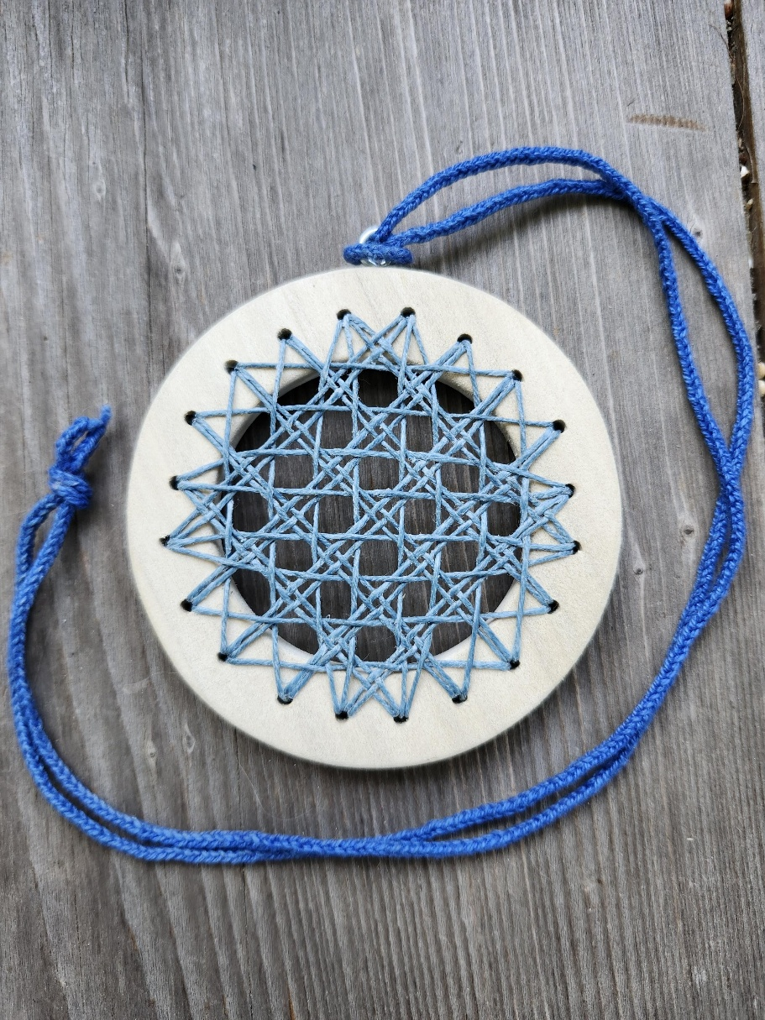**\*\*\*Watch your email closely in case our location changes from Lutheran Church of Our Saviour as our monthly Guild meeting place for the September meeting due to ongoing church renovations.\*\*\***

**Nantucket basket for October 12th meeting. 😊**

**We will have a sign up sheet at the September meeting also.**

**The cost of this class will be $30.**



