OCTOBER 2024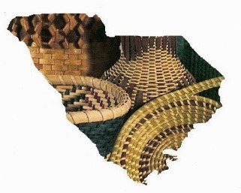 Newsletter

Upper SC Basketmakers Guild

*“Preserving the Art of Basketweaving”*

Meets 2nd Saturday each month (Feb. – Dec.) 9:30-2:30

Lutheran Church of Our Savior, 2600 Wade Hampton Blvd, Greenville, SC

Website: basketweaversofsc.com

Facebook: Upper SC Basketmakers Guild⁹

Contact: [upperscbasketmakers@gmail.com](mailto:upperscbasketmakers@gmail.com)

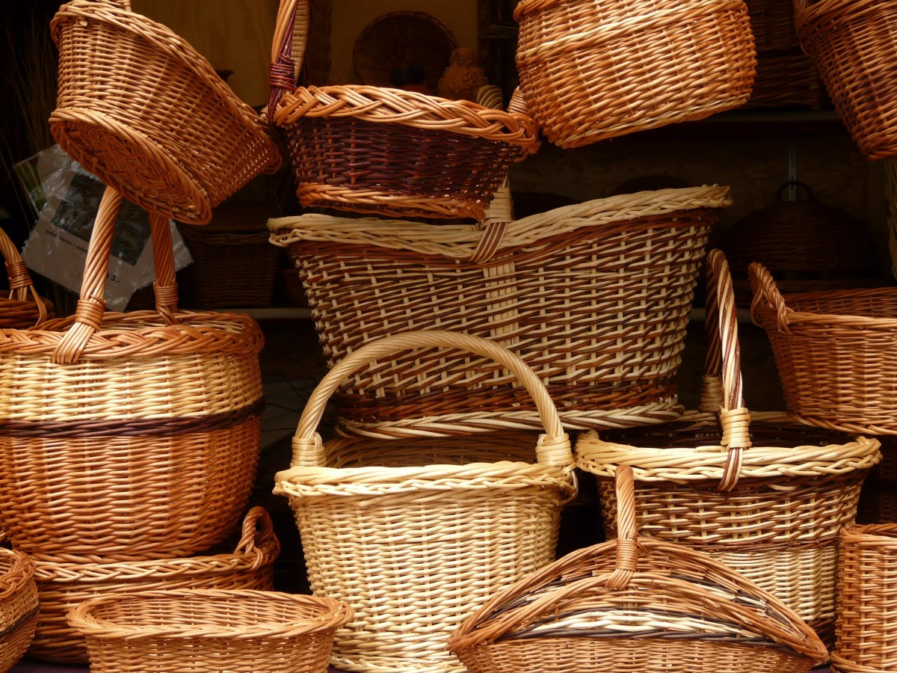

**********************************************************

Other related basket weaving groups you may want to check out:

**Dolores von Rosen Basket Guild**

4th Tuesday per month 10AM-2PM

Silverstreet Community Center (Near Newberry, SC)

**SC Natural Weavers Group currently not meeting but will be again soon stay tuned**

Used to meet 3rd Monday per month 10AM-12PM Rensing Center Library, Pickens, SC

**Your Board:**

Deborah Hill -President [deborahhill54@gmail.com](mailto:deborahhill54@gmail.com)

Judy Brooks -Vice President [jdbrooks0226@gmail.com](mailto:jdbrooks0226@gmail.com)

Denise Gillam -Treasurer [denise.gillam@gmail.com](mailto:denise.gillam@gmail.com)

Michele Hartwell -Newsletter Editor [micheleflgarden@gmail.com](mailto:micheleflgarden@gmail.com)

Janet Lampson -Recording Secretary lampsonjc@reagan.com

Julie Honchar -Web Mistress (+ so much more) [jfhonchar@yahoo.com](mailto:jfhonchar@yahoo.com)

Debbie Wilson -Member-at-large/Past President [artbasgo@gmail.com](mailto:artbasgo@gmail.com)

Pati English -Member-at-large [basketsmyspecialty@yahoo.com](mailto:basketsmyspecialty@yahoo.com)

Tina Few -Member-at-large [kristina.few@gmail.com](mailto:kristina.few@gmail.com)

Basket Guild meeting September 14, 2024 Judy Brooks opened the meeting with thanks to Denise for teaching the round woven ornament class. We had a good turn out and there are some beautiful woven necklace/ ornaments in progress.

Calendar:

October class will be the Nantucket class, several have signed up

November class will be the Josephine Knot basket with two choices to be taught by Pati English.. She will also teach us to make Josephine Knot ID tags.

December – Party and basket exchange

Please be aware that even if you are not going to take the class, you are welcome to bring a project that you are working on.

Denise gave a treasurers report and announced that the dates for the next convention will be Jan 29-February 1, 2026. She is working with the Embassy Suites to get all of the plans made.

Submitted by Janet Lampson

**CALENDAR**

**October 12**: the Nantuckets

**November 9**: Patti English will teach her Josephine knot basket.

**December 14**: PARTY!!!

***I’m still trying to get folks to submit bios and a picture for the newsletter, in an effort to get to know our members better.***

***ANYONE is welcome to send one to me that is a member.***

***Anything basket related that you would like to submit to the Newsletter is welcome. Special tips in basket making, basket resources or vendors you’d like to share.***

***I would also like to do a recipe feature each month. If there’s a dish that you’ve brought for our potluck* that *month, please email me your recipe. For next month’s Newsletter-please have submissions to me by October 18th Thank you***[***Micheleflgarden@gmail.com***](mailto:Micheleflgarden@gmail.com)

**Nantucket basket for October 12th meeting. 😊**

**We will had a sign up sheet at the September meeting.**

**The cost of this class will be $30.**

**If anyone is interested and hasn’t signed up yet, please contact Judy Brooks ASAP** [**jdbrooks0226@gmail.com**](mailto:jdbrooks0226@gmail.com)

**GORGEOUS BASKET!!!**

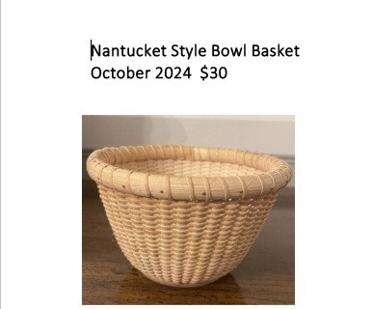

**PLEASE sign up for Pati English’s class, if you haven’t already.**

**Sure to be a fun and beautiful project!!!😊**

