AUGUST 2024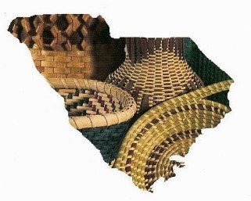 Newsletter

Upper SC Basketmakers Guild

*“Preserving the Art of Basketweaving”*

Meets 2nd Saturday each month (Feb. – Dec.) 9:30-2:30

Lutheran Church of Our Savior, 2600 Wade Hampton Blvd, Greenville, SC

Website: basketweaversofsc.com

Facebook: Upper SC Basketmakers Guild⁹

Contact: [upperscbasketmakers@gmail.com](mailto:upperscbasketmakers@gmail.com)

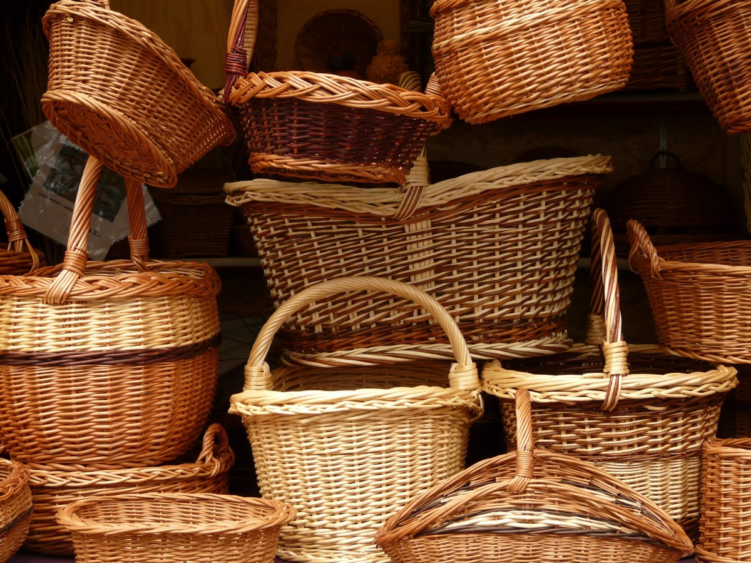

**********************************************************

Other related basket weaving groups you may want to check out:

**Dolores von Rosen Basket Guild**

4th Tuesday per month 10AM-2PM

Silverstreet Community Center (Near Newberry, SC)

**SC Natural Weavers Group currently not meeting but will be again soon stay tuned**

Used to meet 3rd Monday per month 10AM-12PM Rensing Center Library, Pickens, SC

**Your Board:**

Deborah Hill -President [deborahhill54@gmail.com](mailto:deborahhill54@gmail.com)

Judy Brooks -Vice President [jdbrooks0226@gmail.com](mailto:jdbrooks0226@gmail.com)

Denise Gillam -Treasurer [denise.gillam@gmail.com](mailto:denise.gillam@gmail.com)

Michele Hartwell -Newsletter Editor [micheleflgarden@gmail.com](mailto:micheleflgarden@gmail.com)

Janet Lampson -Recording Secretary lampsonjc@reagan.com

Julie Honchar -Web Mistress (+ so much more) [jfhonchar@yahoo.com](mailto:jfhonchar@yahoo.com)

Debbie Wilson -Member-at-large/Past President [artbasgo@gmail.com](mailto:artbasgo@gmail.com)

Pati English -Member-at-large [basketsmyspecialty@yahoo.com](mailto:basketsmyspecialty@yahoo.com)

Tina Few -Member-at-large [kristina.few@gmail.com](mailto:kristina.few@gmail.com)

Minutes July 13, 2024

Debbie Hill opened the meeting.

Next month is our August Moon weave-in on the Friday (1 PM) and Saturday (starting at the usual time). Food (tropical grill) will be brought in for Friday evening and Saturday noon (probably from Publix). We will weave until midafternoon. Mona will be staying with Michele for two nights and will go home on Sunday. Some of us may plan to go out to dinner with her.

In September, Denise is planning to teach us how to make a woven 3-inch ring necklace. She will have an example for us to see in August.

For October, we will learn about how to make a Nantucket style basket with Judy Brooks. In November, Patti English will teach a Josephine Knot basket and nametag. December will be our usual party.

Treasurer report by Denise: still solvent and we need to have a committee meeting to discuss the next convention.

Submitted by Janet Lampson

**PLEASE BRING DONATION ITEMS FOR THE CHURCH’S FOOD PANTRY TO OUR AUGUST MEETING. PAPER GOODS, NON PERISHABLE FOOD ITEMS APPRECIATED, THANK YOU!**

**WHEN OUR MEETING IS OVER ON SATURDAY, PLEASE HELP PUT THE AUDITORIUM BACK THE WAY IT WAS BECAUSE IT IS BEING USED FOR CHURCH SERVICES RIGHT NOW.**

**PLEASE BE ADVISED: Debbie Hill’s email address has been hacked and someone keeps sending out emails asking for “help”. Please do NOT click on anything or think that this is Debbie, but report as SPAM. Debbie’s actual email address is** [**deborahhill54@gmail.com**](mailto:deborahhill54@gmail.com) **.**

**ANNOUNCEMENT-**

**IFYOU NEED BASKET SUPPLIES OR ANYTHING FROM AUGUST MOON, LET MONA KNOW SO SHE CAN BRING IT FOR YOU TO PURCHASE AT THE AUGUST MEETING. WEBSITE :**

**Augustmoonbasketry.com 😊**

**CALENDAR**

August 9and 10- workshop weekend with August Moon baskets **details ATTACHED,** but all paid members will have the teacher’s fee of $25.00 paid for this 2 day workshop !!!

More August info: Mona from August Moon is coming to teach her baskets. The list of baskets was in the last newsletter and is available here.

The cut-off date to sign up for the two-day class is June 20. **THE SIGN UP DATE HAS LONG SINCE PAST…YOU MAY BE ABLE TO CONTACT MONA DIRECTLY IF YOU ACT QUICKLY TO ORDER SUPPLIES OR BASKET KITS.**

**WEBSITE Augustmoonbasketry.com 843-672-3534**

Please remember to sign up for the level basket you are sure you can handle. Debbie and Janet plan to help the beginners but you still need to sign up for the level you can handle. Mona will work with everyone on shaping skills for the basket you have chosen.

If you are a member of our guild, the guild is picking up the $25 teachers fee/ person. The guild is also paying to bring in food for Friday supper.

We will start at 1pm on Friday and weave until …

Saturday we will start at our normal time (9:30 to 10:00) and weave until mid afternoon.

**September 14**: A cane necklace ornament.

**October 12**: the Nantuckets

**November 9**: Patti English will teach her Josephine knot basket. **December 14**: PARTY!!!

Attention-Yearly Membership dues of $20.00 Need to be sent to Denise Gillam including your information by either printing and filling out the form on our website or including that info along with your check…THANK YOU😊

***I’m still trying to get folks to submit bios and a picture for the newsletter, in an effort to get to know our members better.***

***ANYONE is welcome to send one to me that is a member.***

***Anything basket related that you would like to submit to the Newsletter is welcome. Special tips in basket making, basket resources or vendors you’d like to share.***

***I would also like to do a recipe feature each month. If there’s a dish that you’ve brought for our potluck* that *month, please email me your recipe. For next month’s Newsletter-please have submissions to me by August 23rd Thank you***[***Micheleflgarden@gmail.com***](mailto:Micheleflgarden@gmail.com)

**Our August 9th and 10th Basket Mini Weave with August Moon!!**

**The $25.00 teacher’s fee will be paid for all currently paid members😊**

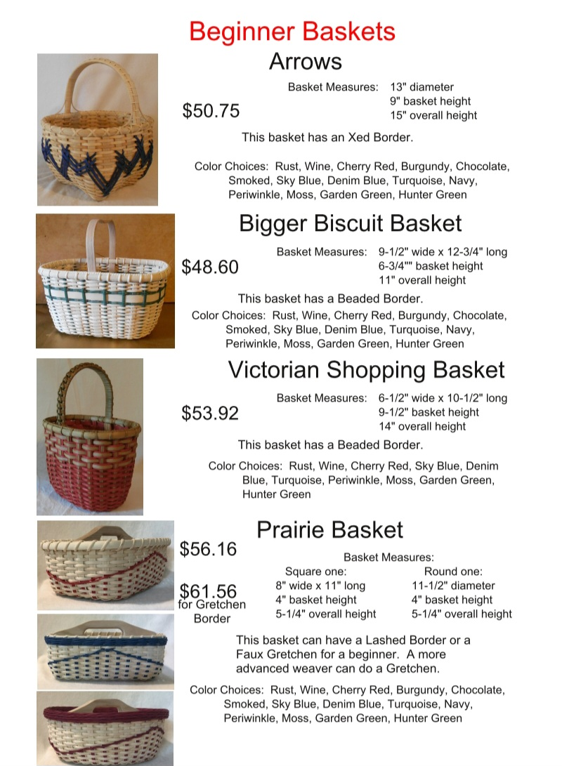

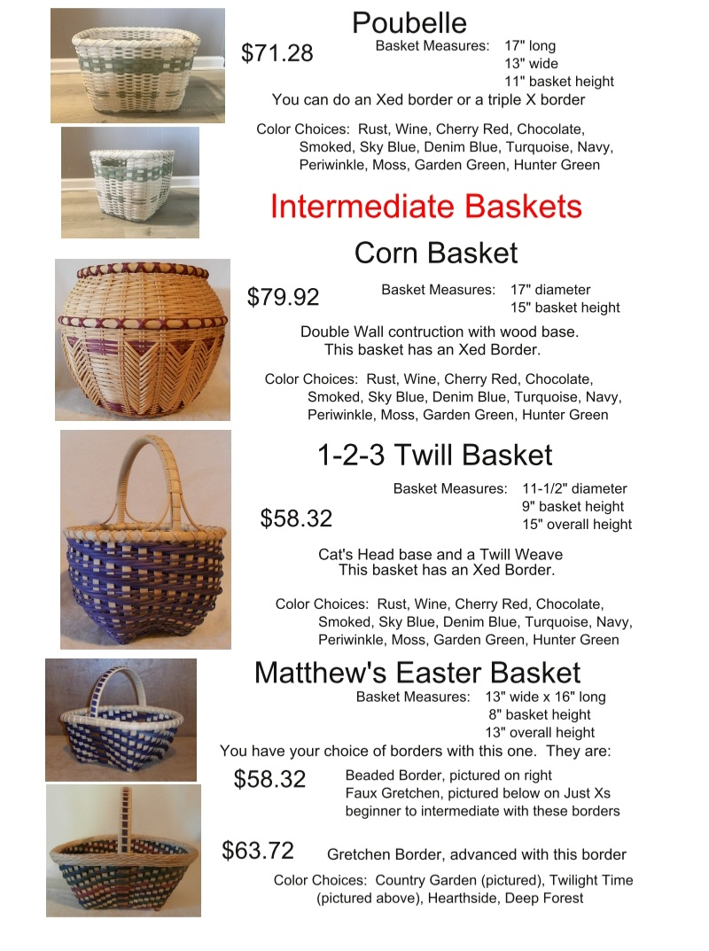

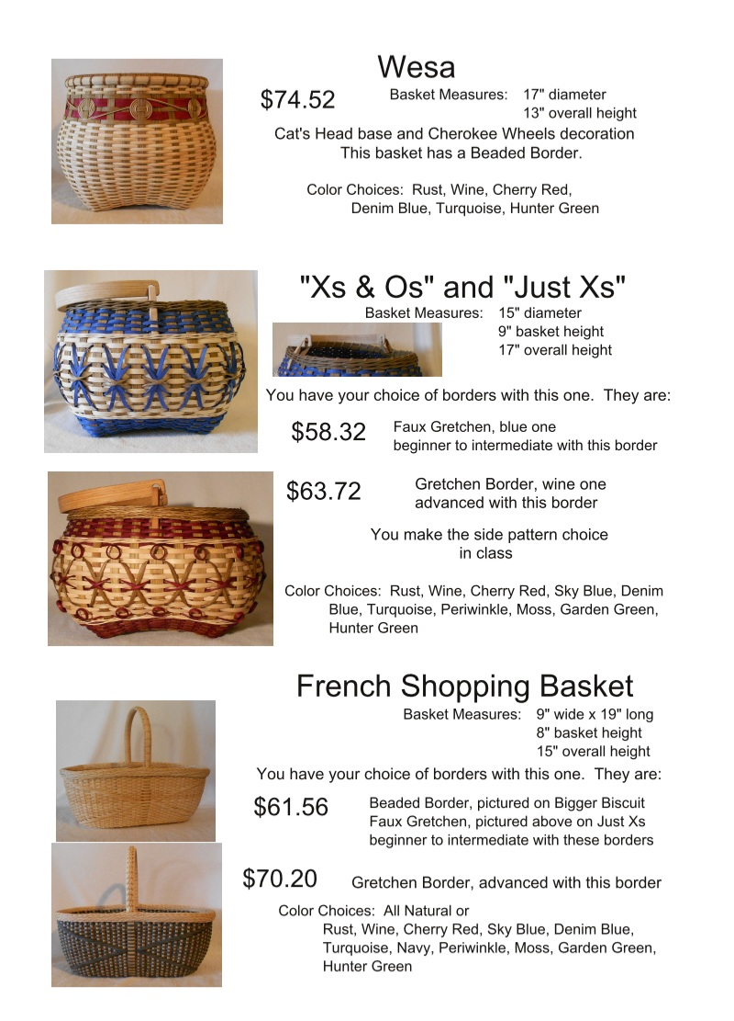

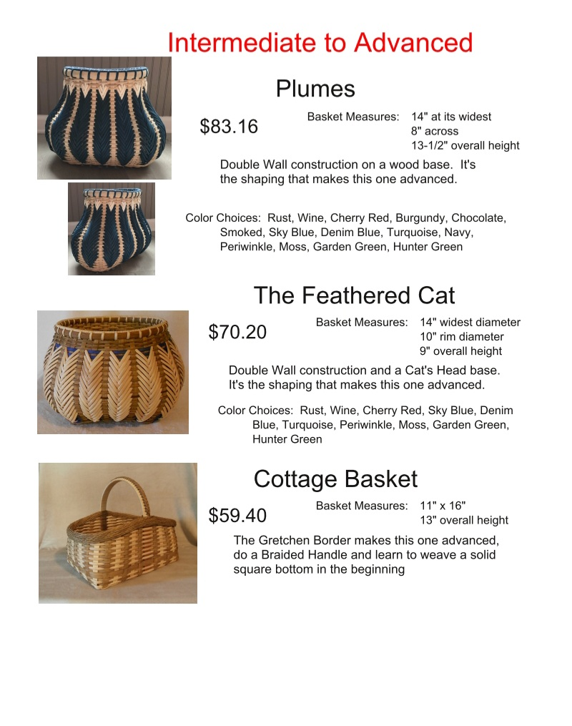

**The 82nd NC Gourd Festival offers 30 classes this year!  Seven of them are basket-weaving! Pam Milat is teaching 4 half-day classes and Jim Anspach is teaching two half-day classes (one class is offered twice). I've attached photos of these classes. You might also want to try wood burning (Regina Pena provides the burners!) and gourd classes.**

**All classes are listed on our website:**[**https://ncgourdsociety.org/**](https://ncgourdsociety.org/)

**Registration is open until August 20.**

**The cost is $15 to join the NC Gourd Society for one year, plus the cost of each class.**

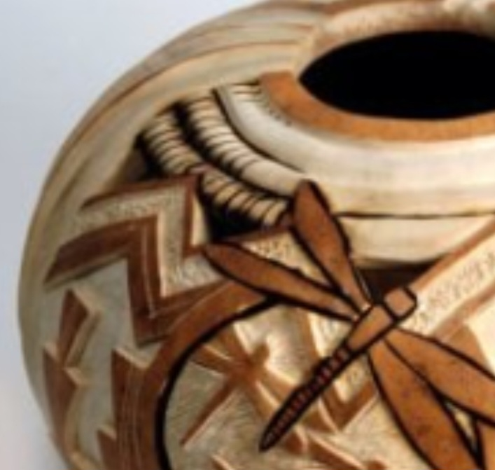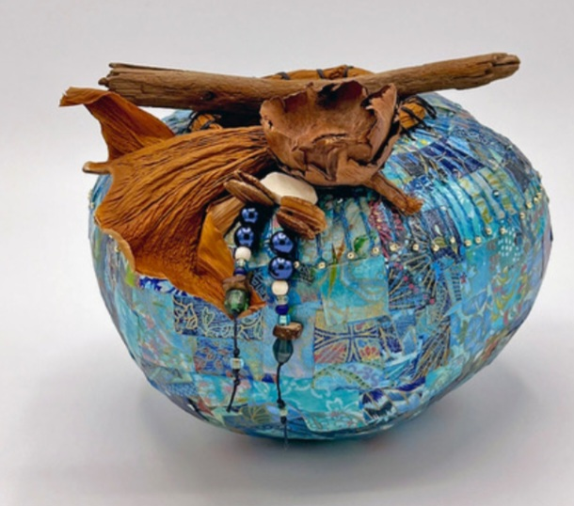**We'll again be in the Holshouser ("Village of Yesteryear") Building at the fairgrounds.  I hope to see you all there!**

