JUNE 2024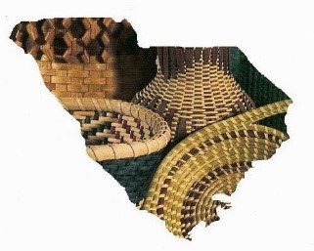 Newsletter

Upper SC Basketmakers Guild

*“Preserving the Art of Basketweaving”*

Meets 2nd Saturday each month (Feb. – Dec.) 9:30-2:30

Lutheran Church of Our Savior, 2600 Wade Hampton Blvd, Greenville, SC

Website: basketweaversofsc.com

Facebook: Upper SC Basketmakers Guild⁹

Contact: [upperscbasketmakers@gmail.com](mailto:upperscbasketmakers@gmail.com)

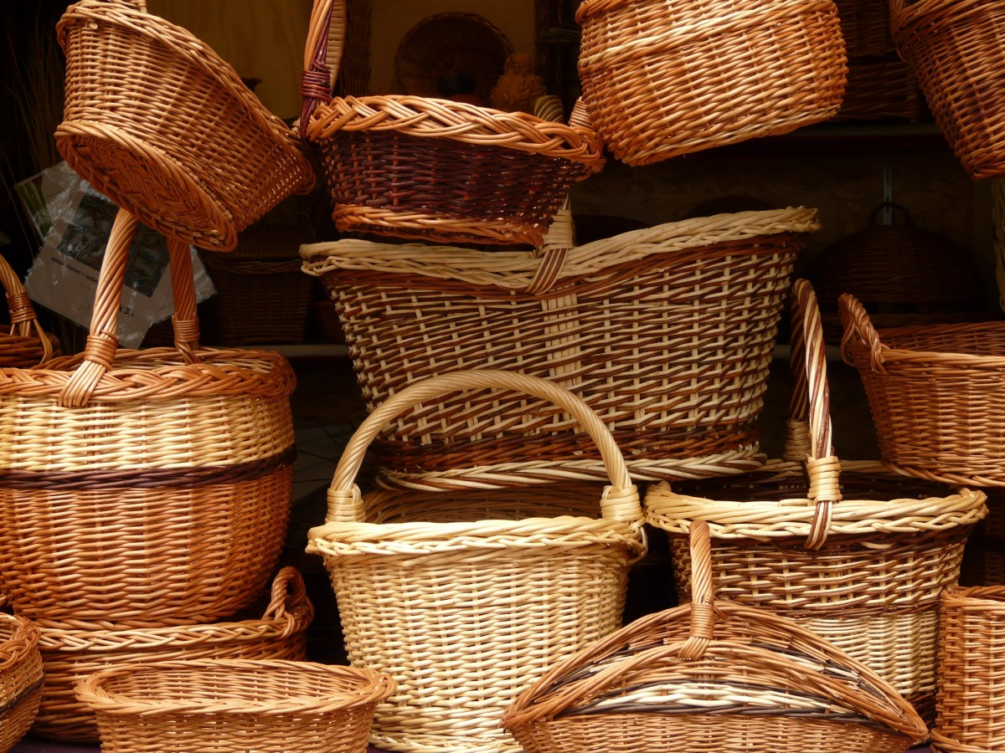

**********************************************************

Other related basket weaving groups you may want to check out:

**Dolores von Rosen Basket Guild**

4th Tuesday per month 10AM-2PM

Silverstreet Community Center (Near Newberry, SC)

**SC Natural Weavers Group currently not meeting but will be again soon stay tuned**

Used to meet 3rd Monday per month 10AM-12PM Rensing Center Library, Pickens, SC

**Your Board:**

Deborah Hill -President [deborahhill54@gmail.com](mailto:deborahhill54@gmail.com)

Judy Brooks -Vice President [jdbrooks0226@gmail.com](mailto:jdbrooks0226@gmail.com)

Denise Gillam -Treasurer [denise.gillam@gmail.com](mailto:denise.gillam@gmail.com)

Michele Hartwell -Newsletter Editor [micheleflgarden@gmail.com](mailto:micheleflgarden@gmail.com)

Janet Lampson -Recording Secretary lampsonjc@reagan.com

Julie Honchar -Web Mistress (+ so much more) [jfhonchar@yahoo.com](mailto:jfhonchar@yahoo.com)

Debbie Wilson -Member-at-large/Past President [artbasgo@gmail.com](mailto:artbasgo@gmail.com)

Pati English -Member-at-large [basketsmyspecialty@yahoo.com](mailto:basketsmyspecialty@yahoo.com)

Tina Few -Member-at-large [kristina.few@gmail.com](mailto:kristina.few@gmail.com)

Minutes from May 11, 2024 Meeting

Judy Brooks opened the meeting.

The **upcoming classes** are as follows:

June class with Peggy McCarson. The deadline has passed to sign up but you can give her a call to see if she will add you to the roster.

July class is “Weaving on a Vase” with Debbie Hill and Janet Lampson. The class is $25.00. Materials provided will be a glass vase with a wooden base, black spokes and natural weavers. A sign-up sheet will be available at the June meeting.

August is when Mona will be coming from August Moon on the 9th and 10th. All orders need to be in by June 20th so the money and kit orders can be sent in by the June 30th. The tuition fee will be paid by the guild as well as paying to bring in food on those two days.

September class to be taught by Denise Gillam. We will learn to weave a pendent.

October class is to be weaving a Nantucket style basket that will done on a mold.

November class Patti English will teach a Josephine Knot basket. We will also make nametags.

**Convention news:**

We need to decide if we are going to do another convention in 2026. We will need to talk to the hotel and make a deposit by the end of the summer if we are going to go forward with it.

The profit from the Convention came from the raffle (about $2500). Other categories broke even.

Denise: To make her comfortable as the treasurer, we need to have between 12 and 15 thousand in the bank to have enough to fund a convention.

Submitted by Janet Lampson

**CALENDAR**

**June 8:** Peggy McCarson can come and teach **DETAILS ATTACHED**

**July 13**: weaving on a glass vase with Debbie Hill and Janet Lampson **DETAILS ATTACHED**

August 9and 10- workshop weekend with August Moon baskets **details ATTACHED,** but all paid members will have the teacher’s fee of $25.00 paid for this 2 day workshop !!!

More August info: Mona from August Moon is coming to teach her baskets. The list of baskets was in the last newsletter and is available here. Please sign up on the sign-up sheet at the next meeting. Choose the baskets you want to work on, the colors, and style. The sheet also has a place to put the price of the baskets and cost as well as if you paid by check or cash. Checks can be made out to Janet Lampson. I will put my address on the form for anyone who needs to send their check to me by mail. The forms will be available at the May and June meetings. The cut-off date to sign up for the two-day class is June 20. Please remember to sign up for the level basket you are sure you can handle. Debbie and I plan to help the beginners but you still need to sign up for the level you can handle. Mona will work with everyone on shaping skills for the basket you have chosen.

If you are a member of our guild, the guild is picking up the $25 teachers fee/ person. The guild is also paying to bring in food for Friday supper.

We will start at 1pm on Friday and weave until …

Saturday we will start at our normal time (9:30 to 10:00).

**September 14**: A cane necklace ornament.

**October 12**: the Nantuckets

**November 9**: Patti English will teach her Josephine knot basket. **December 14**: PARTY!!!

Attention-Yearly Membership dues of $20.00 Need to be sent to Denise Gillam including your information by either printing and filling out the form on our website or including that info along with your check…THANK YOU😊

***I’m still trying to get folks to submit bios and a picture for the newsletter, in an effort to get to know our members better.***

***ANYONE is welcome to send one to me that is a member.***

***Anything basket related that you would like to submit to the Newsletter is welcome. Special tips in basket making, basket resources or vendors you’d like to share.***

***I would also like to do a recipe feature each month. If there’s a dish that you’ve brought for our potluck* that *month, please email me your recipe. For next month’s Newsletter-please have submissions to me by June 26th Thank you***[***Micheleflgarden@gmail.com***](mailto:Micheleflgarden@gmail.com)

**Our June 8th Meeting with Peggy McCarson (I took my very first basket making class from her 6 years ago, MY FAVORITE TEACHER!!!)**

**JULY PROJECT**

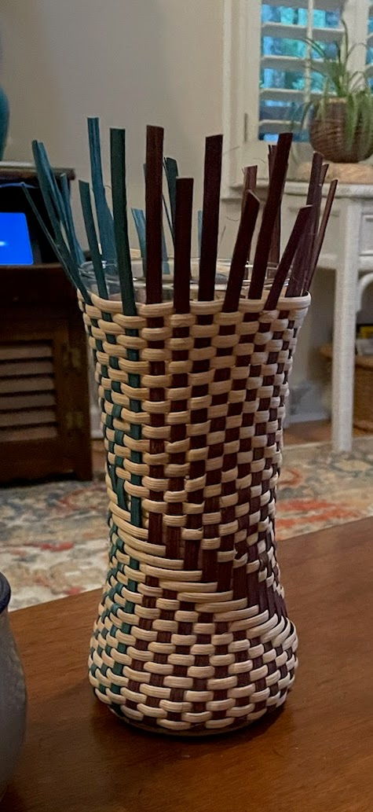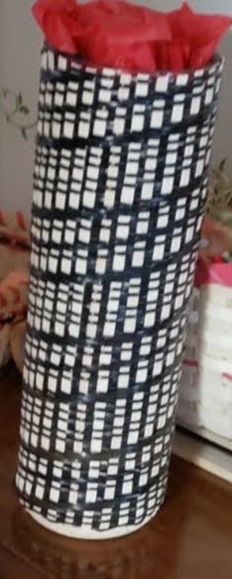**WEAVING ON A VASE WITH DEBBIE HILL AND JANET LAMPSON. CLASS IS $25.00 AND INCLUDES A GLASS VASE WITH WOODEN BASE, BLACK SPOKES AND NATURAL WEAVERS. A SIGN UP SHEET WILL BE AT THE JUNE MEETING OR CONTACT EITHER DEBBIE HILL** [**deborahhill54@gmail.com**](mailto:deborahhill54@gmail.com) **or JANET LAMPSON** [**lampsonjc@reagan.com**](mailto:lampsonjc@reagan.com)

**Our August 9th and 10th Basket Mini Weave with August Moon!!**

**The $25.00 teacher’s fee will be paid for all currently paid members😊**

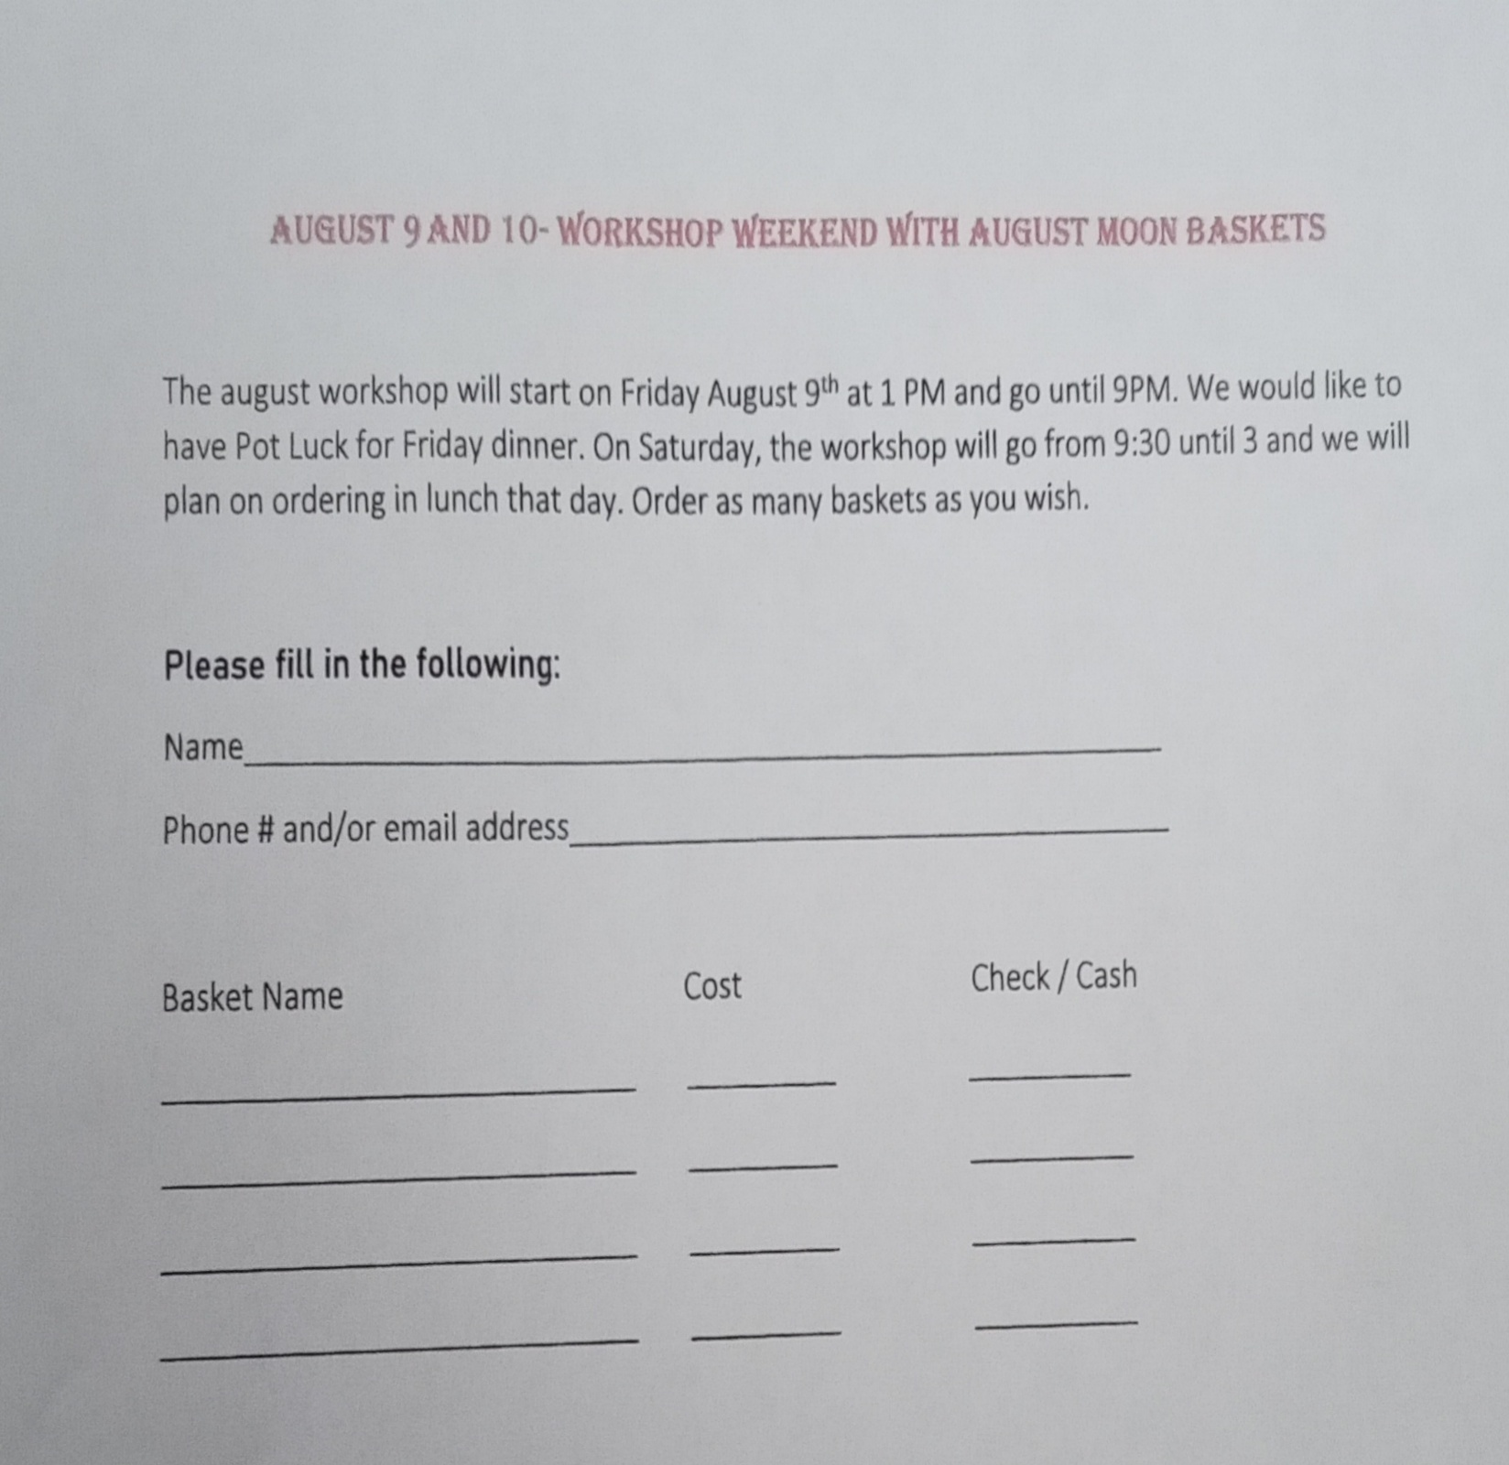**Please fill out attached form and either bring to our next meeting or mail to Janet Lampson @ 518 WINDWARD WAY GREER SC 29650 along with a check made out to Janet Lampson.**

