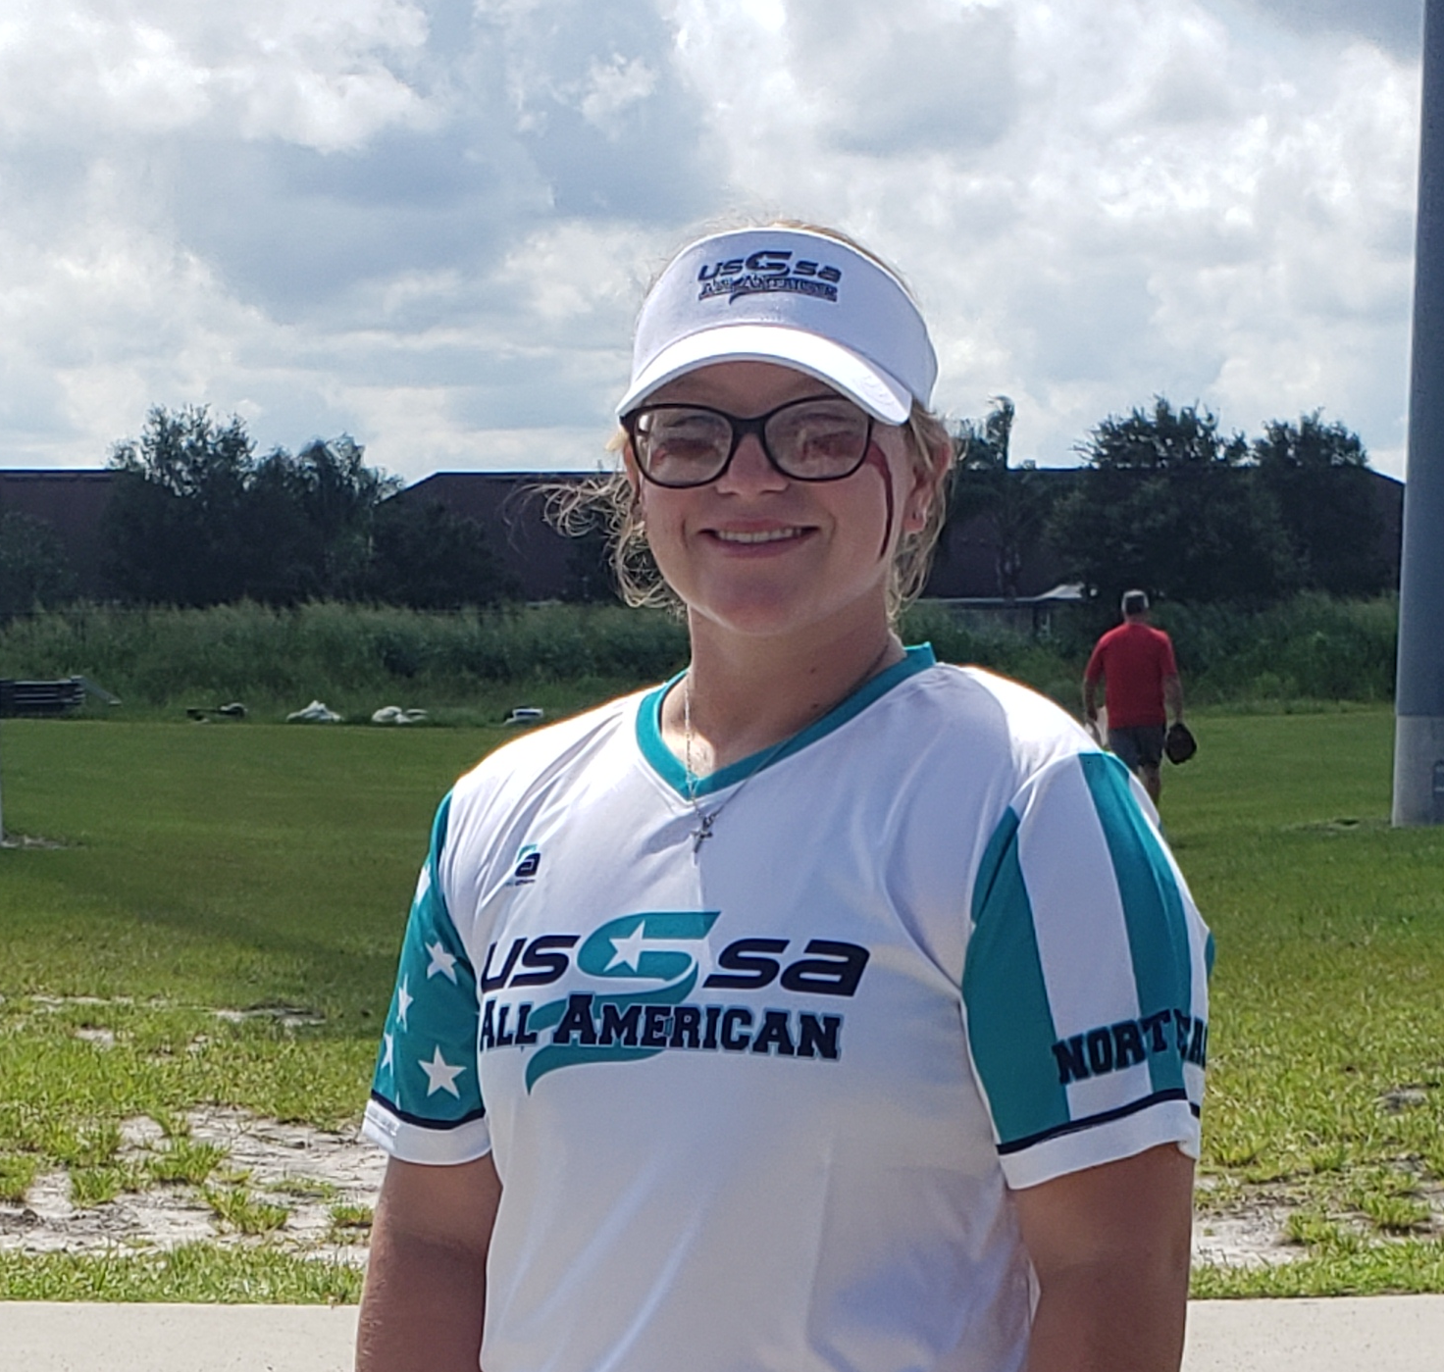

**Brooke Ludwig #9**

**Player Phone:** 717-798-5159

**Player Email:** [brooke.ludwig27sb@gmail.com](mailto:brooke.ludwig27sb@gmail.com)

**Contacts**

**Parents:**

Stephen Ludwig – [stephen.ludwig@comcast.net](mailto:stephen.ludwig@comcast.net) 717-495-0679

Leslie Ludwig – [leslie.ludwig@comcast.net](mailto:leslie.ludwig@comcast.net) 717-608-1102

**Hitting Coach:**

Doug Boyd – 484-221-1638

**High School Coach:**

Sarah Smith – [slsmith@cdschools.org](mailto:slsmith@cdschools.org) 717-XXX-XXXX

**Player Videos:**

Brooke’s YouTube channel

**Spring 2024 Schedule**

May 25-27 – Mason-Dixon Memorial Day Super NIT

Chambersburg, PA

June 8-9 – Indiana County Summer Showcase

Indiana, PA

June 15-16 – Happy Valley Fathers Day Hitfest

State College, PA

June 22-23 – Central PA State Championships

State College, PA

July 6-7 – Fun in the Sun

Baltimore, MD

July 15-21 – Northeast National Championships

Jackson, NJ



**Head Coach:** Zach Robinson

Email: [zach7272@gmail.com](mailto:zach7272@gmail.com) 717-418-2721

**High School:** Central Dauphin

**Graduation Year:** 2027

**GPA:** 3.9

**Major/Interest:** Nursing

**Positions:** 2B, OF

**Bats:** Left

**Throws:** Right

**Height:** 5’ 1”

**Weight:** 135

**5/10/5 20yd Sprint Fastest Pitch**

**5.07** **3.88** **N/A**

**Overhand Throw Bat Exit Speed Pop Time**

**49 58 N/A**

**Achievements**

* 2023 USSSA All American Team

**2024 High School Freshman**

* .750 average, 20AB, 16 RBI, 11 BB, and 3 SO

**2023-24 Travel Ball – PA Shockers**

* .380 average, 50 AB, 16 RBI, 10 BB, and 13 SO
* 6.2 IP, 52 BF, 7 K, 10 BB, 4.2 WHIP, 14.7 ERA

**2022-23 Travel Ball – PA Shockers**

* .447 Average, 38 AB, 7 RBI, 6 BB, and 6 SO
* 34.1 IP, 176 BF, 43 K, 27 BB, 2.1 WHIP, 6.73 ERA