Lido Beach Shore Protection Project: Advancing Renourishment and Dune Resilience
By Nikesh Patel, City Engineer
Dear Lido Key Residents,
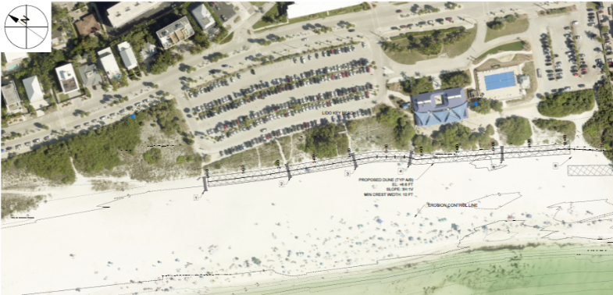
The City of Sarasota, in close coordination with Sarasota County and the U.S. Army Corps of Engineers (USACE), continues to make significant progress on vital shoreline protection initiatives for Lido Beach. These efforts include the next phase of beach renourishment and a future dune enhancement project—both essential to reducing storm-related impacts and safeguarding our coastline.
Federal Authorization and Local Collaboration Drive Progress
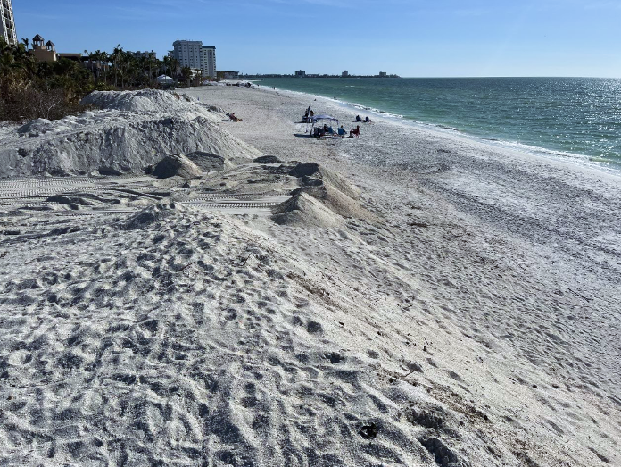
A major milestone was achieved on May 5th, 2025, when the Sarasota City Commission approved two key agreements: a Temporary Access and Work Area Easement and the temporary assignment of 21 Perpetual Beach Storm Damage Reduction Easements (PBSDREs) to Sarasota County. These agreements empower the County, serving as the non-federal sponsor to USACE, to meet the real estate certification requirements necessary for construction. Both the easement and the assignment to the County are temporary, in support of the project, and will expire on December 31st, 2026.
The Water Resources Development Act (WRDA) of 2025 further strengthens our ability to move forward by allowing the temporary use of existing easements for up to two years. This provision enables the project to proceed without further delay, while the City retains concurrent rights to the easements during this period to ensure ongoing oversight.
Scope and Timeline of Upcoming Improvements
The coordinated project includes:
- New Pass Dredging: Conducted by USACE to enhance navigation safety, with the dredged sand reused to replenish Lido Beach.
- Beach Renourishment: Placement of beneficial sand fill to stabilize the shoreline, protect adjacent infrastructure, and enhance ecological and recreational value.
- Dune Enhancements: A 1.57-mile-long dune system—scheduled for Fall 2026 through early 2027—will be constructed to reinforce natural storm protection and improve habitat continuity.
Project mobilization is anticipated in late 2025, following the County’s real estate certification in June. Beach fill operations are expected to run through Summer 2026.
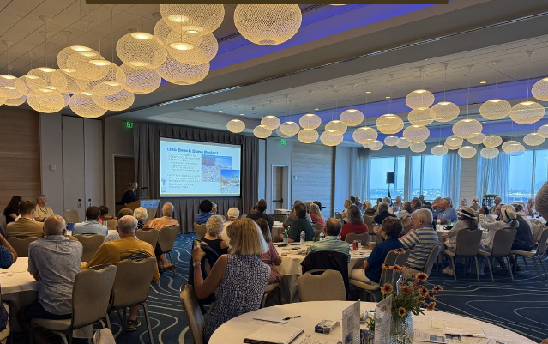
Design Refinements and Community Input
The dune system, originally developed in 2021 and permitted by the Florida Department of Environmental Protection (FDEP) in 2023, is currently being revised to reflect the updated beach conditions. Thank you to those who came to the informational meeting on March 26th and to Lido Beach Resort for their hospitality. While the City initially explored constructing dunes ahead of nourishment, the current plan is to implement dune enhancements after the USACE completes the renourishment in late 2026. Community engagement will remain a key component as we work with properties to utilize the most suitable sand sources available.
Sustainable Sand Source Planning
With the New Pass nearing depletion, the City is actively pursuing federal support to secure sustainable sand sources for the future. Long-term shoreline protection relies on reliable material access, and identifying alternative sources is crucial for maintaining Lido’s resilience.
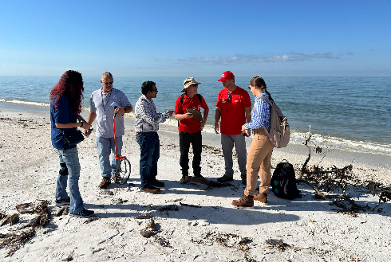
Commitment to Coastal Protection
Lido Beach remains a cornerstone of our community’s environmental and economic vitality. Guided by interagency collaboration, scientific expertise, and meaningful public engagement, the City of Sarasota is advancing proactive measures to safeguard this treasured coastal resource for future generations. We are grateful for the continued partnership of Sarasota County, the USACE, FDEP, Mote Marine Laboratory, the Sarasota Audubon Society, and our engaged local stakeholders.
We also extend our sincere appreciation to the offices of U.S. Representative Greg Steube and U.S. Senator Rick Scott for their advocacy and collaboration with our City Commissioners in advancing this critical project.
For more information, please contact:
Alyssa Thomas
Assistant City Engineer
Office: (941) 263-6520 | Mobile: (941) 400-4582
Email: alyssa.thomas@sarasotafl.gov

