Tedfold Cottage Farm
1 Tedfold Stud Cottages
Rowner Road
Billingshurst
West Sussex RH14 9HU
pigkeepingcourses@hotmail.com
www.pigkeepingcourses.com

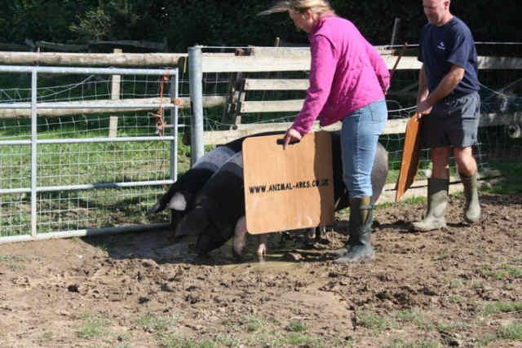

One-Day & Half-Day Pig Course Booking Form

Name(s):

Address:

Contact Number(s):

Email address:

Any dietary or disability requirements?
How did you hear about us?
Redeem Voucher Number?

I would like to book ______place(s) on the______________20

One-day course fees are £99 per person (£190 for two sharing a manual) to include complimentary refreshments and lunch plus a course manual. Half-day course fees are £55 per person (£100 for two) to include complimentary refreshments and a course manual.

All you need to bring are a coat and some clean boots.

Please return this form and payment to secure your place(s). Please make cheques payable to M Giles; BACS details are Bank: Santander, Name: Dr M Giles, Sort: 09-01-27, Account: 11777995 or use the website PayPal link. Your place will be held for 7 days until the booking form is returned via post or email and we then confirm your booking by return.

Thank you for choosing Tedfold Cottage Farm for your course and we both look forward to meeting you. Michaela & Oliver Giles

Ps: Don’t forget to let us know if you wish the course confirmation to be sent inside a special card – write anywhere on the form we will see it!!

