AFRICAN SWINE FEVER MOVES WESTWARDS IN EUROPE
What can pet pig keepers, smallholders, and commercial pig producers do to prevent disease reaching our pigs?
African swine fever (ASF) is an extremely serious disease of pigs. It’s a viral disease that often causes pigs to die. The virus first entered European Union Member States in 2014 from countries further east in Europe. ASF has been spreading since then in wild boar in eastern and central Europe with outbreaks also occurring in domestic pigs, especially in pigs in small herds. Many pigs have died from this disease, and many thousands more have been culled to try and control its spread. There is no effective vaccine available for control. Fortunately this virus does not infect humans and there is no risk to public health.
In September 2018, ASF was detected in Belgium for the first time in wild boar found dead in the Luxembourg region, near the border with France. This is a very significant development in the westward spread of ASF in European Union Member States. It illustrates how this disease can move large geographic distances, most likely by people moving infected meat or meat products or objects, materials or equipment contaminated with the virus from ASF-infected areas.
Since then further cases of ASF have been found in wild boar in this area of Belgium. As a consequence, Belgian pig farmers have lost much of their international market and all the pigs kept in the infected zone have been culled.
Further afield, ASF has been spreading in China since it was first reported in early August 2018. Updates on this disease in different regions can be found on the gov.uk website:
https://www.gov.uk/government/collections/animal-diseases-international-monitoring#outbreak-assessments-2018
It is vital pig keepers in the UK take action now to reduce the risk of this deadly disease entering their pigs, and to play their role in safeguarding the health of the national pig population. The messages below are important, regardless of whether pigs are kept as pets, in small-scale herds, or on commercial farms.
What you can do to keep pigs free of this virus infection
The biggest risk of ASF entering the UK’s pig population is from pigs eating infected pork or pork products derived from infected pigs or wild boar. The ASF virus can survive for months to years in smoked, dried, cured and frozen meat. Meat products brought into the UK from affected countries as personal imports pose the biggest risk. Commercial trade of such products is not permitted from the ASF-restricted areas.
ASF virus survives at high levels in the blood and carcases of infected pigs or wild boar and is also in their droppings and manure. The virus can therefore also be spread on vehicles, equipment, clothing and boots contaminated from infected pigs or wild boar. As a result, people whose homes are in ASF-affected areas in Europe, and those returning to the UK from holidays or hunting expeditions could unknowingly bring back infection. If these people also happen to keep pigs, or work on pig farms, they could pass that contamination on to the pigs and introduce disease, but there are some straightforward actions that will stop this happening.
1. Feed pigs only with legally permitted foods
- Never allow pigs to eat meat or meat products – this is ILLEGAL
- Never feed pigs catering or domestic kitchen waste – this is ILLEGAL
- Don’t let anyone eat or bring meat or meat products, or waste food, near pigs to avoid accidental access
- Dispose of waste food so that pigs cannot access it
- Provide a balanced diet using a specially formulated pig feed
- Fruit and vegetables can be fed but must not have entered a kitchen or contacted other food.
2. Practice good biosecurity
- Use dedicated protective outer clothing and boots for people coming into contact with your pigs, these should not be used off your premises
- Limit visitors to pigs to a minimum and avoid visits from people just returned from abroad
- Prevent vehicles or equipment from coming on to premises with pigs unless cleaned and disinfected first
- If you have a footpath/bridleway on your land or beside it and near your pigs, display “Do not feed the pigs” signs. These are available to download on the AHDB Pork website at: https://pork.ahdb.org.uk/health-welfare/health/emerging-diseases/african-swine-fever/. Pig keepers in Scotland can download warning posters and get further biosecurity information from the Pig Disease Control Centre: http://www.spdcc.org/

A summary of this information is available in a poster on GOV.UK: http://apha.defra.gov.uk/documents/surveillance/diseases/african-swine-fever-poster.pdf and the EU has produced an animated video to highlight the key messages: http://www.efsa.europa.eu/en/press/news/180711
The Scottish Government has also produced ASF videos for pet pig keepers: https://youtu.be/mGxjwuywols and pig producers: https://youtu.be/vKjwuLe1hVw
What to do if you suspect your pigs have ASF
If a pig is unwell, contact your veterinary surgeon straight away – it is important to register with a veterinary surgeon before any disease problems occur in your pigs. They can advise you on prevention of other diseases too. If you or your vet suspect your pigs have ASF, report this to the Animal and Plant Health Agency immediately as indicated below:
In England: Defra Rural Services Helpline on 03000 200 301
In Wales: APHA on 0300 303 8268
In Scotland: contact the local APHA Field Services Office https://www.gov.uk/government/organisations/animal-and-plant-health-agency/about/access-and-opening#scotland-field-service-offices
Guidance on how to spot and report the disease is available at:
https://www.gov.uk/guidance/african-swine-fever
Further information about ASF is also available on the following websites:
https://www.gov.scot/africanswinefever
https://gov.wales/topics/environmentcountryside/ahw/disease/african-swine-fever/?lang=en
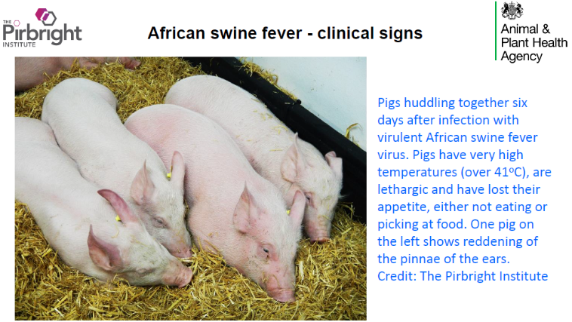

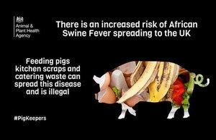

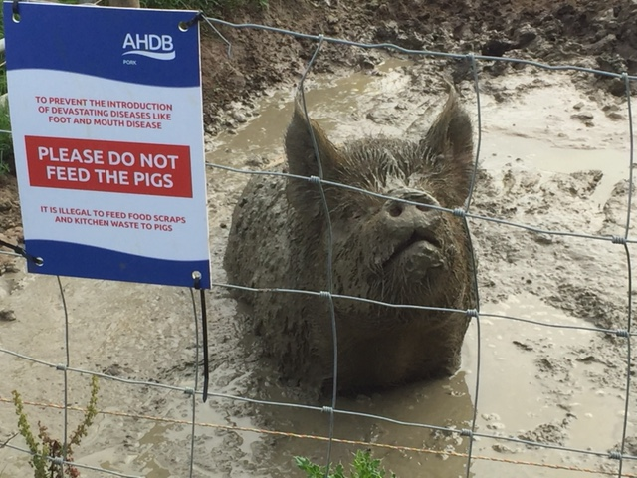

Please share these messages with everyone you know who keeps pigs, whether small-scale or commercial, as it is important that everyone takes steps to stop ASF being introduced and helps protect our pigs from this devastating disease.

