*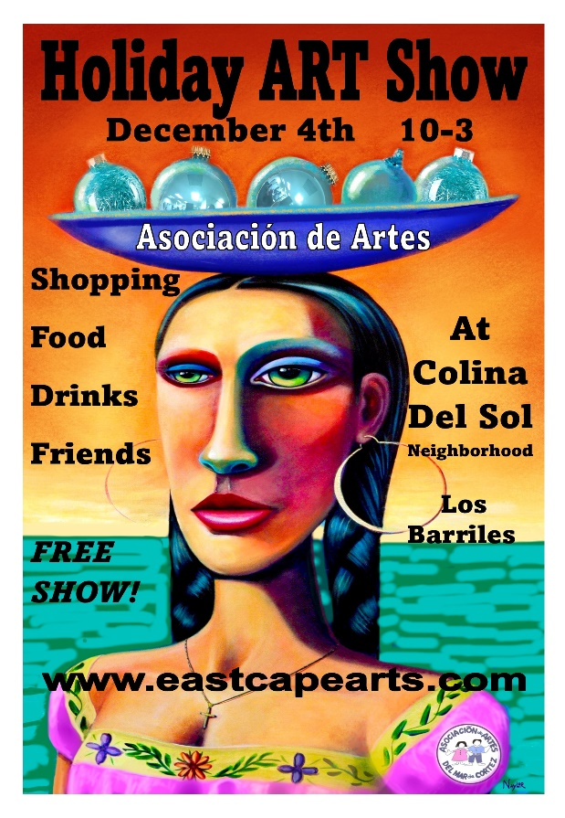Asociación* *de Artes*

invites you to be a vendor at the

**Holiday   
 Art Show**

**December 4th, 10am – 3pm.**

Held at Colina del Sol Clubhouse, Los Barriles

**Details:**

* *Set up*: Saturday, 2pm – 5pm, Sunday gates open at 7am for set up.
* *Cost:* $400 pesos (we will collect it at the event)
* No assigned spaces – all spaces first come basis.
* Space for your 10’ x 10’ tent or just bring a table. (no double booths) There are more table spaces than tent 10’ x 10’ spaces
* Show held around the pool at Colina del Sol neighborhood club house. Spaces are not assigned and centered around the pool at the club house. Please feel free to contact us with questions. We always appreciate a notice if you plan on attending.
* *Questions*: **eastcapersmagazine@gmail.com**

**G**et your designs in front of a large crowd with Christmas shopping on their minds!!! This well attended show with its intimate atmosphere seems to encourage our guests to stay and visit with friends. Don’t be left out on this great selling opportunity. Watch for our article in the Gringo Gazette, front page of East Capers Periodico and other social media publications.

**A**ll proceeds generated from this event go to the programs   
for children that Asociación de Artes supports.  
[www.eastcapearts.com](http://www.eastcapearts.com)