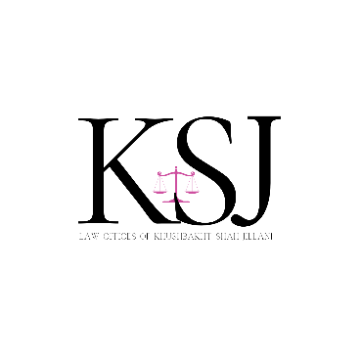

SUMMER SCHOOL 2024

“LAWYER LAUNCHPAD: EXPLORING A GLO-CAL CAREER”

LIST OF GUEST SPEAKERS

Natasha Zahid is a Partner and Head of the Disputes and Investigations at Taylor Wessing practice in the MENA region. She is a dual qualified barrister from the Bar of England and Wales and Sindh Bar, Pakistan with over two decades practising in the region. She specialises in regional and international commercial litigation, arbitration disputes and investigations across a broad range of sectors and industries.

2021-2024 Legal Director, Clyde & Co LLP

2005-2020 Senior Associate, Baker Botts LLP

2003-2005 Senior Legal Counsel, Mashreqbank PSC

2001-2002 Pupillage, 3 Hare Court Chambers, London

Know more about Natasha [here](https://www.taylorwessing.com/en/people/united-arab-emirates/dubai/natasha-zahid).

NATASHA ZAHID

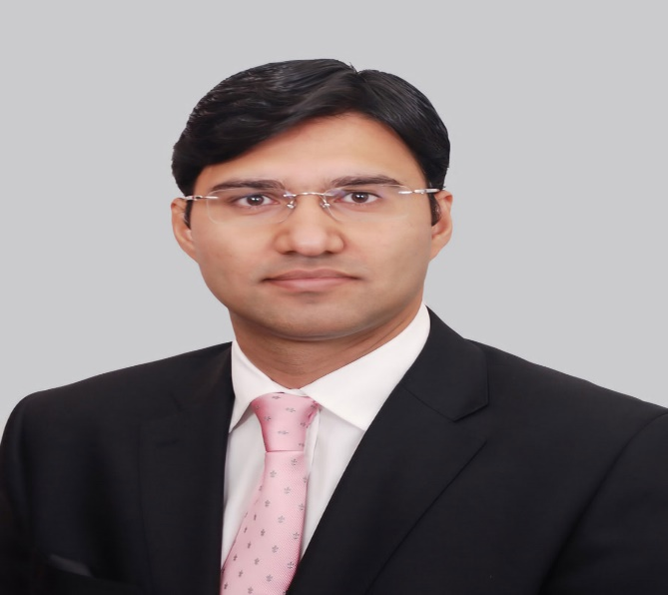

With more than 10 years of experience as a Partner at top international law firms, and now as a Senior Partner at Kilam Law in Pakistan; Consultant with Oman headquartered MAR Law, Mr. Taimur Malik leads strategic legal assignments across Pakistan and the Gulf Cooperation Council (GCC) region, advising clients on a wide range of contentious and non-contentious matters, including cross-border disputes and M&A, contract negotiations, public international law issues and arbitrations.

He is the founder of CourtingTheLaw.com, a leading online platform for legal awareness and education in Pakistan; and is also a Partner at PakLaunch. He holds an MBA from University of Oxford and various certifications from renowned institutions.

Clyde & Co | Partner 2018 - 2023

Curtis, Mallet-Prevost, Colt & Mosle LLP | Partner 2012 – 2018

Vale | Regional Legal Manager - Middle East 2010-2012

Know more about Taimur Malik [here](https://www.linkedin.com/in/taimurm/?originalSubdomain=pk).

TAIMUR MALIK

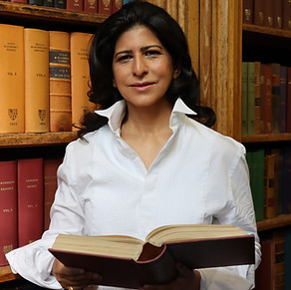

Mahnaz Malik is an international arbitrator, barrister, and author. She currently practices as a Barrister and Arbitrator at Twenty Essex Chambers. She has over 21 years of experience advising governments, corporations, and international organisations on international law issues and disputes. She has acted as counsel on behalf of both investors and states in landmark investments and commercial disputes, including ICC, ICSID, LCIA, and PCA administered arbitrations.

After graduating with a MA in Law from Cambridge University, she qualified as an Attorney at Law (New York), Solicitor (England & Wales), advocate of the high court in Pakistan and an English Barrister (Lincoln’s Inn). She has analysed some 1000 treaties and advised over 20 governments and three regional groupings on international law. She has designed and delivered training for over 600 government officials.

Know more about Mahnaz Malik [here](https://www.mahnazmalik.com/).

MAHNAZ MALIK

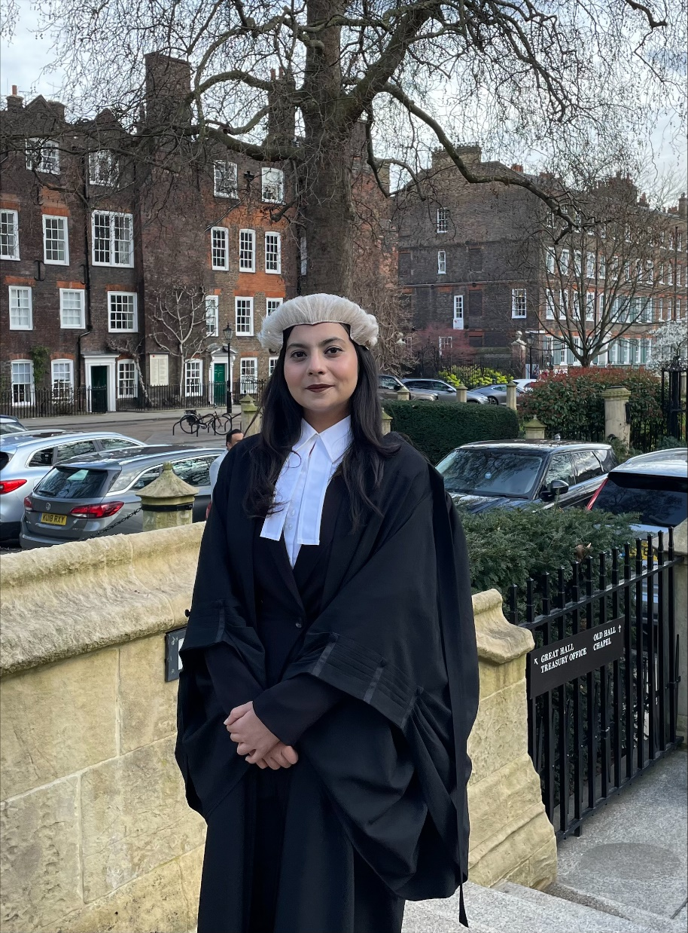

Maarij Shabbir is a Barrister (unregistered), currently working as a Litigation Associate at SAJ Legal in London. Her legal journey began in 2017 when she started LLB Honours Degree with the University of London, and secured multiple distinctions, including a World Distinction in Commercial Law.

Prior to joining SAJ Legal Solicitors, Maarij worked at the Office of the Deputy Attorney General of Pakistan and several reputable international law firms. She received the “Academic Excellence Award” from the University of London and “Achievement Award” from Women Lawyers Forum, Pakistan. She has completed advocacy training with the Western Circuit, training on trial advocacy and International law by the United States Department of Justice and training on intellectual property law by the University of Pennsylvania

Know more about Maarij [here](https://www.linkedin.com/in/maarij-shabbir-b569a01a7/?originalSubdomain=uk).

MAARIJ SHABBIR



Rahmat Kamal is a Partner at Haidermota & Co. and specializes in Projects & Infrastructure, Energy & Natural Resources, Project Finance, PPP, Privatization, and Public Procurement. She has advised projects valuing between US$ 30 million to US$ 1.9 billion, from inception through the operations phase, across a spectrum of industries and technologies including solar, wind, coal, LNG and hydropower power generation; energy distribution & transmission; mining; terminals; and transportation.

Chambers & Partners’ (2021) review states that she “*attracts strong praise from clients, who appreciate that she is ‘very meticulous and hard-working’ and offers ‘thorough knowledge on law and is very methodical.*’” A client quoted by Chambers stated that Rahmat “*stands out in her performance*”. Market sources cited in Legal 500 (2022) have said she “*is like a keen technician working through the issues and coming up with an excellent product”.*

Know more about Rahmat Kamal [here](https://www.hmco.com.pk/team/rahmat-kamal-ghanghro/).

RAHMAT KAMAL GHANGRO

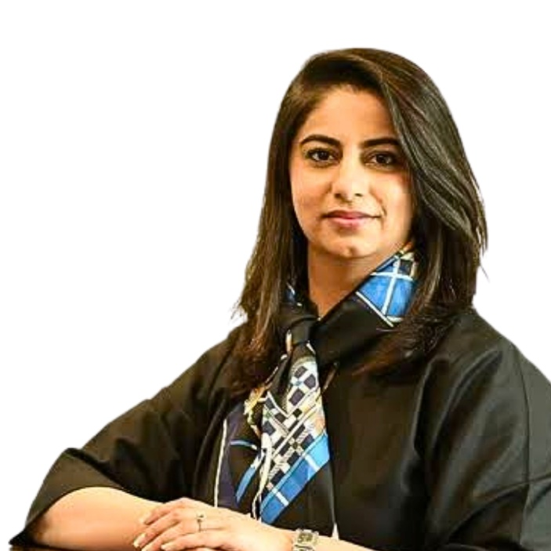

Mehvish Muneera Ismail is the Company Secretary & General Counsel (Executive Vice President) at HBL Microfinance Bank (HBL MfB). Mehvish is the youngest member of the bank’s senior management and is a recipient of Pakistan’s first Women in Law Awards 2020-2021 for the category of “In-house Legal Counsel”. She is a seasoned professional with over a decade of diversified legal experience. With expertise in corporate and commercial advisory, including regulatory and legal compliance, corporate governance, company and banking laws, Mehvish’s career trajectory has exposed her to multiple legal jurisdictions ranging from Qatar, UK, US and Pakistan.

Prior to joining HBL MfB, Mehvish was the Chief Legal Officer at U Microfinance Bank Ltd. After completing her BA-LL.B from LUMS, Mehvish got an LL.M from the University of Cambridge, where she was a recipient of the Cambridge Commonwealth Trust Award and the Noon Educational Foundation Award, and was subsequently presented as a Cambridge Pegasus Scholar.

Know more about Mehvish Muneera [here](https://www.linkedin.com/in/mehvish-muneera-41263696/?originalSubdomain=pk).

MEHVISH MUNEERA ISMAIL

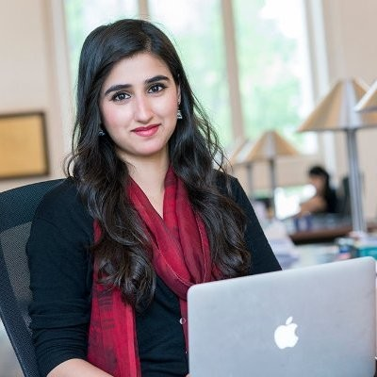

Fatima Yasmin Bokhari holds a Master of Laws (LL.M.) from Harvard Law School and an LL.M. in ‘Criminology and Criminal Justice from the University of London. She is the co-founder & CEO of Musawi, a private organization based in Pakistan which engages with both governmental and non-governmental stakeholders, via research, capacity building, monitoring evaluation and litigation for the purpose of affecting evidence-based legal and policy reforms.

She is a legal practitioner with over 10 years of professional experience specializing in criminal justice reform, rule of law and human rights.  Prior to establishing Musawi, Fatima was an Aryeh Neier Fellow and staff member with the Open Society Justice Initiative in Budapest and New York, where she engaged in strategic litigation within the national security and criminal justice context for select jurisdictions in Europe and Asia.

Know more about Fatima Bokhari [here](https://www.linkedin.com/in/fatima-yasmin-b-2b1946bb/).

FATIMA YASMIN BOKHARI

Hasan Saeed has over half-a-decade of experience in designing, planning and implementing a diverse set of programming in the Rule of Law, Economic Growth and Education space. He has served as the Program Delivery Specialist at the Legal Aid Society and currently working as a Programs Manager at Adam Smith International.

He has experience in designing and implementing projects centered on Gender & Child Security, Freedom of Religious Beliefs, Women's Economic Empowerment and Climate Security and has also been heavily involved in curating robust monitoring and evaluation frameworks for programs at the regional and national level with international partners from the US (Department of State), UK (FCDO/DFID), and UN bodies (IOM, UNDEF, UNFPA and UN Women.

As an Accredited Mediator in Sindh, he routinely undertake pro-bono mediation cases pertaining to civil and commercial disputes/claims (family disputes, maintenance, commercial issues etc.).

Know more about Hasan Saeed [here](https://www.linkedin.com/in/hasan-saeed-449906151/).

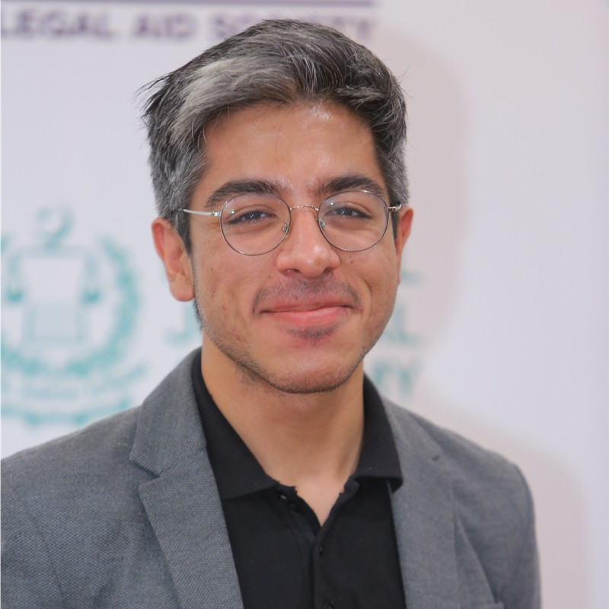HASAN SAEED

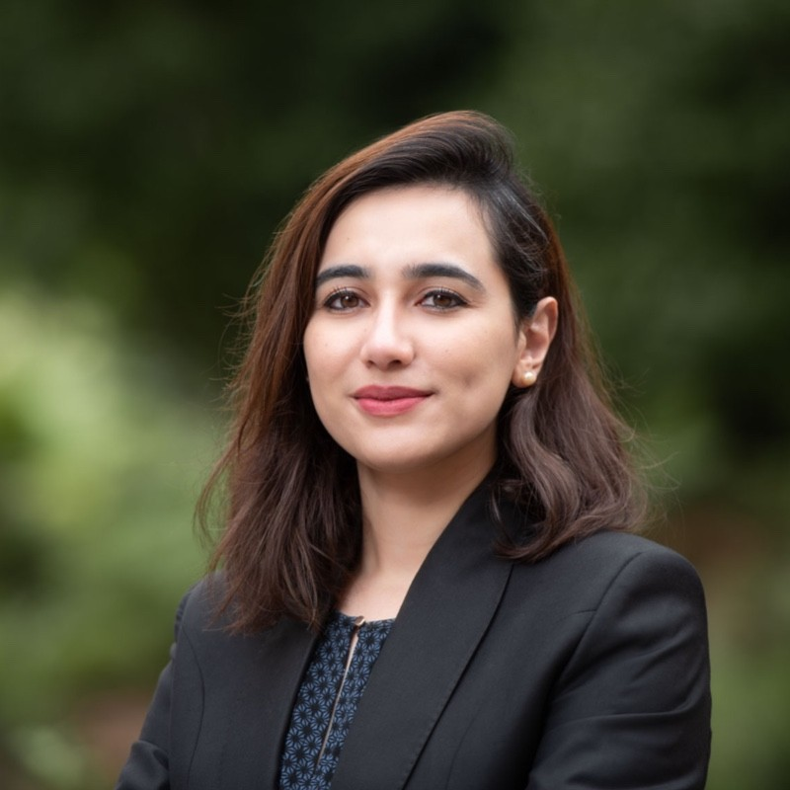

Hira Jaleel is a Teaching Fellow and Adjunct Professor at the Center for Animal Law Studies in Portland, Oregon USA. As a Teaching Fellow, Hira is responsible for contributing to the success of the online Animal Law LLM and Animal Law MSL degree programs. As an Adjunct Professor, Hira teaches Aquatic Animal Law in both the in-person and online modalities, and also co-teaches Food Law with Professor Pamela Frasch. Hira’s research and scholarship focuses on international and comparative animal law issues, and she is especially interested in developing animal law as a field of study in South Asia, with a focus on Pakistan.

Prior to that, Hira has also extensively litigated on behalf of animals in Pakistan. Hira has acted as co-counsel and appointed as amicus in multiple cases before the Lahore High Court. Hira has also been a consultant for Pakistan’s Federal Ministry of National Food Security & Research, and has worked on a new Federal Animal Health Bill for Pakistan in collaboration with the World Organization for Animal Health (WOAH).

Know more about Hira Jaleel [here](https://www.linkedin.com/in/hira-jaleel-879630125/).

After graduating from the Shaikh Ahmad Hassan School of Law LUMS, Hiba went on to complete her LLM from Harvard Law School, where she actively led and participated in student led initiatives. Hiba's experience ranges from interning at the New York State Supreme Court to working in boutique law firms in New York and Illinois.

Know more about Hiba Hassan [here](https://www.linkedin.com/in/hiba-hassan-661644203/).

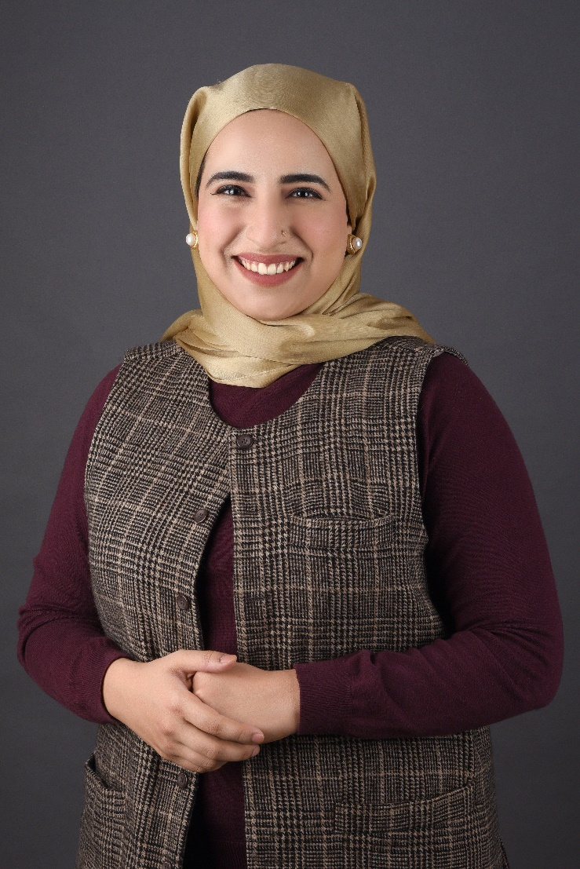

Khushbakht Shah Jillani has a multi-faceted career as a lawyer and an ESG/SDG consultant-practitioner. She is a Family Law & Domestic Violence Litigation Specialist leading her law office KSJ Legal in Karachi. From being nationally recognized as the Rising Star by the Government of Pakistan to later being awarded the Best Litigator by APAC Insider, Khushbakht has successfully made a mark in the Pakistani legal industry as a lawyer with a commitment to serving justice. She has spoken about her work on international forums such as WEF Annual Meeting at Davos, UNFPA and sits on the Board of Girls Human Rights Hub, UK. She is actively working for the betterment of the bar & bench in the province of Sindh; and is also a member of the American Bar Association’s committee of Family Law.

Khushbakht is founder of *Adal Aur Sehat* –an initiative working towards gender & social justice in Pakistan through legal and health awareness, research, digital advocacy, knowledge dissemination and litigation. Her projects include *Mehfooz* & F.O.C.U.S. The former is working on curbing domestic violence; & the latter is creating awareness on ADHD/neurodivergent brains. She is a Curator at the Global Shapers Community, Karachi Hub where she is representing the diverse interests of 10m young people of Karachi. She is engaged with Climate Forward Pakistan as a Policy Analyst and is also pursuing projects for justice through AI in Pakistan.

Know more about Khushbakht Jillani [here](https://www.linkedin.com/in/khushbakhtshahjillani/?originalSubdomain=pk).

KHUSHBAKHT JILLANI

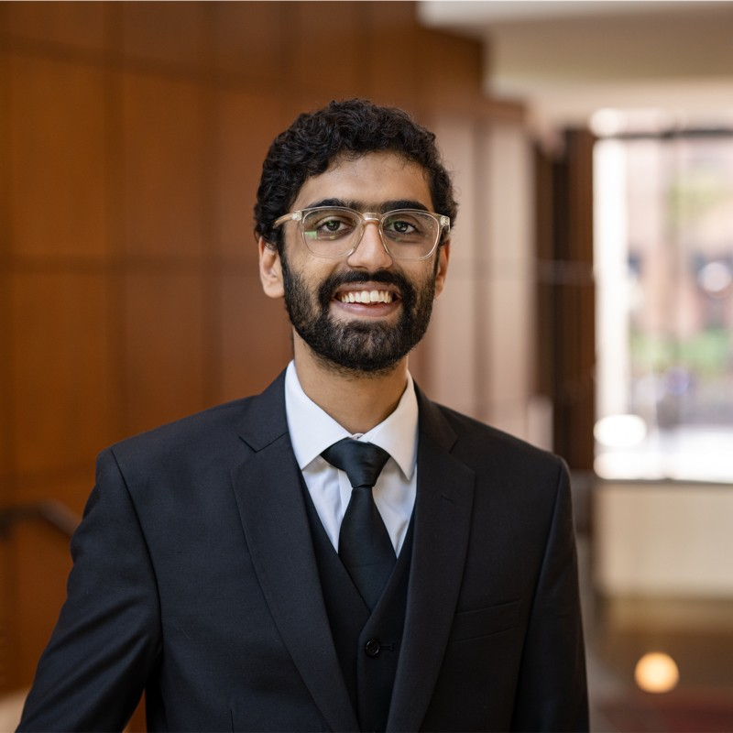

Adam Khan holds an LLM from University of Pennsylvania (UPenn) and BA LLB from LUMS. He is an Attorney at Law (New York) and is also qualified to appear in Pakistani courts.

Prior to starting his career in New York at Cefalu Law, Adam worked at ABS & Co. on corporate litigation; and with NGOs including Chesapeake Legal Alliance and Delaware River Project on environmental advocacy. Additionally, Adam has an interest in tech transactions and ESG. He also holds a certificate from Wharton School of Business (UPenn) which provides lawyers with a deep understanding of how corporations work and how to interact with them in any capacity.

Know more about Adam Khan [here](https://www.linkedin.com/in/adam-khan-b32574192/).

ADAM KHAN