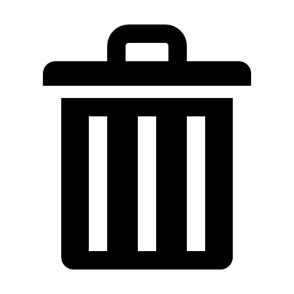**Thank you for using this bin for soiled waste only.**

**Used unsoiled couch roll and paper towels can be placed in the recycling bin.**

**