JUDICIAL CODE

United States Precision Rifle Association

5 Oct 2023– v1

CONTENTS:

PREAMBLE 3

1. INTERPRETATION 3

2. MEDIA / DISCUSSION Suppression 3

3. COMMON JUDICIAL PROCESSES 4

3.1. NOTICE OF HEARING 4

3.2. HEARINGS 4

3.3. HEARING OUTCOME 5

3.4. SUGGESTED HEARING PROCEDURE 5

3.5. SANCTIONS 5

3.6. APPEAL 6

4. DISCIPLINARY PROCESS 7

4.1. PARTIES 7

4.2. CONTRAVENTION 7

4.3. FORMATION OF THE DISCIPLINARY COMMITTEE 7

4.4. DISCIPLINARY COMMITTEE 7

4.5. PRELIMINARY INQUIRY OF THE DISCIPLINARY COMMITTEE 8

4.6. RIGHTS OF THE RESPONDENT 8

4.7. PRE-DISCIPLINARY REVIEW 9

4.8. NOTICE OF DISCIPLINARY HEARING 9

4.9. DISCIPLINARY HEARING 9

4.10. FINDINGS / OUTCOME 9

4.13. SANCTIONS 9

4.14. APPEAL AGAINST DISCIPLINARY OUTCOME 9

5. GRIEVANCE / MEDIATION PROCESS 10

5.1. AMICABLE RESOLUTION 10

5.2. PARTIES 10

5.3. APPLICATION 10

5.4. FORMATION OF THE MEDIATION PANEL 10

5.5. MEDIATION PANEL 10

5.6. NOTICE OF MEDIATION MEETING 11

5.7. MEDIATION MEETING 11

5.8. MEDIATION OUTCOME 12

6. ARBITRATION PROCESS 13

6.1. PARTIES 13

6.2. FORMATION OF THE ARBITRATION COMMITTEE 13

6.3. ARBITRATION COMMITTEE 13

6.4. NOTICE OF ARBITRATION MEETING 13

6.5. ARBITRATION HEARING 13

6.6. ARBITRATION FINDING & OUTCOME 14

6.7. APPEAL AGAINST ARBITRATION FINDING & OUTCOME 14

7. APPEAL PROCESS 15

7.1. PARTIES 15

7.2. FORMATION OF APPEAL COMMITTEE 15

7.3. PRELIMINARY MEETING OF THE APPEAL COMMITTEE 15

7.4. NOTICE OF ARBITRATION HEARING 16

7.5. APPEAL HEARING 16

7.6. FINDINGS / OUTCOME 16

7.7. SANCTIONS 16

7.8. APPEAL AGAINST APPEAL OUTCOME 16

# PREAMBLE

The following USPRA Judicial processes have been established to fairly and justly regulate; disagreements between individuals, contraventions of the USPRA; Constitution, Rules, Regulations, Codes, Policies, and serious firearm safety infractions.

# INTERPRETATION

The interpretation of the Judicial Code shall be the same as the interpretation of the Constitution of the United States Precision Rifle Association.

* 1. the following words and expressions shall have the following meanings:

“Appellant” the individual/organisation who takes an appeal of a decision made in a judicial process as outlined herein;

“Applicant” the individual/organisation who applies for a remedy or relief set out in an Application;

“Application” a request of USPRA for remedy or relief against another individual/organisation;

“Contravention” a breach or violation of the provisions of the; USPRA Constitution, Rules and Regulations, or Code of Conduct.

“Committee” the Committee duly constituted to supervise over a Disciplinary, Arbitration or Appeal Hearing.

“Party” USPRA/individual/organisation who is either Applicant / Appellant or Respondent;

“Preliminary Inquiry” an inquiry before a Hearing to decide whether there is sufficient evidence to warrant a Hearing;

“Respondent” the individual/organisation who is in response to or in opposition to an Application made by the Applicant; or the individual/organisation who is charged with a Contravention; or  
USPRA/member/visitor/organisation who is in response to or in opposition to an appeal taken by an Appellant.

“Suspended Sentence” where an individual/organisation is found to be in Contravention, USPRA suspends the passing of a sentence and releases the individual/organisation on conditions set out in a probation order. Upon the expiration of the probation order, where the individual/organisation has not been charged with further offences and has complied with all conditions of a probation order, USPRA will not sanction the person;

## MEDIA / DISCUSSION SUPPRESSION

At all times during any USPRA judicial process, Parties shall not publicize the issue, the process, or malign/comment on any other Party involved. Any such publicization may result in Disciplinary Process.

* 1. Parties involved in ANY USPRA; Mediation / Arbitration / Disciplinary or Appeal Processes shall not publicize; the process, issue/dispute/contravention or malign/comment on any other party involved, including but not limited to;
     1. discussion with Members or other individuals,
     2. posting on social media and/or forums,
     3. posting in public or private chat groups,
     4. or publishing in print media or any other manner.

# COMMON JUDICIAL PROCESSES

The following are common processes within the USPRA Judicial Framework.

## NOTICE OF HEARING

* + 1. Notice of any USPRA Hearing must be delivered to the Parties no later than 14 (fourteen) calendar days before the Hearing is due to take place.
    2. The written notice of a Hearing shall inform the parties concerned as to;
       1. the date and location of the Hearing,
       2. the name of the chairperson of the Committee,
       3. the nature of the Contravention/Application/Appeal,
       4. the Sanction that may be sought (if applicable),
       5. as well as the possible outcome(s) of the Hearing.

## HEARINGS

At any USPRA Hearing, the type of Contravention/Application/Appeal, the particular parties involved, the particular circumstances of the Contravention/Application/Appeal shall be considered and a just and equitable decision shall be made by the Hearing Committee.

* + 1. The Hearing shall be limited to the Contravention/Application/Appeal outlined in the notice sent to the Respondent.
    2. Should the Respondent fail to attend a properly convened Hearing, then the Hearing will be postponed. However; should the Respondent then fail to attend the postponed Hearing, then the postponed Hearing will continue without the Respondent present.
    3. The Defendant/Respondent, as well as the Applicant/Appellant shall be entitled to call witnesses to give evidence.
    4. Hearsay evidence may not be used at Hearings.
    5. An interpreter must be provided for the Respondent when necessary.
    6. The Hearing must be properly minuted at all times and all records (including evidence) shall be kept by USPRA for a minimum of 5 (five) years.
    7. The Committee may postpone a Hearing at the request of any party to the Hearing, provide that;
       1. The postponement request must be in writing and delivered to the Committee at least 2 (two) days before the date set for the hearing, and
       2. Valid written reasons for such postponement must be provided in writing.
       3. The postponement shall not be more than 30 days from the original date set for the Hearing.
       4. All parties concerned must be notified of the postponement.

## HEARING OUTCOME

* + 1. At the end of any USPRA Hearing, after considering all the evidence, documents and testimonies of all Parties and Witnesses, the Committee, through the Chairperson, may give its decision immediately, or postpone its decision to consider the matter.
    2. If the Respondent has been discharged of the matter then;
       1. no further action or sanction shall take place, and
       2. if their membership was suspended, it shall be re-instated immediately.
    3. Within 7 (seven) calendar days after the hearing, the Chairperson shall provide the parties with a written notification of the decision taken, setting out the reasons for findings on each charge and, if applicable, the sanctions imposed.

## SUGGESTED HEARING PROCEDURE

The following are suggestions as to the procedure followed at a Hearing:

* The Chairperson shall explain the procedure that will be followed in the Hearing.
* At the beginning of the Hearing, the Chairperson must;
  + Put the charges to the Respondent and ask them to plead to the accusation;
  + If the Respondent:
    - pleads guilty to the charge, the chairperson must note the plea, and decide whether or not to hear evidence regarding the charge;
    - pleads not guilty, the Committee must hear the evidence regarding the charge;
    - Refuses or fails to plead, the Committee must enter a plea of not guilty and must hear evidence regarding the charge.
* Opening Statements
  + Applicant/Appellant puts forward the complaint and makes their opening statement.
  + Respondent responds to complaints and makes their opening statement.
* Hear the Applicant’s/Appellant’s evidence through witnesses:
  + Examination
  + Cross-examination
  + Re-examination
  + The club shall submit any relevant documents.
* Hear the Respondent’s evidence through witnesses.
  + Examination
  + Cross-examination
  + Re-examination
  + The Respondent shall submit any relevant documents
* Hear closing arguments:
  + Applicant/Appellant
  + Respondent

## SANCTIONS

* + 1. The following sanctions are available, but not limited, to the discretion of an Arbitration/Disciplinary/Appeal Committee to impose:
       1. Verbal warning.
       2. Written warning.
       3. Suspended sentence.
       4. A fine up to a maximum of 10 (ten) times the annual membership.
       5. Temporary suspension of membership up to a maximum of 24 months, where during the period of suspension, the member shall not be allowed to;
          1. shoot in any further USPRA shoots, nor
          2. shoot as a guest, nor
          3. attend USPRA meetings.
       6. Termination of membership, where;
          1. the member shall not be entitled to;

shoot in any further USPRA shoots, nor

shoot as a guest, nor

attend USPRA meetings.

* + - * 1. The member shall forfeit all fees previously paid to the Federation.
        2. Should the member concerned hold Dedicated Status, in respect of the Firearms Control Act, then Registrar of the Firearm Control Register may be informed as to the termination of the member’s membership with the Federation
      1. The member shall forfeit all fees previously paid to the Federation.
      2. Probation period of membership, where;
         1. Such membership will be for such periods as the determined. (Not exceeding 25 Months in respect of any person)
         2. the member must pay full membership fees annually
         3. the member shall not be entitled to;

attend or vote at any meeting of USPRA , nor

to serve on any committee of USPRA t

Adhere to conditions of probation as determined

Probationary members may join one or more Affiliated Clubs but subject to sanctions and or conditions

## APPEAL

* 1. Once a Hearing Committee has made their decision and the Respondent has been sanctioned, then the Respondent shall have the right to Appeal the following circumstances:
     1. Where the disciplinary measure was too strict in view of the circumstances, or
     2. Where the chairperson had been prejudiced, the Respondent must prove beyond reasonable doubt that the chairperson was prejudiced, or
     3. Where gross procedural errors occurred during the disciplinary hearing or
     4. Where a fair procedure was not followed.
  2. Any Appeal request against the decision of a Hearing Committee must be lodged in writing, by the Respondent concerned, with the Council, within fourteen (14) calendar days of the Hearing Committee’s decision.
  3. The written request for the Appeal as well as written reasons for the Appeal must be stated in a succinct manner~~.~~

# DISCIPLINARY PROCESS

The United States Precision Rifle Association Disciplinary Process is established to impartially regulate the exercise of disciplinary proceedings by USPRA against an Individual or organization falling under the jurisdiction of USPRA.

## PARTIES

* + 1. Applicant: USPRA (their representative) shall be the Applicant;
    2. Respondent: the individual/organisation who is accused of the Contravention shall be the Respondent.

## CONTRAVENTION

* + 1. Any individual/organisation who, contravenes any of the USPRA Constitution, Rules, Regulations, Codes, Policies, or who commits a serious safety violation may be subject to the USPRA Disciplinary Process and be required to attend a Disciplinary Hearing.
    2. In the case of a serious Contravention; an individual/organisation may be immediately suspended by the Council, pending the outcome of a Disciplinary Process.
       1. Serious contraventions include, but are not limited to;
          1. Any Serious Safety Contravention,
          2. Any form of physical assault,
          3. Prolonged verbal (including social media) assault and/or threats,
          4. Any form of theft or unlawful act.
       2. During the suspension, the individual/organisation shall not partake in any club activities whatsoever.

## FORMATION OF THE DISCIPLINARY COMMITTEE

* + 1. The Council must ensure that a Disciplinary Committee is formed if any incident is brought to their attention or reported to them that relates to;
       1. any Serious Safety Contravention
    2. In the case of less serious Contraventions; the Council, after reviewing the incident, may at their discretion establish a Disciplinary Committee.
    3. Should a Disciplinary Committee be established then;
       1. The Disciplinary Committee shall be established within 21 (twenty-one) calendar days of the Council being made aware of any Contravention that warrants it, and
       2. the Respondent shall be notified, by the Council, within 7 (seven) calendar days of the decision to form the Disciplinary Committee.

## DISCIPLINARY COMMITEE

* + 1. The Disciplinary Committee shall consist of the USPRA President, the two USPRA Centerfire Vice-Presidents, and the two USPRA Rimfire Vice-Presidents, or suitable External Professional Persons that;
       1. are not directly involved with the incident or event,
       2. could not be called on as possible witnesses,
       3. have no direct (or otherwise) connection/relation to the individual/organisation concerned.
    2. The Disciplinary Committee shall;
       1. act fairly, impartially, and with decorum, and
       2. consider only the facts presented.

## PRELIMINARY INQUIRY OF THE DISCIPLINARY COMMITTEE

* + 1. The Disciplinary Committee shall;
       1. meet within fourteen (14) days of being constituted, and
       2. conduct an investigation into the Contravention to determine whether there are grounds for a Disciplinary Hearing.
    2. Should the Disciplinary Committee decide that either;
       1. the Contravention does not warrant a Disciplinary Hearing, then the Respondent shall be informed in writing, within seven (7) calendar days of the Preliminary Inquiry, then no Disciplinary Hearing shall be held.
          1. If the Respondent was suspended in the interim, then their membership shall be re-instated immediately.
       2. the Contravention does warrant a Disciplinary Hearing, then;
          1. a written notice shall be sent to the Respondent, within seven (7) days of the preliminary meeting, and
          2. the Disciplinary Hearing shall take place within thirty (30) calendar days of the Preliminary Inquiry, and no sooner than fourteen (14) days after notice has been sent to the Respondent.

## RIGHTS OF THE RESPONDENT

The Respondent has the following rights:

* + 1. The right to prepare to respond to the charge(s) and to receive timely notice of a Disciplinary Hearing.
    2. The right to state their case in defence against the accusation(s).
    3. The right to receive and study any document submitted as evidence beforehand.
    4. The right to object to the chairperson of the Disciplinary Committee within two (2) days of receiving the notice.
    5. A right to be assisted by a representative in the hearing, including legal presentation.
    6. A right to be assisted by a representative in the hearing.
    7. A right to an interpreter to interpret the proceedings in a language they understand.
    8. A right to lead evidence and to call witnesses.
    9. The right of having their case finalised within a reasonable time.

## PRE-DISCIPLINARY REVIEW

* + 1. The Respondent shall be afforded an opportunity to view any documents and any other material, including but not limited to, tape, video, and magnetic disc recordings, relating to the any matter in question in the disciplinary hearing, at any time before the hearing.
    2. No later than three (3) working days before the disciplinary hearing, the parties shall deliver, in writing, to the chairperson information regarding:
       1. the identity of the witness that each party wishes to call, and
       2. The subject matter of the witness’ testimony.

## NOTICE OF DISCIPLINARY HEARING

As per 3.1 NOTICE OF HEARING

## DISCIPLINARY HEARING

As per 3.23.1 HEARINGS

## FINDINGS / OUTCOME

* 1. The Chairperson must inform the Respondent of the right to appeal the decision taken by the Committee.
  2. As per 3.33.23.1 HEARING OUTCOME

## SANCTIONS

As per 3.53.23.1 SANCTIONS

## APPEAL AGAINST DISCIPLINARY OUTCOME

As per 3.6 APPEAL

# GRIEVANCE / MEDIATION PROCESS

The United States Precision Rifle Association Grievance / Mediation Process is established to impartially regulate the exercise of mediation proceedings between two (2) or more Individual(s)/Organization(s) that fall under the jurisdiction of USPRA.

The primary objective of this Grievance/Mediation Process is to at first mediate the issue/dispute in an attempt to resolve the matter without recourse to any formal judicial procedure.

All Parties in the Mediation shall be bound to the Mediation Process. Should either party fail to co-operate during the Mediation, it may be held against them and may result in a Disciplinary Hearing.

## AMICABLE RESOLUTION

* + 1. It is requested that before an Individual/organization starts the grievance process, that they approach the Individual/Organization with whom they have the grievance prior to proceeding to try to reasonably resolve the matter amicably.

## PARTIES

* + 1. Applicant: the Individual/Organisation who applies to USPRA for a remedy or relief set out in the Application shall be the Applicant.
    2. Respondent: the Individual/Organisation who is in response to or in opposition to an Application made by the Applicant.

## APPLICATION

* + 1. If the Parties cannot resolve the issue the Applicant must make an Application in writing to the Council for Mediation.
    2. Only an issue or dispute that occurred within the last three (3) months may be referred for resolution through the Mediation Process.
    3. The Application must in a succinct manner state;
       1. the names and details of both parties, and
       2. the issue / nature of the dispute, and
       3. the relief sought.
    4. The Application shall be submitted to the Council.

## FORMATION OF THE MEDIATION PANEL

* + 1. Once the Application has been received by the Council, it will be discussed at the next Board Meeting or if it is an urgent matter, at a Special meeting.
    2. The Mediation Panel shall be established within fourteen (14) calendar days of the Council meeting to discuss the Application.

## MEDIATION PANEL

* + 1. The Council shall appoint a USPRA Member to appear as the Mediator (Chairperson).
    2. The Mediator may appoint two (2) additional USPRA Members to the Mediation Panel.
    3. The Mediation Panel shall consist of between one (1) to three (3) USPRA Members that;
       1. are not directly involved with the Application,
       2. could not be called on as possible witnesses,
       3. have no direct (or otherwise) connection/relation to the Applicant or Respondent concerned.
    4. The Mediation Panel shall;
       1. act fairly, impartially, and with decorum, and
       2. endeavour to assist both parties in reaching an amicable decision.

## NOTICE OF MEDIATION MEETING

As per 3.1 NOTICE OF HEARING

## MEDIATION MEETING

At a Mediation Meeting, the Application shall be discussed by the Parties with the aim of reaching an amicable decision through Mediation.

* + 1. The Mediation Meeting shall take place within thirty (30) calendar days, and no sooner than fourteen (14) days after notice has been sent to the Parties.
    2. The Mediation shall be limited to the Application outlined in the notice sent to the Respondent.
    3. The Mediator may postpone a Mediation at the request of either Party to the Mediation, provide that;
       1. The postponement request must be in writing and delivered to the Committee at least two (2) days before the date set for the hearing.
       2. Valid written reasons for such postponement must be provided in writing.
    4. Any postponed Mediation shall not be more than thirty (30) days from the date set for the original Mediation, and
       1. All parties concerned must be notified of the postponement, and
       2. The postponement shall not marginalise either Party.
    5. A Mediation shall not be conducted in the absence of either Party.
       1. Should either Party fail to attend a properly convened Mediation, then the Mediation will be postponed.
    6. At a Postponed Mediation Meeting;
       1. If the Applicant fails to attend, then the Mediation will be considered to be completed, and no further Application by the Applicant to the Council regarding the Issue will be considered.
       2. If the Respondent fails to attend, then the Mediator will take the Application to the Council for Arbitration.
    7. The Parties shall be entitled to call witnesses to give evidence.
    8. Hearsay evidence may not be used at Mediations.
    9. An interpreter must be provided for either Party when necessary.
    10. No legal representation shall be allowed by either Party at the Mediation.
    11. The Parties are entitled to consult with legal counsel before the Mediation.
    12. The Mediation must be properly minuted at all times and all records (including evidence) shall be kept by USPRA for a minimum of five (5) years.

## MEDIATION OUTCOME

* + 1. If the Mediation is successful, then all parties shall sign a legally binding settlement agreement, and no further Application by the Applicant to the Council regarding the Issue will be considered.
    2. If the Mediation is not successful the Mediator may refer the Application to the Council for Arbitration Process.
    3. If during the Mediation, the Mediator finds any matter to be in Contravention of any of the USPRA; Constitution, Rules and Regulations, or Code of Conduct, then the Mediator may, refer the matter to the Council for Disciplinary Process.

# ARBITRATION PROCESS

This Arbitration procedure has been formulated to deal with any issue / dispute that could not be resolved through the Mediation Process.

The primary objective of this Arbitration Process is to resolve an issue / dispute without recourse to any formal judicial procedure.

All Parties in the Arbitration shall be bound to the Arbitration Process. Should either party fail to co-operate during the Arbitration, it may be held against them and may result in a Disciplinary Hearing.

## PARTIES

* + 1. Applicant: the Individual/Organisation who applies to USPRA for a remedy or relief set out in the Application shall be the Applicant.
    2. Respondent: the Individual/Organisation who is in response to or in opposition to an Application made by the Applicant.

## FORMATION OF THE ARBITRATION COMMITTEE

* + 1. The Council shall establish an Arbitration Committee within fourteen (14) calendar days of receipt of the written referral for Arbitration by the Mediator.

## ARBITRATION COMMITTEE

* + 1. The Arbitration Committee shall consist of between one (1) to three (3) USPRA Members that;
       1. have not previously been involved with the Mediation,
       2. are not directly involved with the Application,
       3. could not be called on as possible witnesses,
       4. have no direct (or otherwise) connection/relation to the Parties concerned.
    2. The Mediation Committee shall;
       1. act fairly, impartially, and with decorum, and
       2. endeavour to reach a fair and just decision.
    3. The Council shall appoint a USPRA Member as the Arbitrator (Chairperson).
    4. The Arbitrator may appoint two (2) additional USPRA Members, that have not previously been directly involved with the matter, to the Arbitration Committee.
    5. The Arbitration must be properly minuted at all times and all records (including evidence) shall be kept by USPRA for a minimum of five (5) years.

## NOTICE OF ARBITRATION MEETING

As per 3.1 NOTICE OF HEARING

## ARBITRATION HEARING

As per 3.23.1 HEARINGS

## ARBITRATION FINDING & OUTCOME

* + 1. As per 3.33.23.1 HEARING OUTCOME
    2. If during the Arbitration, the Arbitrator finds any matter to be in Contravention of any of the USPRA; Constitution, Rules and Regulations, or Code of Conduct, then the Arbitrator may, in addition to the outcome, refer the matter to the Council for Disciplinary Process.

## APPEAL AGAINST ARBITRATION FINDING & OUTCOME

* + 1. The Chairperson must inform the Respondent of the right to appeal the decision taken by the Committee.
    2. As per 3.6 APPEAL

# APPEAL PROCESS

This Appeal procedure has been formulated to deal with any Appeal to the process, decisions or sanctions made in a previous Arbitration or Disciplinary Process.

All Parties in the Appeal shall be bound to the Appeal Process. Should either Party fail to co-operate during the Appeal, it may be held against them and may result in a Disciplinary Hearing.

## PARTIES

* + 1. Appellant: the Individual/Organisation who appealed the Mediation / Disciplinary Hearing Outcome.

## FORMATION OF APPEAL COMMITTEE

* + 1. The Council shall establish an Appeal Committee within fourteen (14) calendar days of receipt of a written request to Appeal an Arbitration or Disciplinary Outcome.
    2. The Appeal Committee;
       1. shall consist of;
          1. one (1) member of the Council, and
          2. two (2) other USPRA Members, that;
       2. have not previously been involved with the Mediation,
       3. are not directly involved with the Application,
       4. could not be called on as possible witnesses,
       5. have no direct (or otherwise) connection/relation to the Parties concerned.

## PRELIMINARY MEETING OF THE APPEAL COMMITTEE

* + 1. An Appeal is confined to the records of the proceedings a quo, but the Appeal Committee may substitute their own conclusion based on the merits from that of the Arbitration/Disciplinary Committee.
    2. The Appeal Committee shall;
       1. meet within fourteen (14) days of being constituted, and
       2. conduct an investigation into the Arbitration/Disciplinary Hearing to determine whether the merits put forward for Appeal warrants an Appeal.
    3. If the Appeal has been rejected then;
       1. the Appeal Committee shall within seven (7) calendar days of the Preliminary Meeting inform the Appellant, and provide the reasons as to why the appeal was rejected.
    4. If the Appeal committee finds that there is sufficient ground and reasons for the Appeal then;
       1. the Appeal Committee shall within seven (7) calendar days of the Preliminary Meeting inform;
          1. the Appellant, and provide the reasons as to why the appeal was rejected.
          2. the Arbitration/Disciplinary Chairperson who made the decision in question of the Appeal, supplying him/her with the Appeal documentation, and request him/her to respond in writing within seven (7) days, as to why the Appeal should not be upheld.
       2. the Appeal Committee may decide whether the Appeal shall be dealt with on the basis of written arguments only within fourteen (14) days, or
       3. the Appeal Committee may decide to hold an Appeal Hearing.
    5. Should the Appeal Committee decide to hold an Appeal Hearing then;
       1. the Appellant and Respondent (if applicable) shall be notified of the Hearing,
       2. the Hearing shall take place within fourteen (14) days of notice being sent to the Parties,

## NOTICE OF ARBITRATION HEARING

As per 3.1 NOTICE OF HEARING

## APPEAL HEARING

As per 3.23.1 HEARINGS

## FINDINGS / OUTCOME

* + 1. The Appeal Committee shall uphold or set aside the decision made by the Arbitration/Disciplinary Committee.
    2. If the Appeal committee may recommend one of the following courses of action:
       1. reassert the original sanction imposed; or
       2. propose an amendment to the original sanction imposed, which may include a harsher Sanction.
    3. If an Appeal is upheld where the member’s membership was previously suspended or terminated, then;
       1. their membership shall be reinstated immediately, and
       2. they shall continue with their participation in the Club activities and shoots, and
       3. no further action shall be taken.
    4. The decision made by the Appeal Committee is final.

## SANCTIONS

As per 3.53.23.1 SANCTIONS

## APPEAL AGAINST APPEAL OUTCOME

There shall be no further appeal or recourse after the Appeal Committee has dealt with the Appeal, and communicated the outcome thereof to the Appellant.

# JUDICIAL PROCESS DIAGRAMS

The following is a simple flowchart outlining the judicial processes available to USPRA and its members.

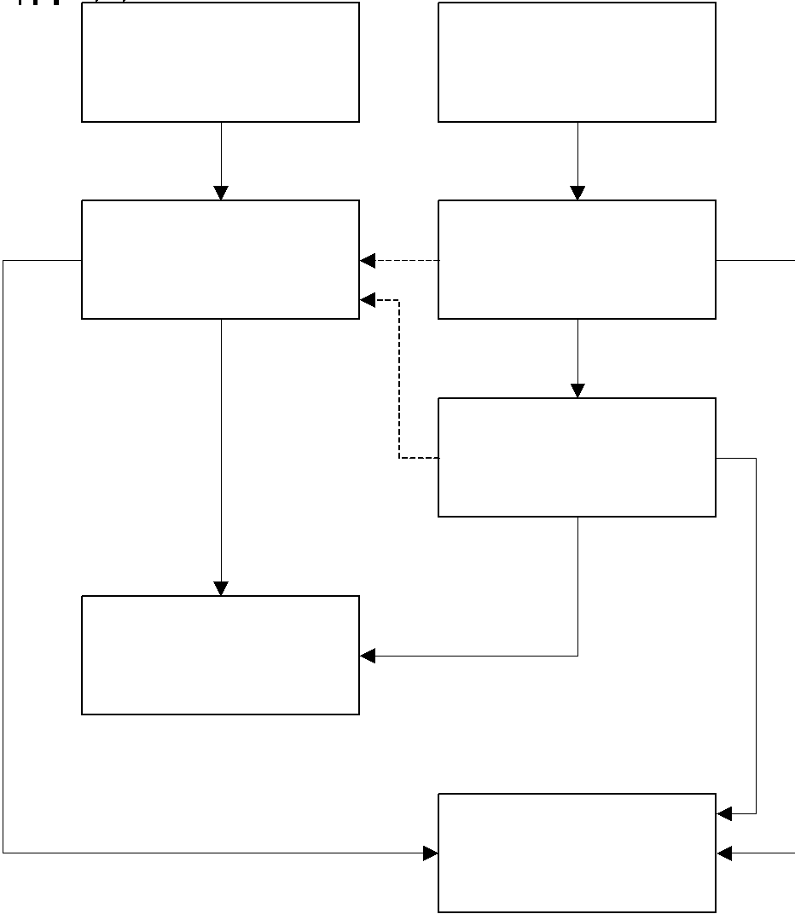

## MEDIATION PROCESS DIAGRAM

The following flowchart outlines the Mediation Process.

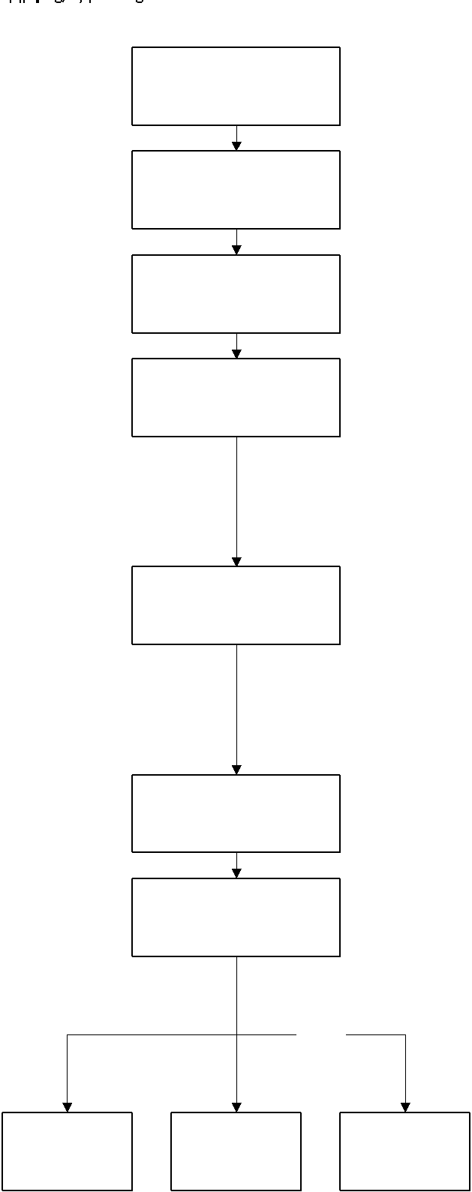

## ARBITRATION PROCESS DIAGRAM

The following flowchart outlines the Arbitration Process.

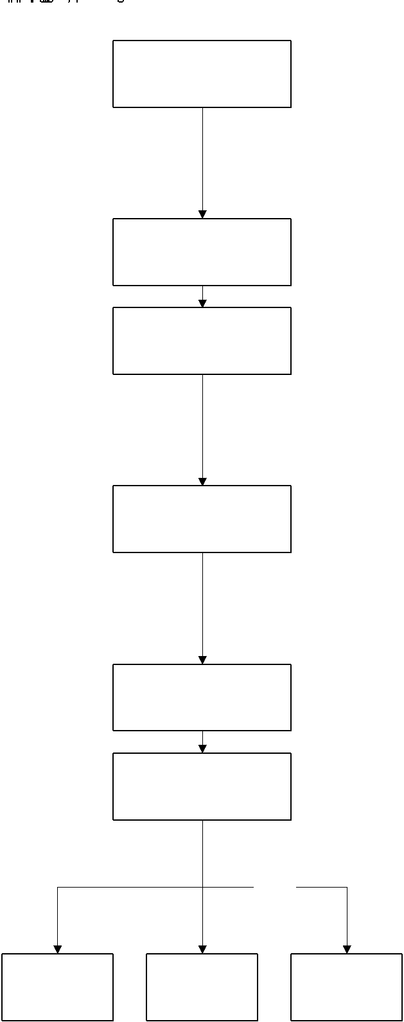

## DISCIPLINARY PROCESS DIAGRAM

The following flowchart outlines the Disciplinary Process.

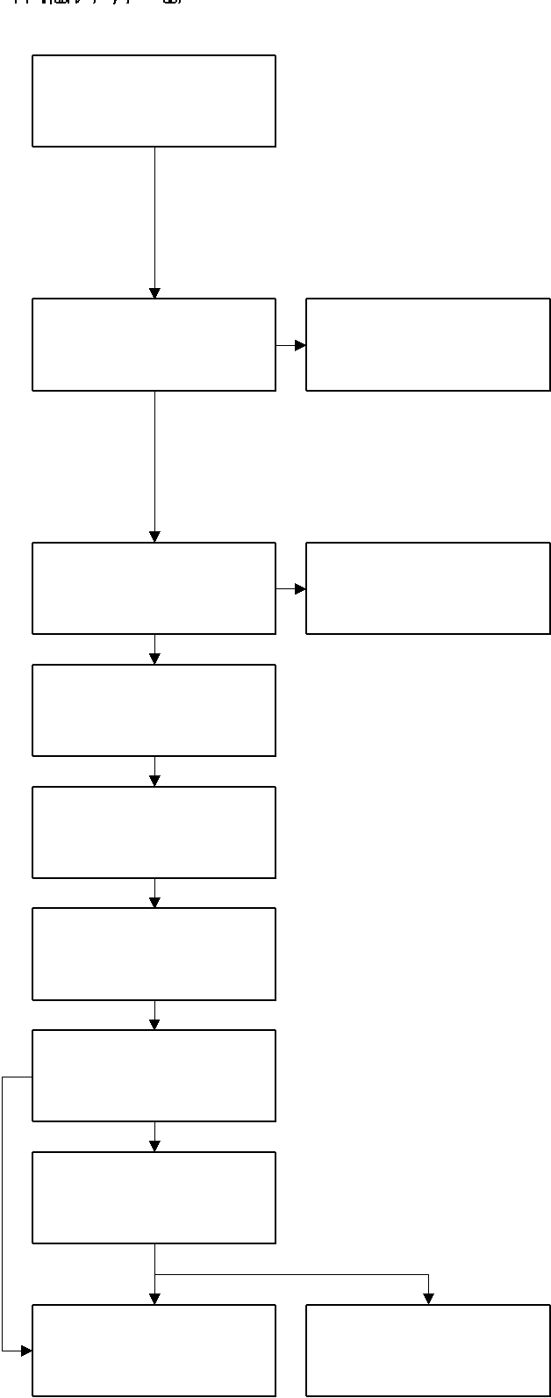

## APPEAL PROCESS DIAGRAM

The following flowchart outlines the Appeal Process.

