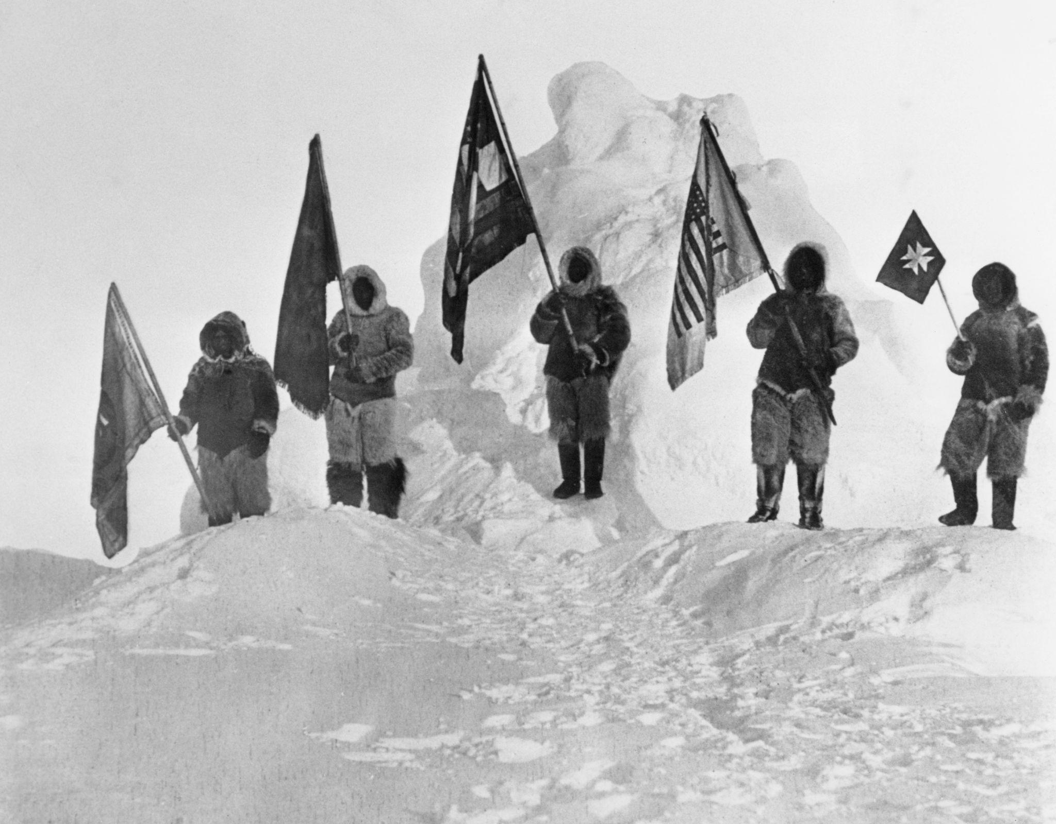
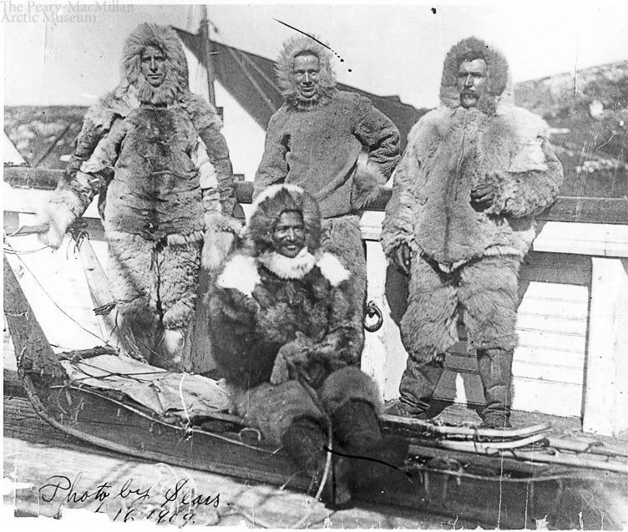
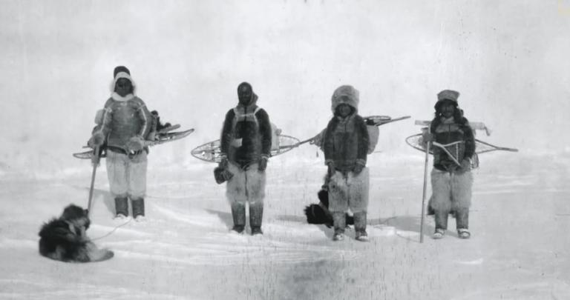

Ootah (also spelled Odaq, Ootah, or in modern Greenlandic Odaq) was one of the most skilled Inuit hunters and dog-sled drivers of northwest Greenland and one of the most important—but often overlooked—members of Robert E. Peary's Arctic expeditions.
Who was Ootah?
- Ootah was an Inughuit (Polar Inuit) from Etah, in northwestern Greenland.
- He was renowned as an exceptional:
  - hunter
  - sled builder
  - dog driver
  - navigator over sea ice
- Peary specifically selected him because these skills were essential for surviving the Arctic.

His role on the 1908–1909 expedition
Most people know the names Robert Peary and Matthew Henson, but the final push toward the North Pole depended heavily on four Inuit experts:
- Ootah (Odaq)
- Egingwah
- Seegloo (Sigluk)
- Ooqueah (Ukkujaaq)
These men:
- chose safe routes across constantly shifting sea ice,
- handled the dog teams,
- built snow shelters,
- hunted for fresh food,
- repaired sledges,
- and kept the expedition alive in conditions that the Americans alone could not have survived.

Did Ootah reach the North Pole?
According to Peary's account, yes.

On April 6, 1909, the final party consisted of:
- Robert Peary
- Matthew Henson
- Ootah
- Ooqueah
- Seegloo
- Egingwah

Peary claimed this party reached the North Pole. Today, many historians question whether the expedition actually reached the exact geographic Pole, but there is no dispute that Ootah was part of the final sledging team that traveled farther north than any previous expedition of its time.

Ootah saved Matthew Henson's life
One dramatic incident illustrates his importance.
While crossing unstable sea ice, Matthew Henson fell into freezing Arctic water. Ootah quickly pulled him out before hypothermia could become fatal. Henson later credited Ootah with saving his life.

Matthew Henson's opinion of Ootah
Henson admired him enormously.
He described Ootah as one of the strongest and most dependable members of the expedition and praised his skill with sledges and navigating dangerous ice. Modern historians generally agree that Henson understood how indispensable the Inuit members were to the expedition's success.

Why isn't Ootah better known?
For many years, popular histories focused almost exclusively on Peary. Even Matthew Henson did not receive widespread recognition until decades later. The Inuit participants—despite providing the expertise that made the expedition possible—were largely omitted from many historical accounts. More recent scholarship has worked to restore recognition to Ootah and the other Inuit explorers.

An interesting connection
Since I noticed you've used the name Ootah before, it's fitting that the name carries associations with:
- resilience,
- exploration,
- self-reliance,
- expertise under extreme conditions,
- and helping others succeed even without seeking recognition.
Those qualities make it a distinctive name for a venture or brand inspired by endurance and pioneering spirit.

