© Enna Global 2025

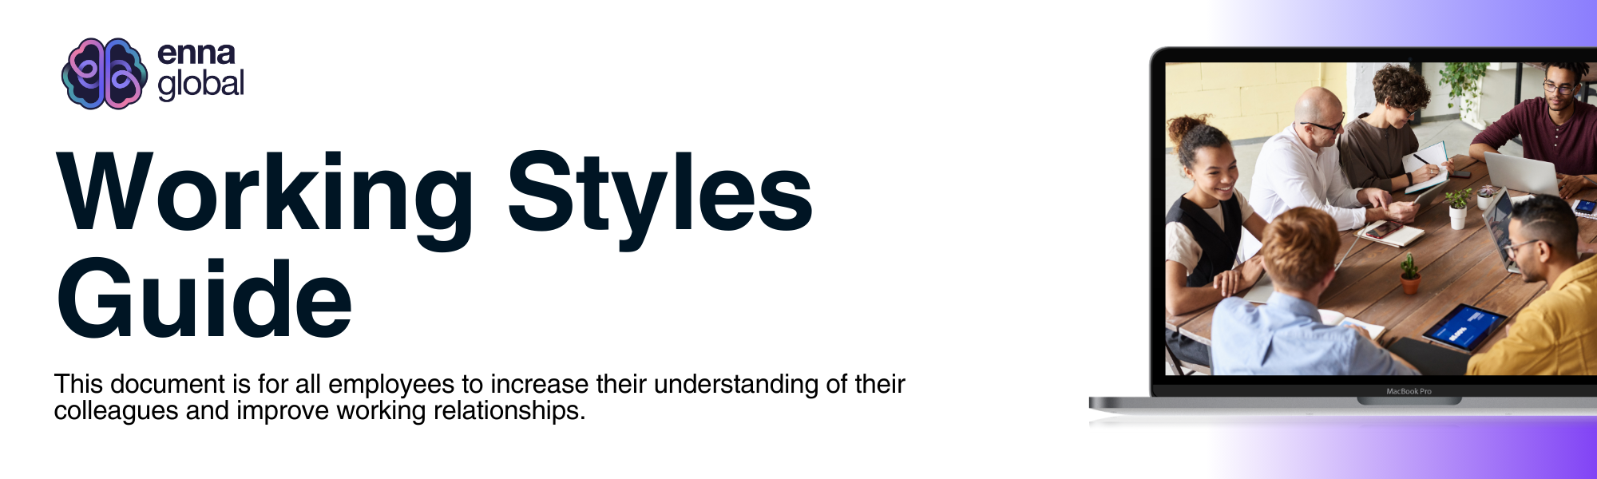

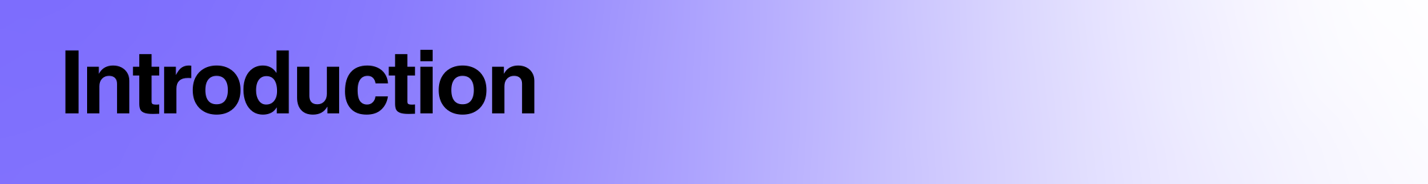

Welcome to the Enna team’s Working Styles Guide. To be happy and successful in our busy work lives, we must understand how to work well together. This guide is designed to help you better understand yourself and your teammates. You’ll uncover each other’s unique ways of working and communication styles to guarantee better collaboration and rapport amongst the team.

Why Understanding Working Styles Matters:

* **Better Communication:** Knowing how you and your teammates prefer to talk and share ideas helps everyone communicate better. Whether it’s face-to-face chats, emails, or messages, you can ensure you understand each other clearly.
* **Easier Collaboration:** Everyone has unique ways of working – some like working alone, and others prefer working in teams. Understanding this helps you work together better, getting things done faster and more effectively.
* **Boosted Productivity:** When we understand each other’s strengths and how we work best, we can work smarter, do more, and feel good about it.
* **Happier Team:** Feeling understood and appreciated makes us happier at work. Respecting each other's differences boosts our morale and motivates us to do our best.

How to use this guide: Complete the workbook below by answering questions independently. Ask a close friend or colleague for their perspective if you are unsure what to write for any of the questions.

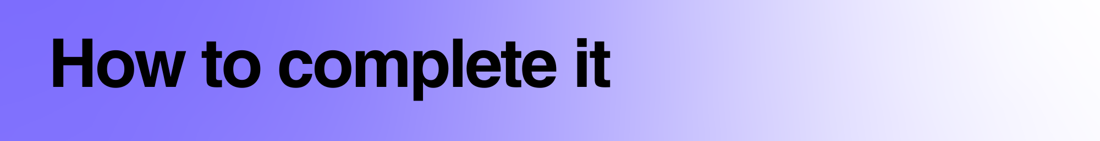

1. Firstly, download this document either to your Google Drive or documents.
2. Secondly, allocate 30 minutes of independent time to complete this in a quiet space. You will need to find somewhere you can focus for this time to think about the questions.
3. Next, spend the time answering the questions below (in bold). Below the questions are some example answers; please remove them and write your own. Think about each question and write your answer in as much detail as you want to. Remember, you can either use this as a reflective exercise for yourself or share it with others—it’s completely up to you!
4. When you’ve completed it, make sure it’s saved!

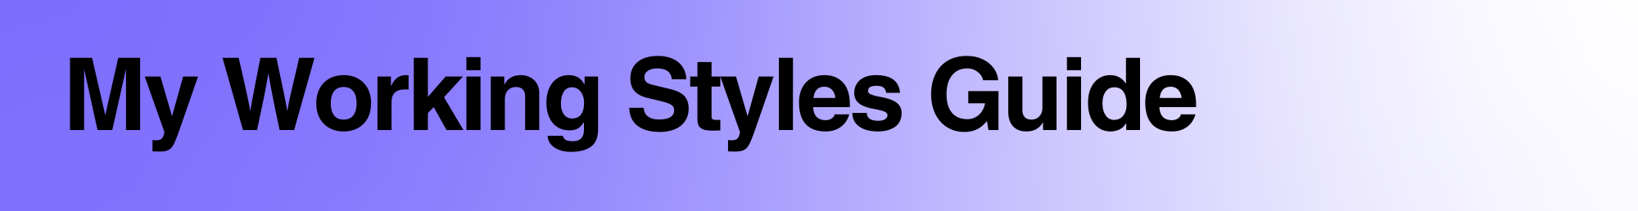

**Brain dump your initial thoughts here:**

|  |  |
| --- | --- |
| **Date** |  |
| **My Information** | **Full Name**    **Job Title**    **Email Address** |
| **Skills** | **Key skills:**   * Organisation * Planning and execution |
| **Strengths and Challenges** | **Key Strengths:**   * Empathy * Communication * Organisation   **Key Challenges:**   * Too many short notice changes and no communication around them |
| **Working Environment Preferences** | **Do you prefer a bustling or quiet working environment?**  I prefer a quiet working environment which allows me to focus.  **Are there any specific tools or software you use to collaborate?**  Which ever the team are using I will adjust  **How do you handle distractions during work hours?**  When I’m focused, I will complete my task, or stop at a point that allows me to deal with the distraction without compromising the task I was doing.  **Are there any specific workspace arrangements or preferences others should know about?**  N/A |
| **Communication Style** | **How do you prefer to communicate (e.g., in-person, email, phone, instant messaging)?**  I prefer people to be direct, honest and transparent so there's no ambiguity. I prefer email / slack and if I need more information, then a call may be helpful or a demonstration.  **What tone do you use to communicate (e.g., formal/informal)?**  I’m friendly and warm, but also clear.  **How do you like to receive information (e.g., learning by doing, auditory instructions, visually etc)?**  If you’re giving me instructions or feedback, please send me written information as I process information better when I can read and digest it. If teaching - i love a demonstration, I'm a very visual learner.  **How do you prefer to receive feedback (e.g., direct, constructive criticism)?**  I prefer people to be direct, honest and transparent so there’s no ambiguity in what’s expected of me.  **Are there any communication preferences or pet peeves others should be aware of?**  Too many acronyms! Or an assumption i will know what you’re talking about - please be clear. |
| **Collaboration Preferences** | **Do you prefer to work independently or as part of a team?**  I prefer to work independently, however I like assigning time for conversations and collaboration.  **How do you prefer to delegate tasks or responsibilities?**  I would prefer to understand what everyone would prefer to do, what would be most effective and allocate tasks all together.  **How do you like to learn (eg., kinaesthetic, auditory, visual etc)?**  I am a kinaesthetic leaner, so learn by doing. |
| **Work Habits and Expectations** | **What are your typical working hours and availability?**  I work Monday to Wednesday. M:9-1 / T:10-2 / W:9-1  **When do you work best?**  N/A  **How do you prioritise tasks and manage deadlines?**  I prioritise tasks by email / slack triage, and writing a to do list on my notepad, which helps me understand what I need to do and when the deadlines are.  **How do you like to organise yourself?**  I focus completely on my listed tasks and keep a eye out of new and incoming tasks.  **Are there any specific work habits or routines that people should be aware of?**  **I**nstead of taking one long lunch break I take many movement breaks during the day (I have ADHD). It helps me to gather my thoughts and focus. |
| **Miscellaneous** | **Are there any misunderstandings people may have about you?**  People can often think I'm direct and get straight to the point. I’m not trying to be rude, I’m just mindful of peoples time and don’t want to lose track of what needs to be done.  **Are there any additional preferences, quirks, or considerations you believe others should be aware of?**  It really bothers me if I make a mistake - although I am very patient if others do!  **What interests do you have outside of work which can help someone get to know you better?**  I really enjoy exercising and spending time in nature walking my dog. I’m a keen horse rider. |

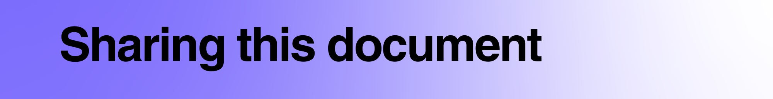

Our Working Styles Guide can either be a reflective document (for you to think independently about your working style) or share it with others to help them learn about you. It’s entirely your decision. You can either print it out or share it electronically. Below are the reasons outlined for sharing it with different people:

**Your manager:** Many people use our Working Styles guide to help their manager understand them better. This could improve your working relationship and enable you to freely discuss your strengths or challenges.

**The wider team:** Most people who complete it use it to share with their immediate team members. Many people may ask their team to complete it and discuss their answers. This can help your team understand you better, improving your working relationship.

**The department:** You can share the document with everybody within your department to help them understand you better.

**The organisation:** This is the least popular option. However, many people may complete it to share with their whole organisation, which can encourage everybody else to complete a guide, too. We have worked with many organisations that have chosen to roll this out to everybody.

**Myself:** If you’re using this to reflect, that is absolutely fine! The team at Enna cannot access this document when you have downloaded it, and all information is private. If you’d like us to take a look at it, you’re more than welcome to send it to hello@enna.org, and we can give you feedback.

I would like to share this document with:

~~My Manager~~

~~The Wider Team~~

The Department

The Organisation

~~Myself~~