**Scan the QR code to download the Savings Edenred app to your phone to have the same all in the palm of your hands!**



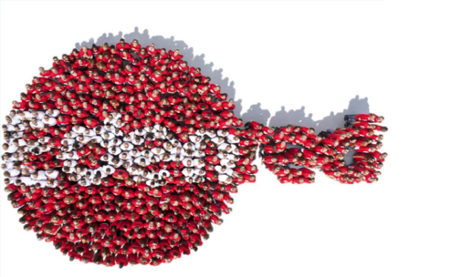

Happy Saving!