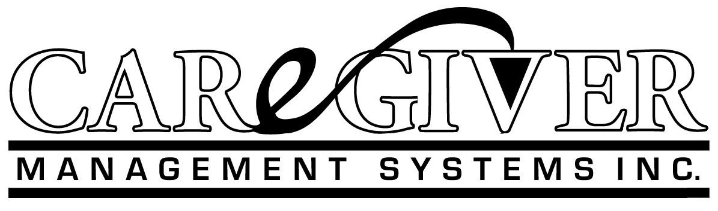
January 5, 2017
President-elect Donald Trump
Transition Strategy: Repeal of Obama Care and its Replacement Plan
Congratulations on doing the impossible by getting elected. Now the mountain gets bigger because of the gridlock that is constructed by the lawmakers (primarily attorneys trained at Harvard) and the so called expert professors at Universities that have never seen what I have experienced. Hopefully someone will give you this solution to the biggest problem that America faces as we all age.
What is the problem?
- Obama Care is the typical government buyer of last resort thinking. Government giveth and taketh away for politics not Americans heath care results. Why? America is 38th in quality and 1st in cost per capita in Worldwide statistics. No accountability for cost or results.
- The Republican and Democratic thinking is to go forward with an insurance program rather than an investment in America’s improved health and care thereof.
- Medical savings accounts are a small step to a large need. Why not make the paradigm shift now and have something all Americans and politicians can live with and benefit from now not in ten years?
- Vouchers aren’t the solution for competitive decision making because there is no definition by providers of what consumers will get in outcomes. Now providers are paid for input units not output results. (diagnosis, prescriptions, encounters, per diems are input not output units). Therefore, no cost accountability or quality control. Its fools play for pay.
What is the solution? SHIFT (Self Health Investment Funding Trust) … a win-win for everyone!
- SHIFT the paradigm to an Enterprise Model and replace the Institutional Model. This means the responsibility for health care is going to be that of the individual not the government. Shift health care funding to an investment by each American in their own health. We each then automatically internalize the economics of why the current externalized method is a failure.
- Set-up personal withholding accounts for each working American as an investment in their own health care preservation, prevention and care. The deposits from each paycheck would go to a Mutual Health Care Plan that they collectively have ownership in. An Enterprise Model.
- If we want effective management of the quality and cost we need the providers to have cost accounting systems that define their services and price their services competitively. Currently, they don’t have standardized processes defined or costed before doing their pricing and billing. Unlike the general business theory that you need to know your cost to be able to price your product, including a profit, the health care institutions get paid incomes regardless of outcomes.
- Provide the following to Americans and the politicians will vote for it:
  - Preexisting conditions barred
  - No limitations on coverages
  - No deductibles
  - No coinsurance
  - No denials of coverage
  - Full accountability by the providers
  - Includes coverage for prevention and preservation of current health
  - Eliminate governmental demonstration projects that don’t improve results
  - Eliminate regulatory enforcement that treats providers as the enemy
  - Retain Medicare for a Baby Boomer safety net
  - Recast Medicaid as a safety net for the indigent not sucking up private resources
  - Set-up catastrophic risk pools for aging and disabled Americans
  - Enact SHIFT as the new national health care plan and program and implement over a ten-year period
Can these promises be paid for? In my books: Remedy Eldercide, Restore Elder-pride, America in the Red Zone, and the Boomers Are Coming I have outlined how we can save a trillion dollars per year in wasted resources and rid ourselves of Socialized Medicine for good. I also have calculated the withholding percentages and how to get the providers to finally be cost accountable by being focused on quality outcomes not just their incomes. Also, my son and I have invented and constructed a prototype software program for modeling standard costs at every level of the health care continuum and a ten-year conversion plan for funding SHIFT.
Of course, even if you see this proposal at all, it will be a miracle if my 60 years in all aspects of health care is listened to and followed. Being a CPA at Arthur Andersen & Co. I first audited Blue Cross hospitals in the 1960’s, Medicare/Medicaid in 1970’s, and consulted with physicians and nursing homes over the last 37 years and have owned three nursing homes over the last seven years. Having my Health Care Administrator license since 1987 qualifies me for directing the solution rather than allow a professor or bureaucrat blow it for you.
Very truly yours,
CARGEGIVER MANGEMENT SYTEMS

Jerry L. Rhoads, CPA, FACHCA
www.episodicpricecost.net
jerry.l.rhoads@gmail.com
My books can be found on Amazon and Kindle

