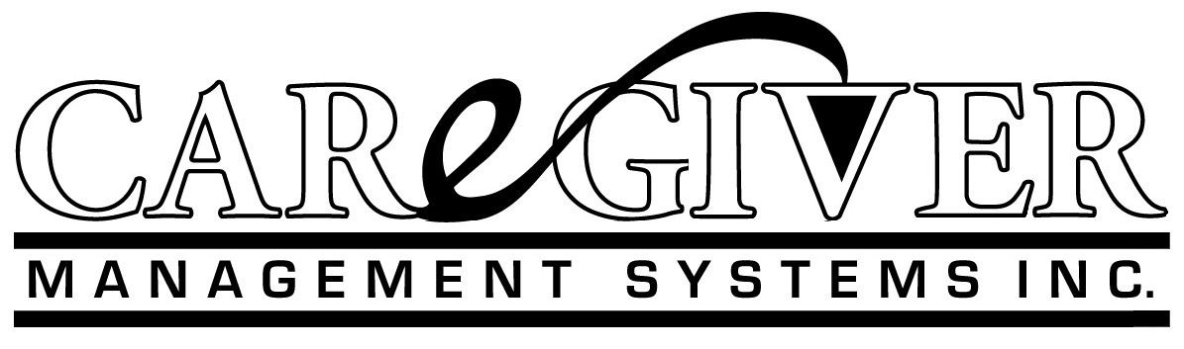
January 21, 2017

President Donald J. Trump
The White House
1600 Pennsylvania Avenue
Washington D.C.

Re: Solutions for the VA Hospitals

Dear Mr. President,

I have written you in the past and met you in Iowa during your campaign for President. Like 59 million other Americans, my wife and I are ardent supporters. We have closely followed your quest for the position of “America’s last great hope”. We are now wanting to help with your planning for making America Great Again. Since health care is a transition priority, we are applying for a role in that effort.

I’m a CPA, graduate of Simpson College in Iowa and former health care consultant at Arthur Andersen & Co. My experience includes the rollout of Medicare and Medicaid for Blue Cross of America in the late ‘60’s and early ‘70’s. Therefore, my expertise is health care finance and operations. From the early consulting experience with hospitals then skilled nursing homes to expert consultant status with the Federal and State governments on reimbursement I formed my own CPA firm in the ‘70’s. Since then, I have been active in the development of systems and procedures for processing patient care services at all provider levels. For my health care clients, my son and I developed a system that coordinates the care from hospitals to home. We implemented that system in 140 different provider sites over the last 25 years.

Currently, my wife and I are semi-retired after selling our three nursing homes. But we haven’t stopped wondering how the next President will solve the health care problems caused by the politicians and bureaucrats. I wrote you earlier regarding a strategy for amending the Obama Care fiasco. I still believe it can be gutted but what’s put in place has to coordinate the episodic care at all provider sites. That’s what the software that we developed does, including the cost of each episode, the margins and provides the documentation system for tracking progress and patient specific outcomes.

My wife suggested that we show you how the Caregiver Management System converts an input (treatment) driven income based treatment culture to a true episodic outcome processing system. This system can be implemented in the most volatile health care behemoth … the VA. It will focus the admission and assessment of our veterans’ problems and formulates care coordination plans of interventions and defined outcomes being pursued by body system (not diagnosis. It will include a strategy, using the Caregiver System, to contract with hundreds of skilled nursing facilities, assisted living units and home care services to provide long term care restorative services immediately to the veterans, in coordination with the VA hospitals.

President Trump (continued)

In summary, we as consultants will bring a prototype for a standardized assessment and care coordination system that can be the platform for either repealing Obama Care in its entirety or amending it in a rational way to get Congress on board. If the VA can be organized and effective so can the American health
care system. The Caregiver System brings cost accountability with the pursuit of coordinated specific episodic outcomes in an efficient and effective environment. I call it the American Enterprise Health Care Model. It simplifies and organizes the processes focusing on problems and solutions, not just diagnosis.

I and my wife Shari and son Kip are available to present this software system to you and those responsible for fixing the American health care system. The focus on the VA debacle will give the Trump Administration credibility and traction for attacking the other pressing budgetary problems.

We are available either before, during or after the transition to truly affordable health care. It’s important President Trump that you see for yourself and have something specific to replace Obama Care. My contact information is below. Thanks for the opportunity to pursue solutions for making America Great Again.

Very truly yours,
CAREGIVER MANAGEMENT SYSTEMS

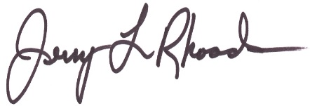
Jerry L. Rhoads, CEO
2 Westwind Court, Hawthorn Woods, IL 60047
Jerry.l.rhoads@gmail.com 847/303-3946
www.epsidoicpricecost.net

PS: Currently health care is paid on an input basis not output. It’s an institutional model making the providers rich and the patients sicker. The bureaucrats have made the Institutional Model so complicated and ineffective we continue to escalate the costs with no focus on the outcomes.

For example, the following are the current methods of payment by the government and insurance companies:

Hospitals Diagnosis Groups (DRG’s), Physicians relative value units (RVU’s), nursing homes resource utilization groups (RUG’s), home care per visit by nurses or therapists (OASIS), outpatient per visit (OPPS), pharmaceuticals and the rest on a per unit basis. There is no relationship to outcome or cost. Therefore, health care has no accountability or effective system to measure results (cost vs benefit). To be successful in managing health care we must get results using an Enterprise Model; not just incurring higher institutional costs, with no accountability for outcomes before the providers receive incomes.

