PSA WEST COAST 2026
WAIVER & REGISTRATION FORM
Release and Waiver of Liability / Indemnity Agreement

Athlete’s Full Name: _________________________ Guardian/Parent Name: _____________________
Email Address: _________________________ Mobile #: __________________________
Athlete’s birthday:_______________
Jersey & shirt size (Youth Small-Large):__________________________
Three potential jersey numbers:_______________________

WARRANTY AND CONSENT (READ BEFORE SIGNING)
I, undersigned, by my signature below here by acknowledge,
IN CONSIDERATION of allowing me or my minor child to participate in the program, related events, and activities of PINO’S SPORTS ACADEMY WEST COAST (PSA WC) BASKETBALL.
I WARRANT TO YOU THAT:
- I am familiar with the risk of serious injury and death which any participant in this program must assume.
- I believe that I am physically, emotionally, and mentally able to participate in this program and that my equipment is mechanically it for my use in this program.
- I understand that all applicable rules for participation must be always followed and that the sole responsibility for personal safety remains with me.
- I will immediately remove myself from participation, and notify the nearest official, if at any time I sense or observe any unusual condition or if I feel that I have experiences deterioration in my physical, emotional, or mental fitness for continued participation in the program.
- I understand that at any point during the training session, I or my child can be released due to disruption to the academy, coaches, and/or other athletes and a refund will not be issued.
I UNDERSTAND AND AGREE on behalf of myself, my heirs, assigns, personal representatives and next of kin hat my participation in his program and execution of this document constitutes:
- A FULL AND FINAL RELEASE OF WAIVER OF LIABILITY of the program organizer and all persons and organizations associated with it and the program including, without limiting the generality of the foregoing, its officers, directors, officials, agents, and/or employees, other participants, sponsors, advertisers, owners, of the premises used to conduct the program, sanctioning bodies, medial or rescue personnel (RELEASEES), of and from with the respect to all injuries, disabilities, death or loss or damage to person or property whether arising from the negligence or negligent rescue of or by the foregoing or otherwise.
- AN UNDERSTANDING NOT TO SUE the RELEASEES for any loss, injury, costs, or damages of any form or type, howsoever caused or arising, and whether directly or indirectly from the participation in this program by me.
- AN AGREEMENT TO INDEMNIFY AND TO SAVE AND HOLD HARMLESS THE RELEASEES, and each of them, from any litigation expense, legal fees, liability, damage, award, or cost of any form type whatsoever, they may incur due to any claim made against them or any one of them whether the claim is based on the negligence or the gross negligence of the RELEASEES or otherwise.
- I HAVE READ, UNDERSTAND AND WILL ABIDE BY PSA WC BASKETBALL.RULES AND REGULATIONS. I HAVE READ THIS DOCUMENT THOROUGHLY. I UNDERSTAND THAT THE RELEASEES ARE RELYING UPON MY WARRANTIES, ASSUMTIONS, WAIVER AND RELEASE, UNDERTAKINGS AND AGGREEMENTS WHEN ACCEPTING MY PARTICIPATION IN PSA WEST COAST BASKETBALL.
- BY SIGNING BELOW, I ACKNOWLEDGED AND REPRESENT THAT I HAVE READ AND UNDERSTAND THIS WAIVER FORM. I SIGN THIS DOCUMENT VOLUNTARILIY AND WITHOUT INDUCEMENT.

ATHLETE NAME: __________________________________
ATHLETE SIGNATURE:______________________________
TODAY’S DATE: _________________________________________

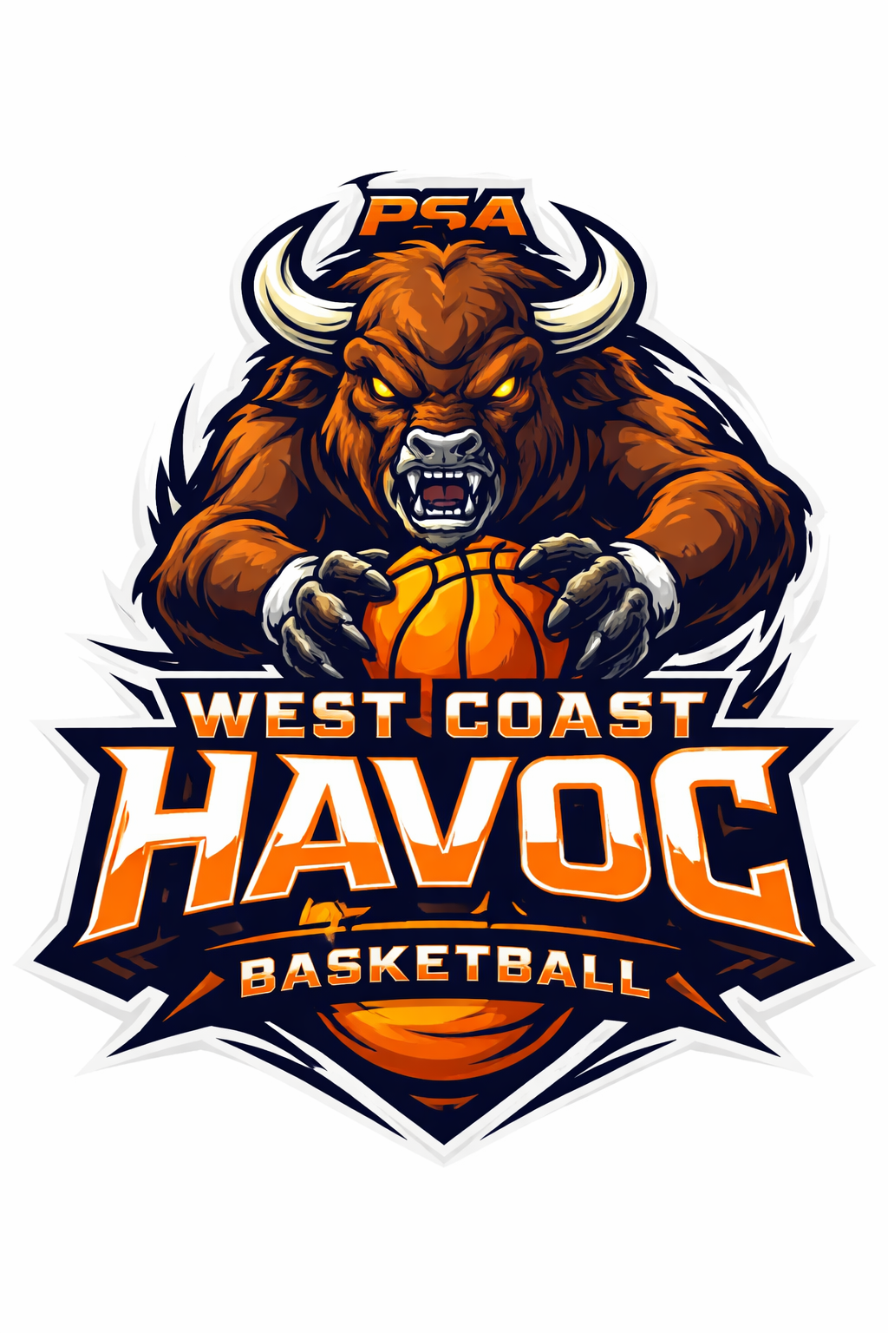
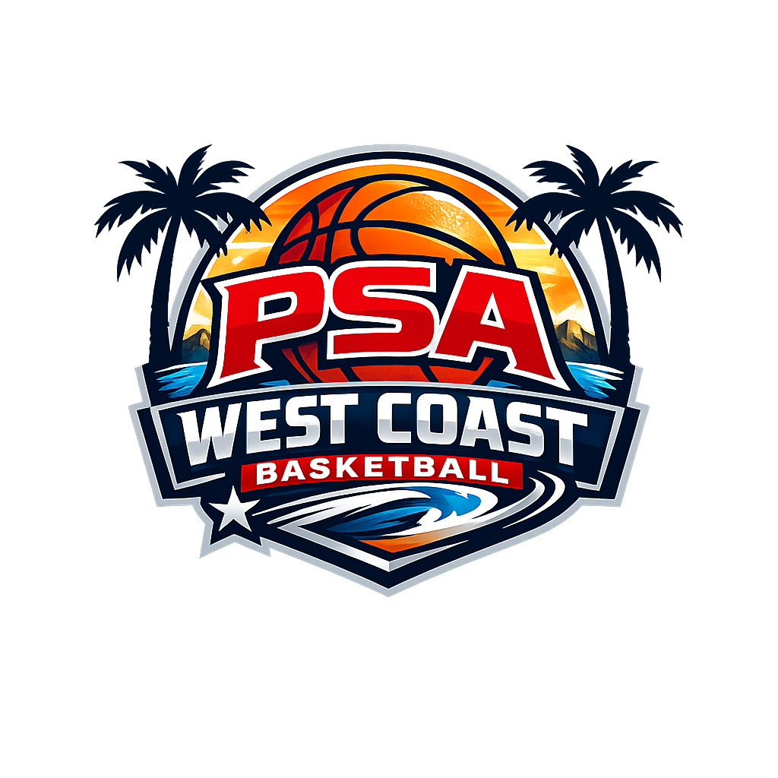
GUARDIAN SIGNATURE REQUIRED IF UNDER 18 YEARS OF AGE: __________________________________
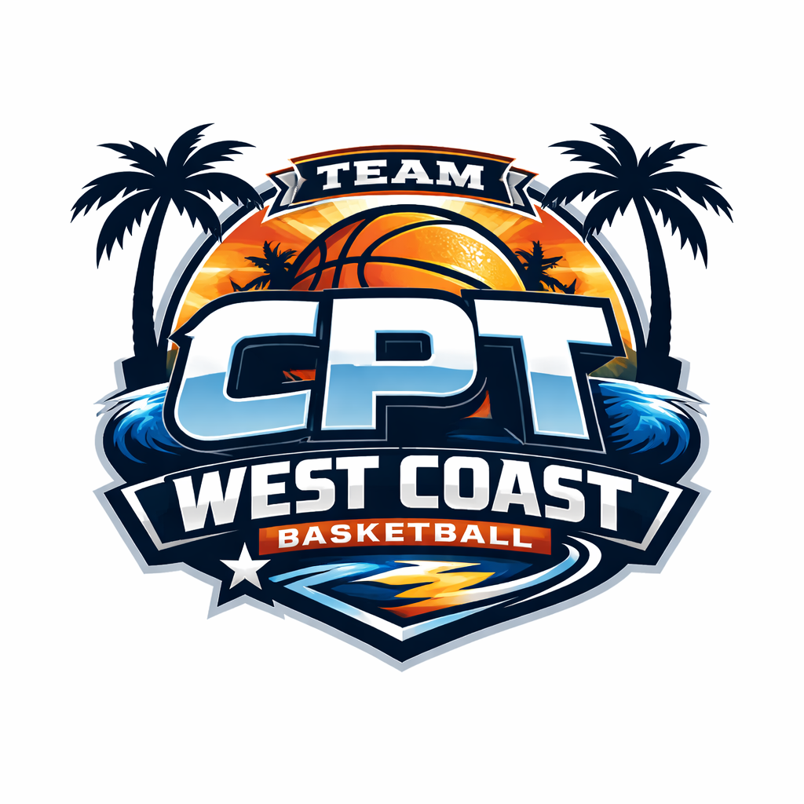
PRINT GUARDIAN NAME IF UNDER 18: ___________________________

