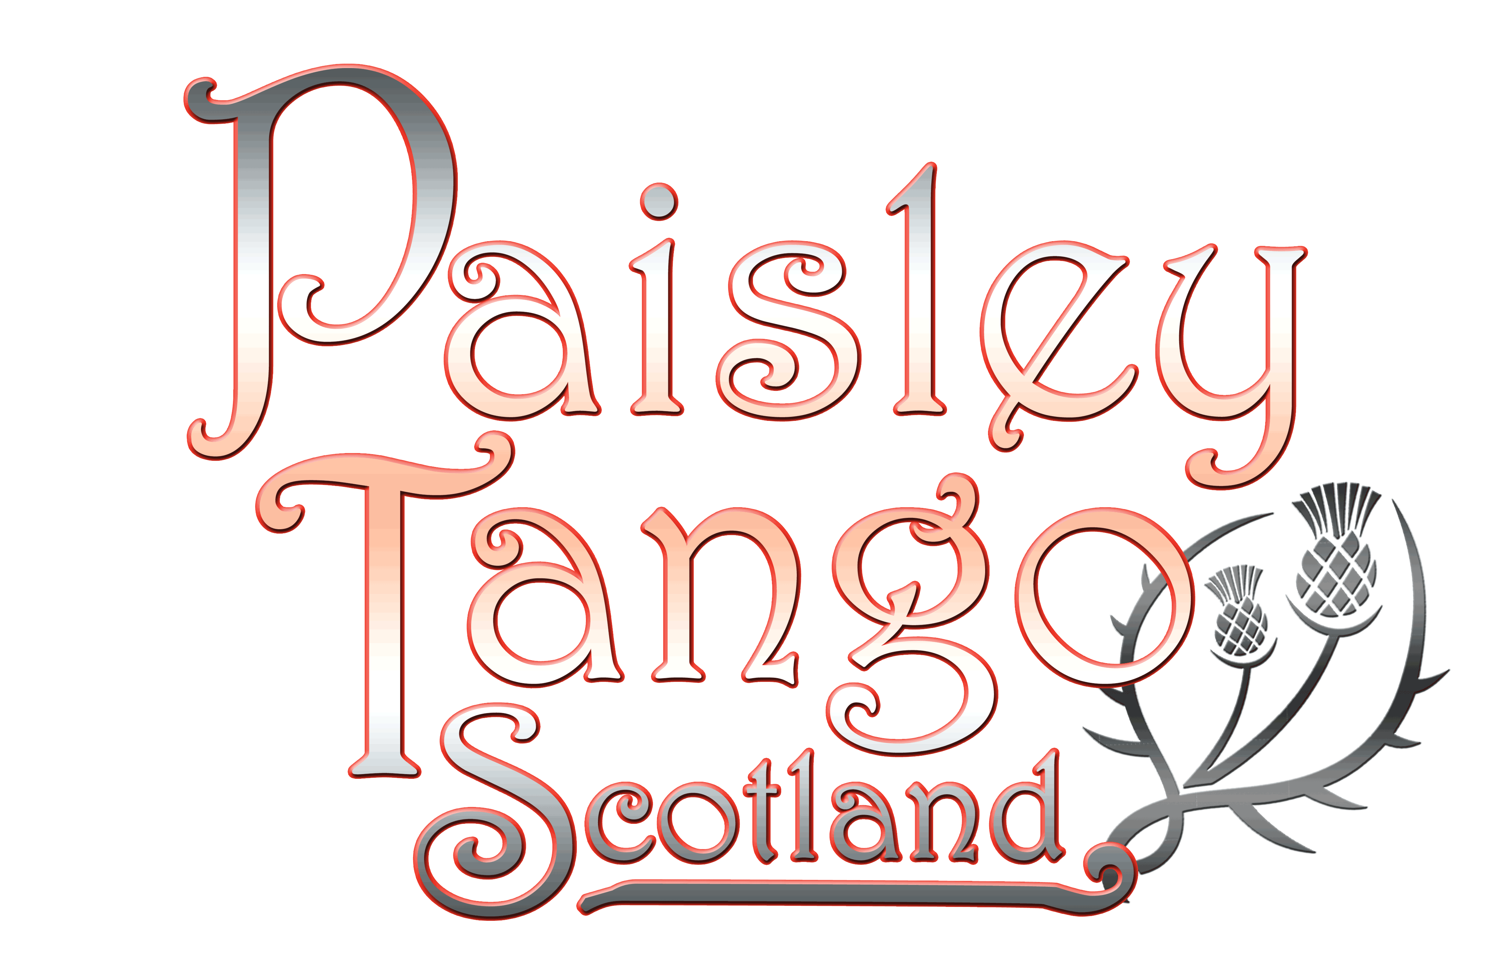

**Tango Develpoment Week in Prague with Paisley Tango and Alejandra Mantinan**

|  |  |  |
| --- | --- | --- |
|  |  |  |
| **Family Name** |  |  |
| **First Name (Mr/Mrs)** |  |  |
| **Street &**  **No** |  |  |
| **City & Postcode** |  |  |
| **Telephone** |  |  |
| **Email** |  |  |
| **D.O.B.** |  |  |
| **Nationality** |  |  |
| **Passport No** |  |  |
| **Issue Date** |  |  |
| **Valid until** |  |  |
| **Place of Issue** |  |  |

|  |  |
| --- | --- |
| **Emergency Contact -** | **Name -** |
|  | **Telephone** |

|  |  |  |
| --- | --- | --- |
| **Requirements** | **Y/N** |  |
| **Single Room** |  |  |
| **2 x Single (Twin Room)** |  |  |
| **Couple (Double Room)** |  |  |

|  |  |  |
| --- | --- | --- |
| **OPTIONS** | **Y/N** |  |
| **Extra Nights in Hotel**  **(state dates)** |  |  |
|  |  |  |

**PLEASE NOTE – Your booking is not confirmed until we receive a completed form and your full deposit.**

**This tour has limited availability, and places will be issued on a “first come- first served” basis.**

**BOOKING DETAILS**

**Check in from 3pm Sunday 2nd November 2025**

**Check out by 11am Sunday 9th November 2025**

**(extra nights in hotel can be booked at initial booking)**



**Payment**

**Based on 2 sharing a Twin or Double room £999 per person**

**Based on 1 person in a room £1199**

**A deposit of £250/person is required to secure your place.**

**Strictly non-refundable**

**Your balance will be due on or before 31st August 2025**

**-------------------------------------------------------------------------------------------------------------**

**Bank Transfer to**

**Mr Andrew Moir**

**Santander**

**Sort code 09-01-29**

**Account Number 36293380**

**--------------------------------------------------------------------------------------------------------------**

**Cancellation by us**

**In the event of cancellation by us, all monies paid will be refunded.**

**Cancellation by you**

**Deposit – non refundable**

**Cancellation within 40 days of travel = 25% of total monies paid will be refunded.**

**We strongly urge you to have full and comprehensive, health & travel insurance.**

**Please check the travel/immigration conditions for the countries you are visiting and for your nationality.**

**PLEASE NOTE – Your booking is not confirmed until we receive a completed form and your full deposit.**