Your child’s molar incisor hypomineralisation (MIH)
This leaflet explains more about MIH. If you have any further questions, please speak to the dentist caring for you.
What is MIH and why has my child got it?
MIH is a tooth condition where enamel and dentine (the outer and middle layers of the tooth) are softer than normal. This can lead to dental decay. Also it can make it more difficult to numb the teeth with a local anaesthetic for dental treatment.
MIH is not usually noticed until the adult incisors (front teeth) or molars (back teeth) come into the mouth around age 6-7 years. It can sometimes affect the back baby molar teeth and in these cases can be seen in the mouth from 2-3 years of age upwards.
One, some, or all of the first adult molars, incisors and sometimes the canines can be affected. Around one in five (20%) people in the UK have the condition in one form or another. Some people may have a mild form and not realise it.
It is thought to be caused by a disturbance in tooth development around the time of birth or in the first few years of life. The cause of it is not fully understood although severe childhood illnesses, high fevers, or a traumatic birth period have all been suggested as possible causes.
What are the signs and symptoms of MIH?
You or your child may have noticed that their front and/or back teeth may have discoloured and appear cream, yellow or brown. Also, their teeth may be painful or sensitive, and even crumbly.
See photographs below showing the signs of MIH.
Are any tests needed to confirm the diagnosis?
We will carry out a full examination and take X-rays if necessary. We will also ask about your child’s medical and family history to attempt to highlight possible causes and rule out any other causes of enamel problems.
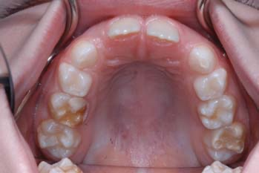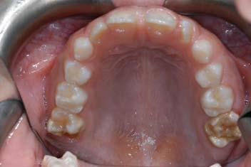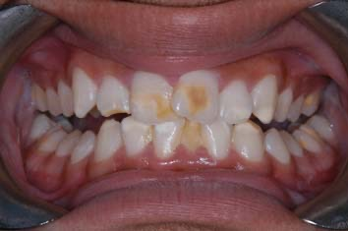
1 of 3
What happens if I do not get treatment?
If your child’s teeth are sensitive and broken down it is likely that treatment would be of benefit. If molar teeth are broken down then this breakdown can continue to get worse, which could lead to more pain, sensitivity, possible nerve involvement, abscess (build up of pus in tissue), and removal of the tooth.
What treatments are available for my child?
There are different types of treatment for different types of teeth. Your dentist will discuss these options in more detail and help you and your child decide the best option.
Front teeth
We treat front teeth to improve sensitivity and poor appearance, and improve surface roughness or breakdown. We use a combination of treatments depending on defect type, and response to treatment. The treatments of MIH on front teeth are:
- fluoride varnish: can help decrease sensitivity.
- acid pumice microabrasion: uses acid and a dental polishing powder to remove the outer
layer of tooth enamel to improve the appearance. This can damage the teeth a little.
- resin infiltrant: improves the appearance of teeth by altering how light reflects off the
teeth. This can damage the teeth a little.
- tooth whitening: aims to blend the discolouration to the colour of the unaffected teeth.
This can cause temporary sensitivity. Tooth whitening is not used in under 18 year olds.
- white filling: a thin layer of white filling is added over the front of the tooth (usually with no
drilling) but will make the tooth thicker. This will fill any areas of breakdown as well as masking the discolouration. This filling will need maintaining over time by your dentist.
Back teeth
Like front teeth, back teeth can be sensitive. We also have to consider how decayed or broken down the teeth are and whether they are likely to last in the long term. The treatments of MIH on back teeth are:
- fissure sealant: covers and protects the natural grooves in a mildly affected tooth.
- stabilisation or a white filling: involves either a temporary filling with no drilling of the tooth
or a filling with drilling of the tooth. Your dentist will advise you which is best for your
child.
- stainless steel crown: a silver-coloured metal tooth-shaped cap which is recommended
for a more decayed or broken down tooth.
- tooth removal: if the tooth is of poor quality it may need to be taken out. Done at the right time, this can allow other adult teeth to move into the gaps.
Affected teeth may receive some of the treatments above, in order to provide relief from sensitivity and further breakdown, and allow for growth and development of the remaining adult teeth, before they need to be removed.
Is there anything I can do to help myself?
Milder forms of the condition, where sensitivity is the main complaint, may be helped by your dentist painting fluoride varnish onto the teeth every three months. This may also help to reduce the chance of enamel breakdown or decay developing. If your child is seven years or older, they can use a fluoride mouthwash. If your child is 10 years or older, they can use a double strength adult toothpaste (on prescription).

