This information leaflet will help you understand what this treatment is for and what you should expect during and after treatment.
Root Canal Treatment
Root canal treatments are made when the soft tissue inside the tooth (pulp) is inflamed or dead. The pulp is a tissue made up of blood vessels, nerves, and connective tissue.
If there is a significant amount of tooth decay, a large restoration such as a crown or filling, or trauma to the tooth, the pulp of the tooth can become inflamed or even die.
An inflamed pulp can cause a toothache or remain painless. When the pulp dies, the root canal (the area the pulp lived in) can quickly become infected with bacteria. This infection can cause pain and swelling in the abscess (supporting tissues) or in some cases the tooth can remain symptom-free.
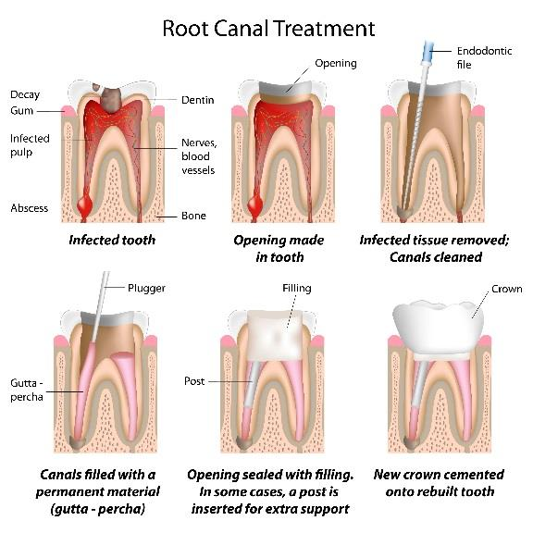
A Root Canal Treatment is performed to remove inflamed tissue and/or bacteria in the root canal allowing surrounding tissues to heal. After the root canal system is cleaned, the space where the pulp is filled with a root filling in order to prevent another infection. A rubbery natural substance called gutta percha is used as the root filling material. During Root Canal Treatment a rubber sheet will be placed over the tooth to keep it isolated and clean. Although this can feel odd to begin with, most patients find this to be more pleasant experience than they expect as it keeps the water and debris out of their mouths during treatment. The root canal system is often quite complex and not easily cleaned and the treatment is time consuming because of its complexity. There is usually not much discomfort during the procedure, although there can be some pain afterwards.
How does endodontic treatment save the tooth?
The dentist removes the inflamed or infected pulp, carefully cleans and shapes the inside of the canal, a channel inside the root, then fills and seals the space. Afterwards your dentist may place a crown or other
restoration on the tooth to protect and restore it to full function. After restoration, the tooth continues to function like any other tooth.
Will I feel pain during or after the procedure?
Many endodontic procedures are performed to relieve the pain of toothaches caused by pulp inflammation or infection. With modern techniques and anaesthetics, most patients report that they are
comfortable during the procedure. For the first few days after treatment, your tooth may feel sensitive, especially if there was pain or infection before the procedure. This discomfort can be relieved with over-the-counter or prescription medications. Follow your dentist’s instructions carefully. Your tooth may continue to feel slightly different from your other teeth for some time after your endodontic treatment is completed. However, if you have severe pain or pressure or pain that lasts more than a few days, call your dentist.
Care After Root Canal Treatment
You should not chew or bite on the treated tooth until you have had it restored by your dentist. The unrestored tooth is susceptible to fracture, so you should see your dentist for a full restoration as soon as possible. Otherwise, you need only practice good oral hygiene, including brushing, flossing, and regular check - ups and cleanings. Most endodontically treated teeth last as long as other natural teeth.
In a few cases, a tooth that has undergone endodontic treatment does not heal or the pain continues. Occasionally, the tooth may become painful or diseased months or even years after successful treatment. Often when this occurs, redoing the endodontic procedure can sometimes save the tooth.
What causes an endodontically treated tooth to need additional treatment?
New trauma, deep decay, or a loose, cracked or broken filling can cause new infection in your tooth. In some cases, the dentist may discover additional very narrow or curved canals that could not be treated during the initial procedure.

