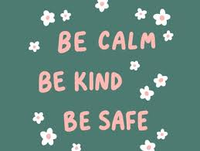

**September 2021**

**Welcome to Grade 3!**

[grainnekinsella@spev.ca](mailto:grainnekinsella@spev.ca)

September 9th 2021

Dear Parents,

I would like to take this opportunity to welcome you and your child back to school. I hope you had an enjoyable and restful summer break. I can tell the students are just as excited as I am to begin this school year. Before things start to get busy, I would like to go over a few items so that the classroom routines will run smoothly and efficiently all year long.

**Communication**

* The most important item I would like to mention is communication. As a teacher, I highly value and rely on your perspective and understanding of your child as it helps me to form a deeper connection with him/her as a learner. Please email me at [grainnekinsella@spev.ca](mailto:grainnekinsella@spev.ca) with any questions, additional information or suggestions over the coming months. I look forward to working with you this year to make your child’s experience in Grade 3 a holistic one.

**School Bags**

* Please ensure that your child has a good sized school bag. Students are not permitted to carry items out of the classroom in their hands; all items must be in their bags when they leave school. This will really help to decrease the number of lost items, folders and projects.

**Gym Gear**

* Students will have two scheduled P.E .periods each week. Students are asked to come to school wearing their gym strip on the days listed below. The students will need to have a full gym strip (including white socks) in order to go to P.E. It is extremely important that each piece of your child's uniform and gym gear, including socks, have a clear label on them. Items of clothing such as socks, gym shirts, shorts etc will be put in the lost and found box should they have no label on them. Having all items labeled allows me to return expensive uniform pieces.

***The students will have PE on ***Tuesdays and Fridays***\*\*\*

* Students will have scheduled DPA times on the days they do not have P.E. There is no need to wear a gym strip on these days. However, I do recommend that students bring their runners to school so they can change into them for DPA.

**Homework**

* Students will write their homework in their planner each day. Parents or guardians are asked to please sign the planner each evening.
* The students will be assigned homework almost everyday. This will consist of home reading, spelling sentences and sometimes reflective writing work to communicate with parents. Regular homework assignments should not take more than **30-40 minutes** to complete. If your child is having difficulty completing their homework or is taking more than this recommended time, it is important that you inform me via email. If your child continually gets frustrated over a certain homework task, it is important that I know so that we can give them the extra support they need to understand the concept. Your communication is crucial and much appreciated here, especially as I take time to get to know the individual needs of each student throughout the month of September.
* We will continue to use Google Classroom this year. However, it will be mainly used for the purpose of sharing useful resources, class newsletters and anchor charts. If you are in need of a refresher or require any technical assistance, please email me at [grainnekinsella@spev.ca](mailto:grainnekinsella@spev.ca). 
* ***Please see the September Class Newsletter for more details about homework.***

**Supplies**

* Student supplies have been purchased in bulk this year and have been placed in your child’s. These supplies will be sent home on the first day of school to be ***labeled and returned to school.*** Students are asked to bring in their own ***pencil box, scissors and ruler from home.***
* Students will not be sharing resources in the classroom. Students have been given individual ‘Math packs’ (a collection of important materials needed to explore Math concepts this term in a large zip-lock bag e.g. base ten materials,a place value template, a 100 square chart, dice, unifix cubes and pattern blocks). These packs will be kept in their desks and used throughout the term in class.

**Lunches**



* The students are asked to bring a healthy lunch from home. What a student eats at recess and lunch really affects their energy levels and behaviour throughout the day. We will be learning about a balanced diet, healthy eating and the Food Pyramid in class over the coming weeks. I encourage you to talk about these topics with your child at home, as they help you to prepare their lunch each day/as you do your weekly shop in the supermarket.
* Water is the only permitted drink for students to have throughout the day. Please note that Saint Patrick's is completely nut free. There are many students with severe allergies. This means peanut butter, Nutella and any other bars containing nuts are not permitted at school for safety reasons. Thank you for your cooperation in this matter.
* Recess and lunch times will be staggered. Students will not be eating lunch outside on the playground this year. I will schedule a time for students to sit in the classroom and eat their snack before recess. Students will have 20 minutes to eat their lunch as usual. Students will not be permitted to share lunches. Lunch drop offs are also discouraged this year. Thank you for your understanding and cooperation as we make necessary adaptations this year.

**A note about air circulation**

* Each morning when I open the classroom, I will also open all of the windows. These windows will remain open throughout the day to provide air circulation. Therefore, it is important that students come to school with a sweater each day to avoid feeling cold and uncomfortable during independent work.
* In addition to this, an air purification system will continue to be used in the classroom.

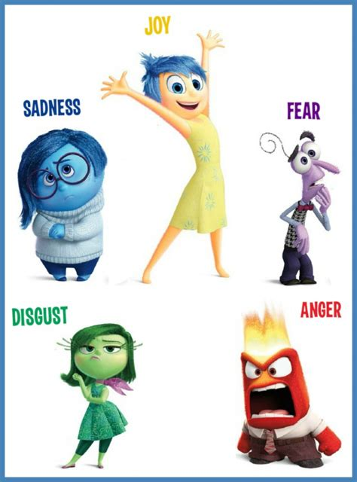

**A note about mental health**

* Now, more than ever before, our mental health has been challenged on a global scale. This has had an enormous impact on children’s anxiety. I am aware that students are returning to school with complex emotions this September, not knowing what lies ahead. In order to support each student, mental health content and check-ins will be incorporated into the school day. This will involve mental health homework at times, even checking in with family members and asking questions etc. It is my hope that this will benefit you and your child this year.

**The Redesigned BC Curriculum**

* The students have been introduced to the new BC curriculum since Kindergarten, when this curriculum was in its 'phasing in' process. You will notice some differences in the redesign, most specifically, a focus on three 'Core Competencies': ***(1) Communication, (2) Thinking and (3) Personal and Social competencies.*** These competencies are a set of intellectual, personal and socio-emotional proficiencies that all students need to develop in order to engage in deep and lifelong learning.
* We will spend September reviewing the language specific to each competency and students will be encouraged to use these terminologies to describe their learning. This will serve as a foundation for the meta-cogntive work that will take place this year. Their attention will be drawn to their own progress and learning through self-assessment.

**I am a Gift from God**

* Grade 3 will be engaging in the 'I am a Gift from God' programme in January. This programme is designed to help children to develop the understanding that the human body, as a gift from God, is to be respected. Parental involvement at home, as with all curricular areas, is integral to the implementation of this programme. More information will be given to you about this programme in January.

I look forward to working with you all this coming year!

Respectfully,

Ms. Kinsella.