SHWC Member Portal Login Instructions
- Go to https://shw.clubautomation.com/
- First time – click “Access My Account”
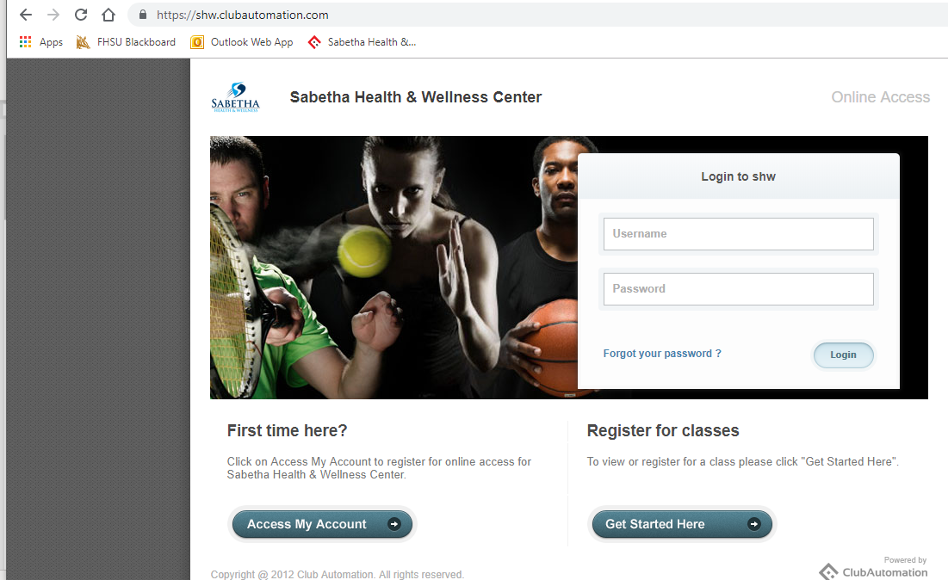
- Enter First and Last name along with email address and click search
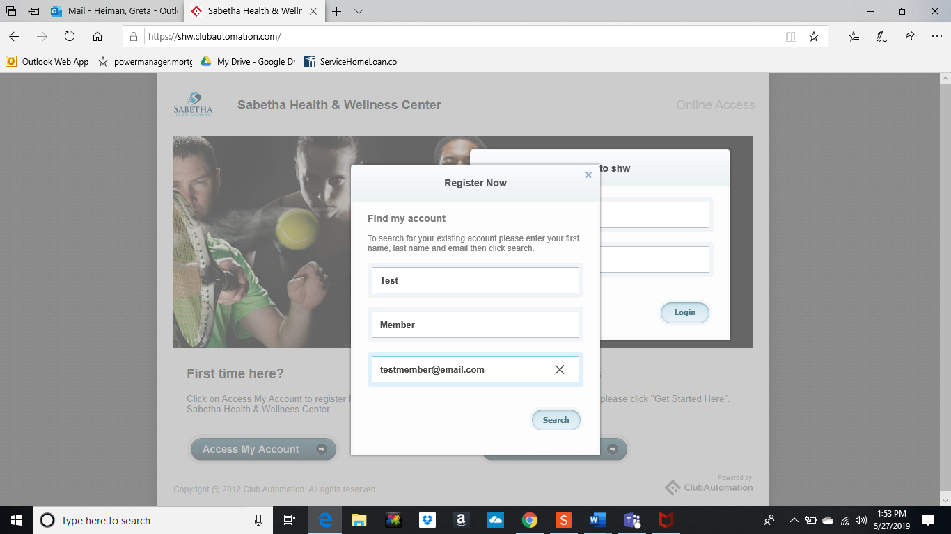
- Once found in the system an email will be sent to your email address.

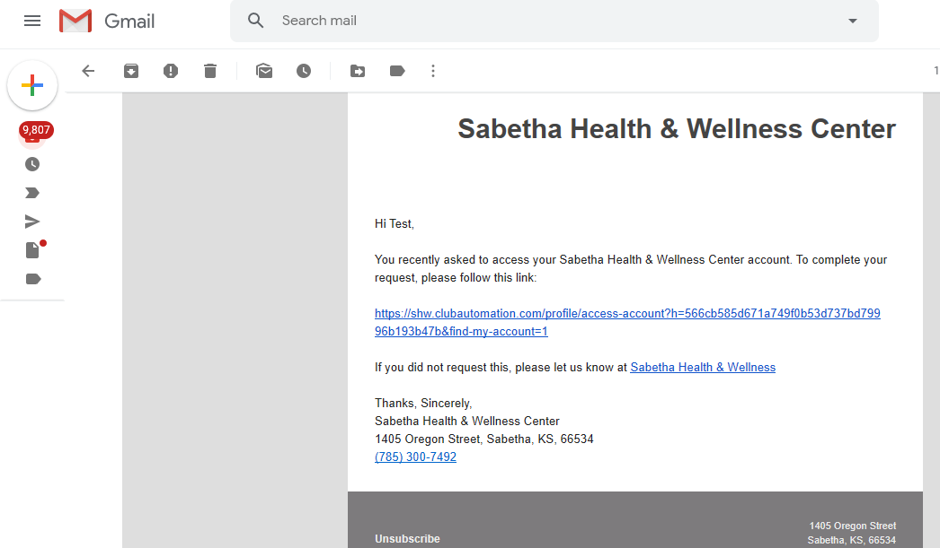
- Click on the link in the email
- Complete information and click “save account” button

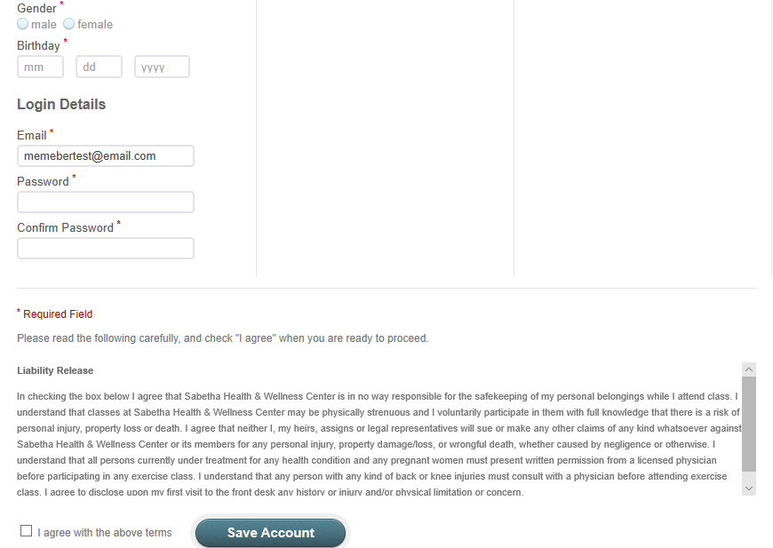
- Enter username and password to login to account
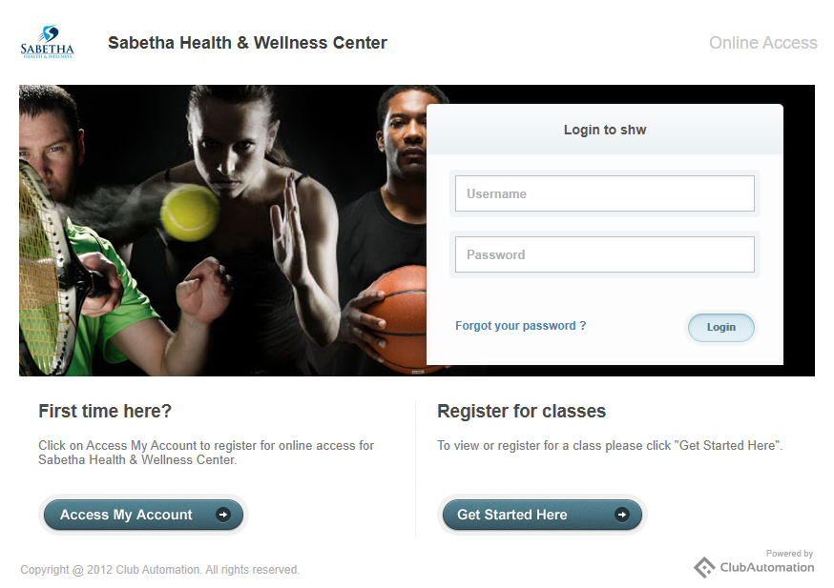
- To reserve a spot in a group exercise class, click on Group Activities
  - Select the correct date range and click the blue “Search classes” button
  - Click the green “Sign Up” button
  - Click on the name of the member you’d like to sign up
  - Click Register
    - You may register for a group exercise class 7 days in advance
