**The Spark**

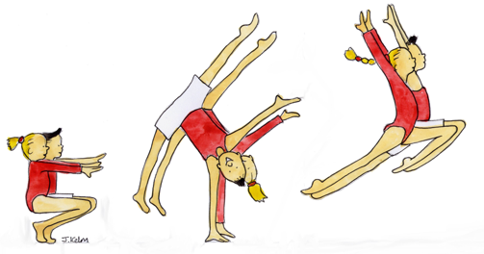

Bath University – 20th May 2018

Entry closing date – 29th April 2018

(Entry opens 1st March)

(*There will be a restriction on the entry so don’t leave it until the last day. We will let you know when it is full)*

*Club……………………………………………………………………………………………………………*

*BG Number …………………………………..*

*Email address ……………………………………………………………*

*Coach …………………………………………………… BG No…………………………………………*

*Coach……………………………………………………. BG No………………………………………….*

*You do not need to provide a judge unless you would like to.*

|  |  |  |  |
| --- | --- | --- | --- |
| ***Name*** | ***DOB*** | ***BG Number*** | ***Level*** |
|  |  |  |  |
|  |  |  |  |
|  |  |  |  |
|  |  |  |  |
|  |  |  |  |
|  |  |  |  |
|  |  |  |  |
|  |  |  |  |
|  |  |  |  |
|  |  |  |  |
|  |  |  |  |
|  |  |  |  |
|  |  |  |  |

*It is the responsibility of the club to ensure that the coaches in attendance are qualified for the level of work of their gymnast. I confirm that the above criteria has been adhered to:*

*Signed ……………………………………………. Print name……………………………………………*

*Entry fee enclosed ……………. @ £12 per gymnast.= £………… All gymnasts must be paid for in advance.*

*Cheques made payable to* ***Bristol School of Gymnastics.***

*post to Shirley Clements, 116 Thornleigh Road, Horfield , Bristol.BS7 8PJ*

*You may enter online to:* [*shirleyclementsbsg@yahoo.co.uk*](mailto:shirleyclementsbsg@yahoo.co.uk)*. When we receive your entry we will email the account number and sort code so you can pay. Your entry will not be accepted until we receive the entry fee. You will be emailed to let you know we have received it.*