Dr. ReVivajennz Spa | Rosacea  Laser Treatment Care Form

Pre-Treatment
- Notify your practitioner of any medications you have used within the last 6 months. *Blood thinning medications can hinder the results of vascular treatments.

- Notify your practitioner if you have a history of perioral herpes.

Immediately Before Treatment
- If applicable, shave or trim any hair in the area to be treated. This will help achieve the best possible results.

- Remove any make-up and/or lotions and make sure that the skin is dry in the area to be treated.

Post-Treatment
- You may return to your normal daily activities immediately after your treatments, but refrain from vigorous exercise for 3 days post-treatment.

- Avoid extended sun exposure or tanning for at least 1-week post treatment.

- Keep the treatment site moist by reapplying an inert moisturizer multiple times per day for a week after treatment. Should any scabbing occur, do not pick or scratch at the treated skin.

- Pronounced vessels may convert to what looks like a cat-scratch (rust coloring or bruising) from 24 hours up to 2 weeks post-treatment. This is a normal occurrence. Such pronounced vascular lesions may disappear and re-appear for a period of up to 3 months post-treatment.

- Avoid blood thinners for 1-2 weeks post-treatment. Avoid hot showers, baths, saunas and steam rooms for 48 hours post-treatment.

- To achieve the best results, complete the full treatment schedule at the intervals recommended by your laser practitioner.

Dr. ReVivajennz Med Spa
418 S. Wagner Rd. Ann Arbor, MI 48103
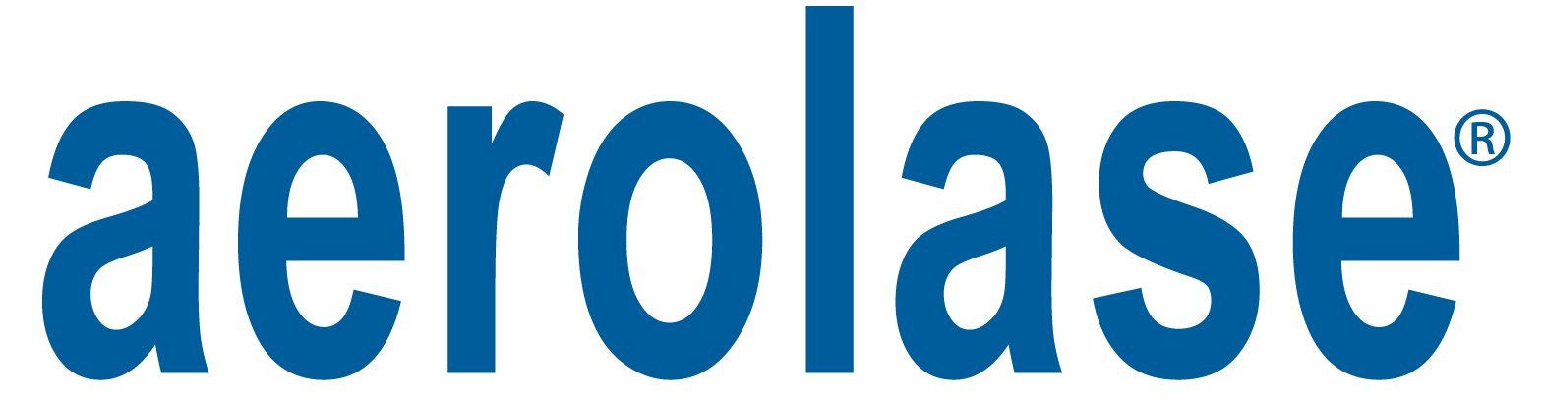
www.revivajennz.com

