**NCRS Nebraska "LAST BLAST 2021"**

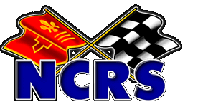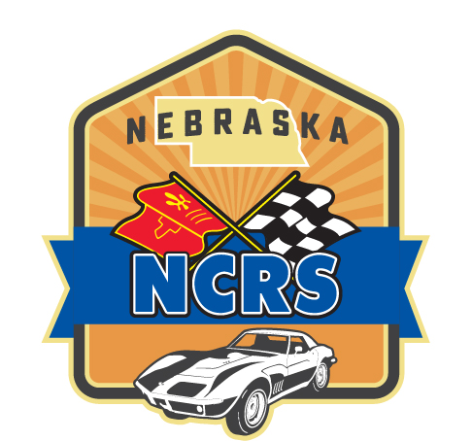

**Two Day Super Chapter**

**Flight & Concours Judging Event**

**Friday & Saturday, October 15-16, 2021**

All NCRS Members are invited to attend and participate in our 3rd annual LAST BLAST Judging & Schools event.

We are excited to return to the Commonwealth Hangar for 2021 and we have a great weekend planned.

***For all NCRS members attending Judging Schools & Judging both days, this will be a 5 point weekend.***

Flight, Concours, Sportsman & MOE display Corvettes are welcome with a special reserved

parking area for all Corvettes driven to the event. New Larger Location this year!

**Commonwealth Airplane Hangar 1721 W. Superior Street, Lincoln, NE 68524**

***Friday, October 15, 2021***  
American Museum Speed Tour 9a-12pm

Judging Meet Registration Open 12-5pm

Arrival & Unloading Judged Cars 11-1pm

Lunch at the Hangar 12-1pm  
Operations Check 1-3pm  
Staging Corvettes inside building 3-3:30

Judging & Tech Schools - 3:30-6pm  
Official end of NCRS Judging events 6pm  
Social Hour 6-7pm  
Dinner On the Judging Floor 7-9pm

***Saturday, October 16, 2021***  
Registration & Sportsman Parking 8am

Coffee & Rolls 8:15

Owners & Judges Meeting 8:30am  
Flight & Concours Judging 8:45am  
Valentino’s Pizza Lunch 12pm

Wrap up judging & Tabulation 12:30  
Awards Presentation 1:30pm  
Remove Cars from Building 2pm  
Goodbye Hugs 3pm

Preregistration is required either via the NCRS National online registration "coming events" tab (preferred)

or by using this paper registration mailed to Brad Hillhouse, 8040 S. 37th Street, Lincoln, NE 68516-7710.

There is a $45 event registration fee for the 2-day judging event and schools. Please add as needed:

**MUSEUM TOUR:** Friday morning Speedway Museum of American Speed Tour. **$15 per person.**

**MEAL PACKAGE:**  Friday & Saturday Lunch, Friday night dinner, Saturday morning coffee. **$30 per person.**

Payment can be made payable to NCRS Nebraska Chapter or PayPal: NCRSNebraska@gmail.com

Name(s) ___________________________________________________ NCRS # ___________________

Address ________________________________________ City ____________State____ Zip__________

Email _________________________________________________ Phone # ______________________

**Event Registration ____@ $45 ______ Museum Tour ____ @ $15 ______ Meal Package ____ @ $30 ______**

(circle): I will Judge**:** *Yes or No* I want to have a Corvette Judged**:** *Yes or No* **TOTAL $ _________**

Event Contact: Brad Hillhouse, Nebraska Judging Chairman. [BradHillhouse@yahoo.com](mailto:BradHillhouse@yahoo.com) 402-730-6898

***NCRS Nebraska Chapter reserves the right to limit judged Corvettes depending on available Judges***

HOLD HARMLESS AGREEMENT I agree to insure my vehicle and property for loss, damage & liability and to provide proof of such insurance to NCRS at time of registration. I agree to assume the risk of an and all damage or injury and to indemnify and hold harmless NCRS, its officers, directors, agents, employees and chapters for any action of acts of omission which may result in the theft, damage or destruction to my property or injury to me or others offering during or as a consequence of this event, wherever located.