Tech Article: Passenger Side Mirror Addition or Repair on C1-C3 Corvettes
Brad Hillhouse
Nebraska Judging Chairman
Bradhillhouse@yahoo.com

Many people over the years have wanted to add a outside mirror to their C2 or C3 to aid in making right hand lane changes. The factory did not make a passenger side mirror standard until they switched over to the “sport mirrors” from the single chrome one that was a staple on Corvettes since the mid 1950’s. Many drivers wanted the help of a passenger door mounted mirror and so you will find many C2 & C3 Corvettes with one added from the dealer.
The dealer and even many Corvette aftermarket suppliers will supply you with a compete kit to add the mirror: Mirror assembly, Metal mounting plate, Hex allen head screw that mounts the mirror to the base, the rubber gasket that protects the paint from the mirror rubbing on it, 2 screws to mount the base and two rubber well nuts to go inside the door and hold the screws/mounting bracket.
If you have ever looked closely or touched one of these added on mirrors, you will find that the weak link in the entire system is the rubber well nuts that go through the door. From the factory, the driver’s door has a floating piece of steel inside the door with steel nuts welded to it for the assembly line worker to attach the mirror. It was a good system (until 40 years later you need to change it and the screws break off but that’s another tech article). The rubber well nuts are designed to be able to secure the mirror mounting plate to the door without removing the door panel and using a metal washer and nut from the inside of the door. This provides a simple way to have a blind nut and after sticking the rubber well nut inside the hole you drilled in the door, tightening the screw will expand the rubber and hold the mirror base to the door. Of course, the rubber is flexible and at speed, the mirror can easily move around – it also can flop when you are washing and cleaning the car as well as when you shut the door. I have never liked this mounting system and have a better solution for either adding a passenger mirror or strengthening the one you have now if it has rubber well nuts securing it to the door.

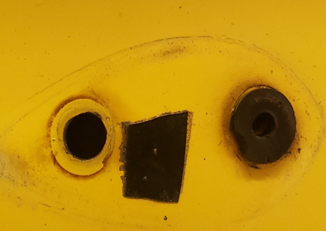
I had a 1968 in my shop for some repairs and the passenger side mirror was very loose. When washing it, the mirror head would easily move more than one inch up and down. I removed the mirror and then the mounting base and found that the two rubber well nuts were old, dried out and very brittle from age. When removing the screws, I found that the rubber was so hard and brittle that when I removed the left screw, the rubber started to tear and disintegrated.

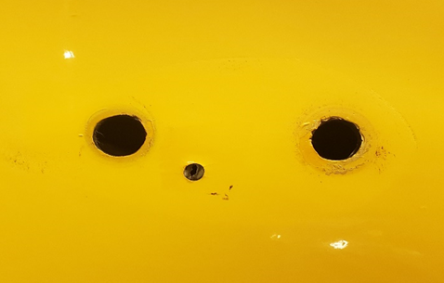
Step two was to remove the other old rubber well nut and then clean and polish the paint so that when the new mirror was mounted, you would not see any evidence of prior paint damage and have the surface nice and smooth. Removing the square rubber piece revealed that the original installation had started off on a bad foot and they had made a mistake with the drill. Since it will be covered back up with the mirror replaced, I only cleaned and polished the area and put a small bit of 3M strip calk sealent in the hole to prevent any water from getting inside.

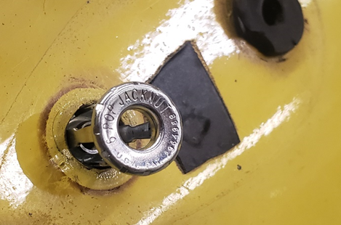
The next step is to use what I consider to be the real solution of installing a passenger mirror, or any place on a Corvette where you need to have a very secure mount but do not have good access to the back side to attach a nut as the fastener. These are designed for several different types of installation - either using a special pop rivet gun that is designed for this type of hidden nut, or you can use the type I used that are available at most hardware stores. This particular brand is called “Jacknut”. This photo shows test fitting it into the hole that was already drilled. They make different sizes of these, and this one is for a 3/8 hole.

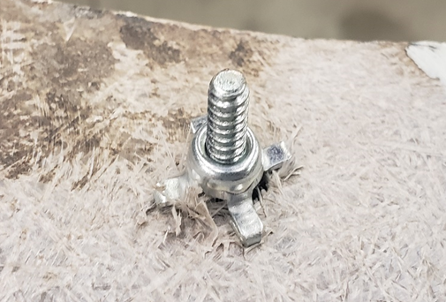
This photo shows the Jacknut installed on a test piece of fiberglass to better show how the Jacknut works when it is tightened down. As the screw is tightened into the nut, the sides of it begin to collapse and fold outwards creating 4 arms that expand past the sides of the hole. As these arms expand, the begin to tighten against the fiberglass from the backside and create an extremely tight bond against the fiberglass. Using this type of fastener is far superior to a rubber well nut when there will be external forces on it trying to get it to move. Anyone with a C2 or C3 knows that GM used the rubber well nut to mount the TI box in front of the driver side wheel well as well as the voltage regulator on the driver side wheel well. In those applications, there is no real force being put upon the box trying to pull it off of the fender. The rubber well nut does its job. Where it is used to try and hold the mirror that has large amounts of wind resistance, the rubber well nut does not do well while the metal Jacknut holds the mirror tight.

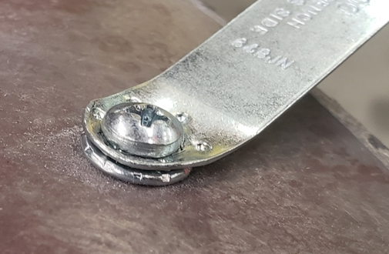
You also need to purchase the special tool that aids in installation of the Jacknut for it to tighten up properly. This tool has “dimples” that hold tight against the Jacknut as you tighten the screw and keep the Jacknut from spinning as you apply force to collapse the backside of the nut. Without this tool, you will have a hard time getting the Jacknut to stay in place and hold tight to complete a secure installation.

Here you can see one Jacknut fully installed and the second one getting inserted and ready to be tightened down. You will be collapsing that Jacknut about ½ of an inch. Be prepared to use some force to tighten it down tight so it is good and secure.

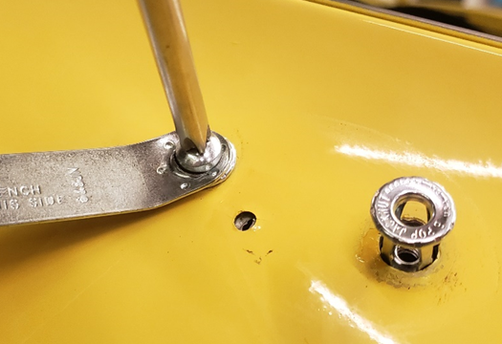
This photo was taken just to show the installation using the tool and screwdriver.
NOTE!! ALWAYS PROTECT THE AREA WITH TAPE when installing these. It is very easy while holding the screwdriver and Jacknut tool for something to slip and lead to catastrophe. Also, you can use a hex head bolt of the same thread as your Jacknut screw and use a ¼ inch ratchet to set the Jacknut instead of the Phillips screwdriver for more safety. Either way, PUT DOWN 2 LAYERS OF TAPE!

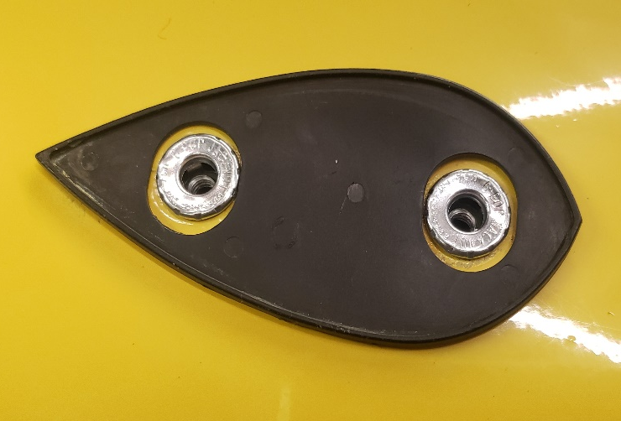
Here is both Jacknuts installed, the extra mistake hole filled and the rubber base mounting gasket in place for test fitting the mirror base to the door. You will be using two Phillips countersunk machine screws to attach the mirror base to the Jacknuts.

The countersunk Phillips screws that go in flush with the mounting base so that they do not interfere with the mirror. I start by tightening them up just snug and then test fit the mirror onto the base and check the spacing of the mirror to the rubber gasket. It will take several attempts to get the base mounted so that the chrome mirror is centered correctly on the rubber door gasket. Take your time, it will be worth it to have the mirror and gasket fitting perfectly all the way around the base. Once you are satisfied with the spacing of the rubber gasket to the mirror, you can tighten the screws to the door for the last time.

Using your 5/16 Allen wrench you can install and tighten the mirror mounting screw into the base and check for final fitment. You may need to readjust your base gasket one more time as when you do the Allen screw install, sometimes the way the mirror tightens to the base bracket, you may want to give it one last fine tuning to perfection. This installation gives a far superior installation of the mirror to the door than using the rubber well nuts that are supplied with a new mirror from the Corvette parts suppliers. At speed, this mirror will not move or flop around in the wind. It is not quite as tight as if you had opened the door and put a steel plate behind the fiberglass and any movement will be from the flex of the fiberglass, not the mounting nuts. With basic hand tools and without doing major surgery on the inside of your door, using the Jacknut method will provide you with a very nice and sturdy installation that will last for years to come.

