TI-84 Workshop Notes
also good for TI-83 and TI-83+

© 2005-06 Dr. Robert J. Rapalje
Math at Hunt Club
Seminole Community College
Sanford, Florida 32773

PART I: Computations

1. Turn [ON]. Off: [2nd] [OFF] or just wait about 4 minutes. It turns itself off! Darken/lighten screen: Press [2nd]. Then press and hold the [↑] or [↓] until the screen lightens or darkens to your preference.

2. When calculator is turned on, press [CLEAR] or [2nd ] [QUIT] to clear the screen of whatever may be on the screen when you turn it on.

3. a) Direct functions—on the buttons in black or white letters.
b) Indirect functions—above the button in color, coded to match the [2nd] button.
Use [2nd] to access.
c) [ALPHA]—another color coded button, lets you to type in uppercase letters,
[2nd] [alpha] type words in lower case letters,
[ALPHA] [ALPHA] allows you to stay in alpha mode for more than one letter.
d) Menu functions—some functions have entire menus that are accessed using
drop-down menus.
Press the [MATH] button for example:
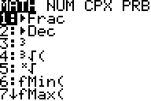
You can access each of the numbered items in this menu by either typing the number itself or by using the down arrow key to scroll down to that function. Notice that there is an arrow after the 7. This arrow indicates that there are additional options below this (a total of 10 functions) that can be accessed by scrolling up or down.

Notice also that there are additional sub-functions within this menu:
MATH NUM CPX PRB
Press the right arrow, and the cursor now on the MATH function moves to the NUM function. Press the right arrow again, and again, and it moves to CPX and PRB giving you the options shown below:

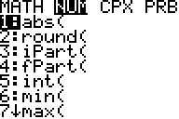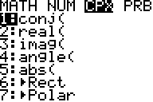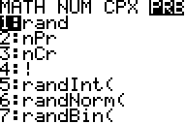
4. a) Raising to a power. 2⁵ : [2] [^] [5] [ENTER] Ans = 32.
b) Squaring numbers. 5² : [5] [^] [2] [ENTER] Ans = 25.
or [5] [x²] [ENTER] Ans = 25.

5. Square root. – Need for parentheses!!

a) : [2nd] [ ] [25] [ )] [ENTER] Ans = 5.
b) : [2nd] [] [1000000] [ )] [ENTER] Ans = 1000
Notice that when you pressed the square root symbol, the square root symbol comes with an automatic open parenthesis. It will be a very good habit to close the parentheses after you type the radicand (the number inside the radical!). In simple problems, it won’t matter, since the calculator automatically closes parentheses at the end of the problem. However, if additional steps follow the square root, if YOU don’t close the parenthesis, it could be a serious problem for you. Try the following example:
c) [2nd] [ ] [25] [ )] [+] [2nd] [ ] [16] [ )] [ENTER] Ans = 9.
d) Just for fun, try calculating part a) and c) above, without closing the parentheses. What you will find is that in 5a) the closed parenthesis is not needed, but in 5c) you end up with the wrong answer. The answer you get is equivalent to .

6. Difference between negative [(-)] and minus [—].

Negative [(-)] is like an adjective. Minus [—] is like a verb.
Calculate: 6 — 3 and compare to 6 (-) 3. The first answer is 3 (subtraction!).
Now, type 6 (-) 3. It results in an error message:



since the TI84 thinks you probably didn’t really mean “negative”. To correct the “error,” press the down arrow to [2: Goto] and press [ENTER]. The cursor goes directly to the [(-)] sign. To correct the error, type [—], which replaces the [(-)], and press [ENTER]. Ans = 3

7. Cube root, fourth root, fifth root, etc. To take a cube root, you begin with [MATH] [], [ENTER] followed by the radicand to be calculated. Notice that, as with the square root symbol , an open parenthesis is included with the cube root symbol. As with the square root, it will be a very good habit to close the parentheses after you type the radicand. Whereas with the cube root your first step is [MATH],. to take a fourth or higher root, you must begin with [4] for fourth root, [5] for fifth root, etc., and then [MATH] followed by [] [ENTER], and then the radicand. Notice that with , there is NO open parenthesis, so there won’t be a closed parenthesis after the radicand.

7. Cube root, fourth root, fifth root, etc. (Continued)

a) : Press [MATH] [] [ENTER] 125 [ )] [ENTER]
Ans 5

b) Press [MATH] [] [ENTER] 1000000 [ )] [ENTER].
Ans: 100

c): : Press [4] [MATH] [] [ENTER] 81 [ENTER] Ans: 3

d) : Press [4] [MATH] [] [ENTER] 4096 [ENTER]
Ans: 8

e) : Press [5] [MATH] [] [ENTER] 32 [ENTER]
Ans: 2

f) : Press [5] [MATH] [] [ENTER] 1024 [ENTER]
Ans: 4

8. Decimals to fractions:
Enter the decimal, then [MATH] [1:►Frac] [ENTER]. [ENTER]

a) Convert 0 .25 to a fraction: [.25] [MATH] [1: ►Frac] [ENTER]. [ENTER]
Ans:
b) Convert 0.1666 to a fraction: [.1666] [MATH] [1: ►Frac] [ENTER] [ENTER]
Ans:
c) Convert = 0.166666666666 . . . to a fraction. Note: Be sure to give the calculator enough 6s (in this case, at least 11 digits of [6]) to establish the pattern as an infinite, repeating decimal.
[.166666666666] [MATH] [1: ►Frac] [ENTER]. [ENTER] Ans:

d) Convert 0.16666 to a fraction:
[.16666] [MATH] [1: ►Frac] [ENTER] [ENTER].
If a decimal results in a denominator of 5 or more digits, the calculator cannot express the result as a fraction, and the calculator gives the answer as the decimal value. Ans: 0.16666

8. Decimals to fractions {Continued)

e) Convert = 0.181818181818 . . . to a fraction. Note: In this case, at least 6 repetitions of the [18] pattern establishes the repeating decimal.
[.181818181818] [MATH] [►Frac] [ENTER]. [ENTER] Ans:

f) Convert 0.1818181818 to a fraction (only 5 repetitions!): Note: In this case, since there are not enough repetitions to establish the repeating decimal, the calculator cannot convert to a fraction, and it gives Ans: 0.1818181818

9. Need for parentheses. There are many occasions in which parentheses are needed in order to establish the correct order of operations. For example,
. The answer is obviously , which is 10. However, if you use the calculator entering 12 times 5 divided by 3 times 2, the result is 40. Obviously, this is not what you really meant to do! The intended order of operations can be established by placing parentheses around the numerator and denominator.
[(] [12] [x] [5] [ )] [÷] [(] [3] [x] [2] [ )] [ENTER] Ans: 10

10. Scientific notation.

a) Multiply 4,000,000 times 2,000,000. Ans: 8E12
Interpretation: The answer 8,000,000,000,000 is too large to display on the calculator screen. Therefore, the calculator automatically converts to scientific notation which the calculator prints as 8E12. Notice that, in words, this is 4 million times 2 million. The answer is 8 trillion. Be sure to give the final answer in the form , not in the form 8E12.

b) Convert 4,000,000 to scientific notation.
Locate the [MODE] function at the top of the second column.
Type [4000000] into the calculator. Press [MODE]. (The calculator displays a screen full of options, most of which are irrelevant at this time.)
In the top row, you should see the words [Normal] [Sci] [Eng].
The word [Normal] should be surrounded by a dark, flashing box.
Press the right arrow key once, and the dark flashing box moves to [Sci].
Press [ENTER] to lock it into scientific notation mode.
Press [CLEAR] to return the calculator to the previous calculation.
Press [ENTER], and the calculator gives the previous answer in scientific notation. Ans: 4E6 which means

10. Scientific notation. (Continued)

c) Calculate 4 times 3. Ans: 1.2E1, which means 12.
You probably now realize that the calculator is still in scientific notation mode, and it will remain in this mode until you change it back to [Normal] mode. Obviously, for ordinary computations, you need to change it back!

d) To return to [Normal] mode, press [MODE] [Left arrow][ENTER] [CLEAR] (The calculator returns to previous calculation.)
[ENTER] Ans: 12

[EE] Button—Entering scientific notation into the calculator.

e) Calculate using the [2nd] [EE] button (located above the [7] button!).
Type [8] [2nd] [EE] [15] [÷] [4] [2nd] [EE] [3] [ENTER] Ans: 2E12 or .
Notice that parentheses were not needed, since the numerator and denominator were entered as single numbers 8E15 and 4E3 respectively.
Also notice that this one could easily have been done without a calculator: 8 ÷ 4 = 2 and subtract the exponents 15 - 3 = 12. Final answer: .

f) Calculate .
Notice that the denominator exponent is a “negative” (not a “minus”) 8.
Again notice that parentheses are not needed.
Type [6.25] [2nd] [EE] [12] [÷] [8.40] [2nd] [EE] [(-)] [8] [ENTER]
Ans: 7.44047619E19, which should be written .

g) Calculate .
In this example, the numerator and denominator contain more than one number, so play it safe and use parentheses around the entire numerator and parentheses around the entire denominator.

Type: [(] [9.24] [2nd] [EE] [9] [x] [2.03] [2nd] [EE] [(-)] [3] [)] [÷]
[(] [5.75] [2nd] [EE] [(-)] [8] [x] [6.42] [2nd] [EE] [9] [)] [ENTER]
Ans: 50811.8651.
However, the answer cannot be more accurate than the numbers that were used to compute that answer! Since the numbers used in the calculation are only accurate to three digits (three significant figures!), this means that the answer is only accurate to three digits. All the rest of the numbers in that answer represent false accuracy. The final answer should be rounded off using only the first three digits. Final Ans: 50,800.

11. Typing Shortcuts/Correcting Errors: [2nd] [ANS]; [2nd] [ENTRY]; [2nd] [INS]

After a calculation has been made, sometimes it is convenient to use this answer in the next calculation. Sometimes it is helpful to be able to re-enter the previous calculator entry, make changes, and recalculate. These can be accomplished using [2nd] [ANS] (above the [(-)] key) and [2nd] [ENTRY] (above the [ENTER] key). The following examples illustrate these calculation shortcuts.

a) Calculate
Keystrokes: [(] [6.3] [+] [3.2] [)] [^] [7] [ENTER]
Ans: 6983372.961
Accurate ONLY to two significant figures: Final answer: 7,000,000

b) Suppose you discover that the previous problem should have been . Calculate this, without retyping the entire problem.
Begin with [2nd] [ENTRY].
The calculator redisplays the previous problem, allowing you to use the left and right arrow keys to move the cursor. Using the left arrow key, move the cursor to the left, over the 6, and type the desired [8], which replaces the 6. Press [ENTER] . New Ans: 26600198.8
Rounded to two significant figures: Final answer: 27,000,000

Perhaps you have noticed that the calculator makes corrections in a “strike-over” mode. That is, when you make a correction, it strikes over what was already there. Sometimes it is better to be able to insert characters instead of typing over them. This can be done using [2nd] [INS] (at the top of the third column). Consider the next example.

c) Suppose you wish to change the previous calculation from to . Calculate this, without retyping the entire problem.
Begin with [2nd] [ENTRY], use the left arrow to move the cursor back to the 3. Now, since you need to insert an extra digit (instead of just replacing a digit), press [2nd] [INS]. Notice that the cursor changes from a “black box” to an “underline.” You are now prepared to “INSert” the digits of 2 and 5. Then, with the cursor under the 3, press the [DEL] (delete) key. Next, press the right arrow until the cursor is over the 2 in the 3.2. Press [2nd] [INS] [2], and the calculator inserts a 2 for you. Now, press [ENTER], and you should have this answer: Ans: 26118241.02
Rounded to three significant figures: Final answer: 26,100,000

11. Typing Shortcuts/Correcting Errors (Continued)

d) Calculate the two values of , and round to the nearest hundredth.
This actually means the two values: and
Keystrokes for :
[4] [2nd] [] [3] [ )] [+] [2] [2nd] [] [6] [ )] [ENTER]
(Note: Remember to close the parentheses after the 3!) Ans: 11.83
Keystrokes for :
[2nd] [ENTRY], left arrow cursor over the +, [—] [ENTER] Ans: 2.03

Sometimes when you make an error, the calculator catches it for you.
e) Suppose you are trying to calculate (see #10f) and in the process of entering the calculations, you enter a [—] instead of a [(-)].

Try it as follows.
[6.25] [2nd] [EE] [12] [÷] [8.40] [2nd] [EE] [—] [8] [ENTER]

The calculator returns with the following message:

Now, you have two choices. You can select [1: QUIT] [ENTER]! Or, you can select [2: Goto] [ENTER] to allow the calculator to show you where the error is.
The calculator “goes to” the error, which is the [—]. To correct the error, simply replace the [—], with a [(-)], press [ENTER], and the calculator gives the answer as before. Ans: 7.44047619E19, which should be written .

PART II: Graphing

Notice that there are five buttons across the top of the calculator right below the display screen. These buttons are labeled

[Y=] [WINDOW] [ZOOM] [TRACE] [GRAPH]

Notice also that above the buttons, in a color that matches the [2nd] button, are the labels:

[STAT PLOT F1] [TBLSET F2] [FORMAT F3] [CALC F4] [TABLE F5]

Before you can graph with the calculator, you must enter the equation by pressing the [Y= ], also called the [F1], button. If the calculator has been used before, the calculator will show the equation of the previous graph entered in the calculator. New or cleared calculators will show only the basic graph menu as shown below.

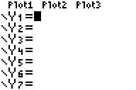

If the graphing component of the calculator has been used before, then any previous graphs will be listed in Y1=, Y2=, etc. For any of these equations that may need clearing, use the down arrow to move down to whatever lines need clearing, and press [CLEAR] for each one.

Now, use the arrow key (if necessary) to return to the line with Y1=, and type in the new equation to be graphed, as illustrated in the following examples. Before beginning, find the second button in the second column [X, T, θ, η], which means “x-variable.” When you type a variable in order to draw a graph, this is the button to use!

1. Graph . If you have not already done so, press the [F1 y= ] button, and clear whatever might already be in the calculator in any of the y= lines.

Next, either press [x-variable] [^] [2], or equivalently press [x-variable] [].

Once you have entered the equation you wish to graph, press [F5 GRAPH]. In most cases you will get the graph below.
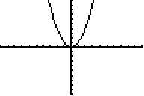

1a). If you do NOT get the graph pictured above, perhaps your calculator is not in the
standard window.

To standardize the window, press [F3 ZOOM] , and a menu drops down . See the first menu listed below. Notice the arrow after the 7. This indicates that there are MORE selections, that you can access by pressing the up or down arrow (see the second menu listed below).

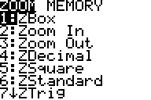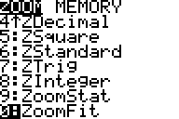

So, to standardize the window, press [F3 ZOOM], then [6: ZStandard]. This process will correct most of the graphing problems. Be sure you have the equation typed correctly, and make sure you have the right window for the calculator—more on that later!

b) There is another source of errors that you may encounter, and this is the DIMENSION ERROR. You have a DIMENSION ERROR if your calculator gives you this screen when you press [F5 GRAPH]:



Your only option is to press [ENTER] and Quit. To correct this dimension error, press [2nd] [F1 STAT PLOT]. What appears on the calculator screen is a summary of the “STAT PLOTS’ for the calculator. In order to do graphing with the calculator, all the stat plots should be [Off]. See the illustrations below. The illustration on the left, with all of the plots set to [Off], is the way the calculator should be, but if, perchance, one of your plots was accidentally turned on, it might look like the illustration at the right. If this occurs, then scroll down to the plot that is turned [On], and turn it [Off]. Then the calculator will graph as it is supposed to graph, assuming you have the correct equation and an appropriate window.
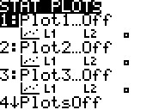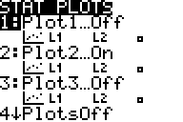

Press [CLEAR] to get out of this menu and return to a blank screen.

2. Graph . Notice that this is “minus 4,” and not a “negative 4.”
Begin with [F1 y =], and [CLEAR] if you want to clear the previous equation. Next, press [x-variable] [] [— (minus)] [4], and [F5 GRAPH] to sketch the graph. The graph should be as the one below.
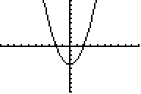

3. Graph . Notice that this is “negative ,” and not a “minus.”
Begin with [F1 y =], and [CLEAR]. Press [(-)] [x-variable] [] [+] [4].
Press [F5 GRAPH] to sketch the graph.
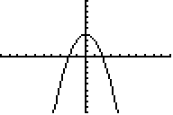

4. Graph .
Begin with [F1 y =], and [CLEAR]. Press [x-variable] []
[[— (minus)] [16], and [F5 GRAPH] to sketch the graph.
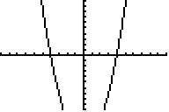

Notice that in the standard graph window, you can’t even see the bottom of the graph. Sometimes it helps to adjust the window. You may want to do this by pressing [F3 ZOOM] followed by [F3 Zoom Out] to zoom out.
Or even better, press [F2 WIND] . The following menu drops down:

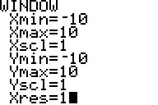

4. Graph . (Continued)

As you can see, the “standard window” shows the graph with values of x from a minimum of –10 to a maximum of 10 with a scale of 1. The y values go from minimum of –10 to a maximum of 10 with a scale of 1. Xres controls resolution. Of course, you can easily change these to set your window depending upon what you want to see. Having seen that the previous graph is “cut off” at the bottom, maybe it would be a good idea to extend the graph down to –20 instead of –10. To do this, just press the down arrow three times, down to Ymin = -10. With the cursor flashing on “Ymin = -10”, type [(-)20] [ENTER]. With the window set to your liking, press [F5 GRAPH], and the calculator gives the graph you can see.

Notice in the graph below, the x units are much larger than the y units, and therefore, the graph is NOT drawn to scale.
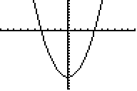

If you want to see what the graph really looks like, drawn to scale, you can go to “zoom square.” This simply means that the x and y axes have equal units (unlike in the window shown above!), and therefore the window is “square.” To do this, press [F3 ZOOM]. From the menu that drops down, select [5: ZSquare].

The graph really looks like this. This is the window [F2 WINDOW]
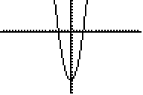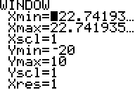

MOST IMPORTANTLY, remember that this is now your “new” window for future graphs. The next time you draw a graph, after you enter the new equation, you should standardize the window: [F3 ZOOM] [6: ZStandard].

5. Graph .

As always begin with [F1 y =] [CLEAR] to clear the previous equation.
Type the equation, using a minus sign: [x-variable] [^] [3] [—] [4] [x-variable].
Remember that in the last graph you changed the window, so now you should return to a standard window: [F3 ZOOM] [6: ZStandard].

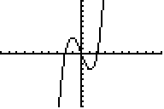

6. Graph . Of course this is a straight line.
[F1 y =] [CLEAR] [3] [÷] [4] [x-variable] [+] [4] [F5 GRAPH]
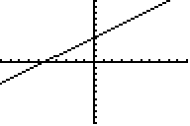
Standard Zoom
In case you are interested in seeing exactly how steep the line really is (), unbiased by the unequal units of the x and y axes, you might want to graph this with a “zoom square”! You do this by pressing: [F3 ZOOM] [5: ZSquare].
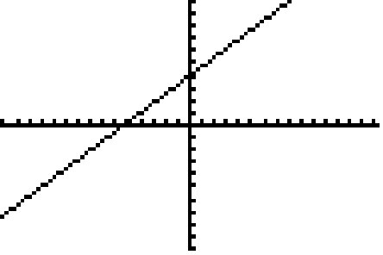
Zoom Square

Now, how do you change it back to the Standard Zoom?
[F3 ZOOM] [6: ZStandard].

7. Graph .
[F1 y =] [CLEAR] [2nd] [] [x-variable] [ )] [F5 GRAPH]
Notice that when you pressed the [] button, what you actually got was a [] with an open parentheses included in it. This means that after you type the [x] you should close the parentheses. However, if you do NOT close the parentheses, then the calculator automatically closes all parentheses at the end, and in this case it will not make any difference in the graph. Usually it DOES make a difference, so this is a good habit to have in graphing with this calculator!!
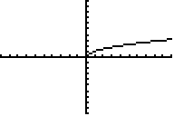

8. Graph and compare to . How these are different?
First, graph , which has only the x within the square root sign!
[F1 y =] [CLEAR] [2nd] [] [x-variable] [ )] [+] [4] [F5 GRAPH]
As in the previous example, notice that when you pressed the [] button, what you actually got was a [] with an open parentheses included in it. This means that after you type the [x] you MUST close the parentheses. In this case, it DOES make a difference! If you don’t close the parentheses, it’s wrong!!
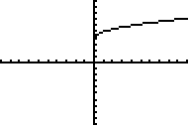
Second, graph , which has the x and the 4 within the square root sign! [F1 y =] [CLEAR] [2nd] [] [x-variable] [+] [4] [ )] [F5 GRAPH]
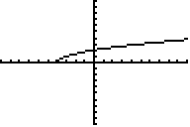
Notice that both of these graphs are the same “shape” as . The difference is that with , the graph is moved up 4 units, whereas with the graph of , the graph is moved 4 units to the left!
9. Graph and compare to and . Do you see how these are different?
There are two easy ways to find absolute value on the calculator. You can go to catalog, which is [2nd] [(decimal point)] . The [CATALOG] menu is listed in alphabetical order, and the calculator should go directly to [abs( ] . A second way to find [abs( ] is by way of [MATH], [right arrow] to [NUM] , and again [abs( ] is the first item in the menu that drops down.
Now, graph .
[F1 y =] [CLEAR] [2nd] [CATALOG] [abs(] [x-var] [ )] [F5 GRAPH]
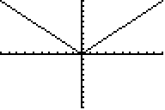
Now, graph .
[F1 y =] [CLEAR] [2nd] [CATALOG] [abs(] [x-var] [ )] [] [4] [F5 GRAPH]
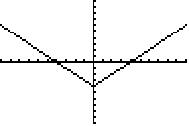
Now, graph .
[F1 y =] [CLEAR] [2nd] [CATALOG] [abs(] [x-var] [] [4] [ )] [F5 GRAPH]
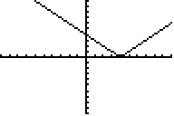
10. Graph , and compare to

Remember that you access the and functions by way of [MATH]. It is important also to notice that the while the comes with a “3” for cube root and an open parentheses, for the , the button to use is [5: ] which does NOT have either the “4” nor the open parentheses.

First graph .
[F1 y =] [CLEAR] [2nd] [MATH] [4:] [x-variable] [ )] [F5 GRAPH]
Notice that when you pressed the [] button, an open parentheses was included in it. This means that, as with the of the previous example, after you type the [x], you should close the parentheses. Remember also that if you do NOT close the parentheses, then the calculator automatically closes all parentheses at the end, and in this case it will not make any difference in the graph.
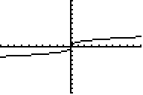

Second, graph . Before you go to the [MATH] menu, you must enter the index of the radical. You MUST begin with the “4” before the [MATH] menu.
[F1 y =] [CLEAR] [4] [MATH] [5: ] [x-var] [F5 GRAPH]
Notice that in this case, there are NO parentheses! Since the calculator did NOT open parentheses, there is NO closed parenthesis, as there was in the previous example. If you try to close parenthesis when there was no open parenthesis, it’s wrong, and you will get an error message telling you about it!!

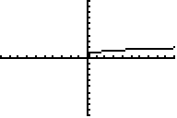
From these graphs, you can see that for , x≥0, but for, x can be any real number.

