# **Happy Holidays**

December is here, and so is the hustle and bustle of the holidays.

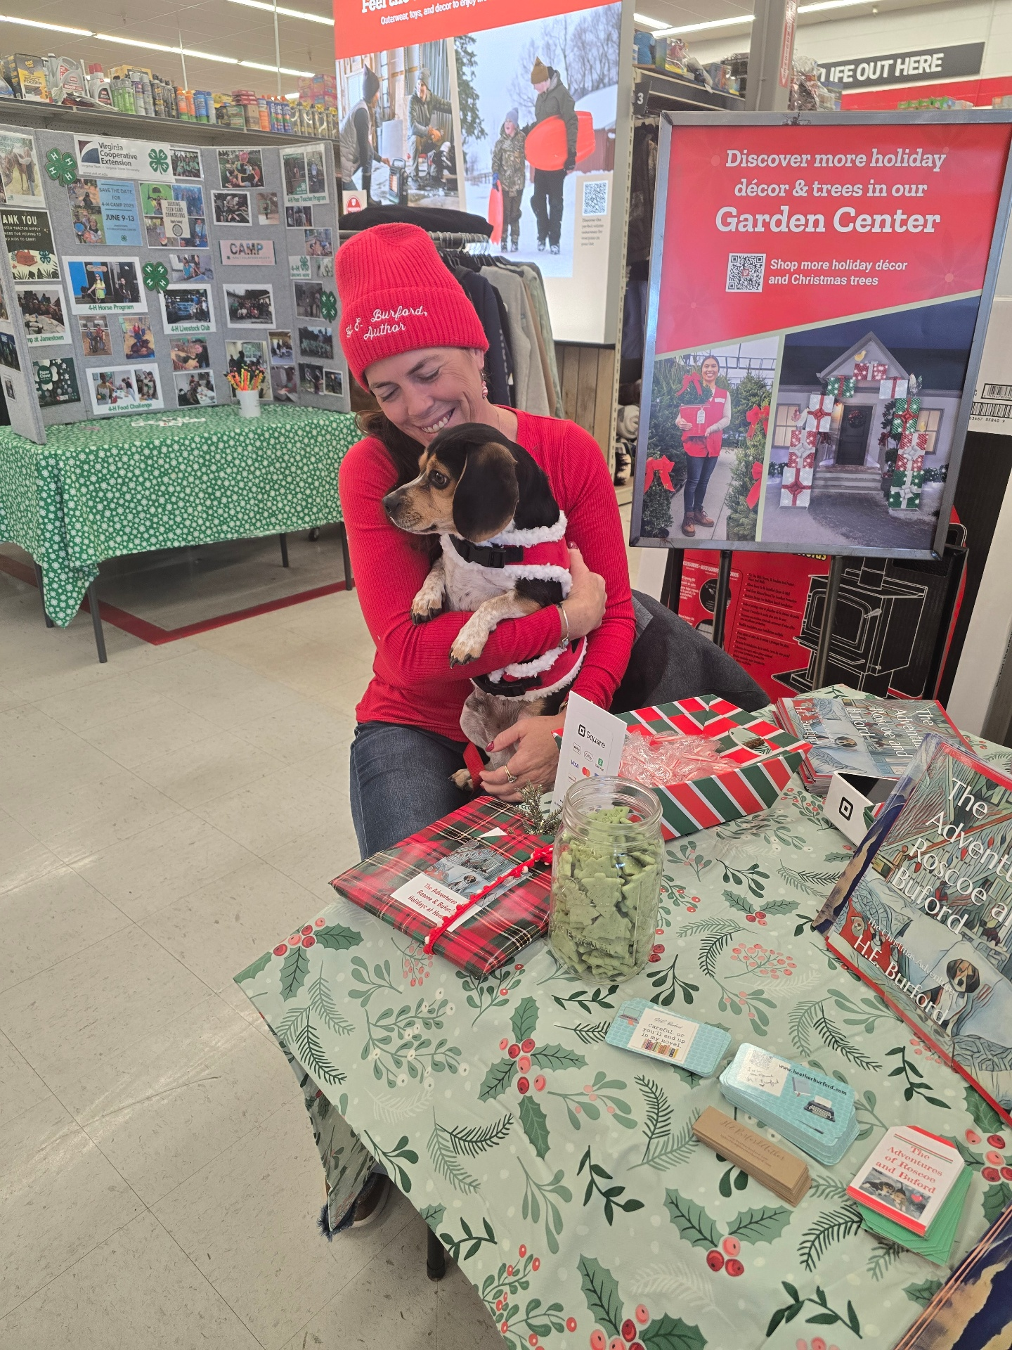I've had a busy few months and I can't thank everyone enough for all.pf the wonderful reviews and feedback on my recent published works. It's been a wild ride. I think the most difficult thing about this process is getting my books to readers. Social media is a double-edged sword. It's great to share, but many people get irritated with regular posting and updates. Just know that as an Indy Author, that is never my intent. One self-published book is published on the average of ONE EVERY 8 SECONDS! With this level of competition, if we don't share regularly, we fall through the cracks, so THANK YOU so much for bearing with me as I navigate this writing and promoting journey. The best gift you can give to me is to share my posts, my videos, and give brief reviews on

Amazon or on my Good Reads Account and to follow my Amazon Author Page. Again, I'm so thankful for your support!

# image1733091530072.png

# **EVENTS THIS MONTH**

I've had so many fun events that I've had the gift of attending these past few months. In December you can find me at Sweet Mary's in Dutton Virginia on Saturday December 7th from 8 a.m. until noon and at The Ware Christmas Market on Saturday, November 14th.

From there Facebook page-

The Gloucester Farmers Market presents Christmas at Ware! Enjoy 70+ vendors, ready to celebrate Christmas with you on the beautiful Campus of Ware Church. Free family activities, including family photos, as well as holiday presentations by various community groups and choirs in the Historic Church. Find perfectly unique gifts for loved ones then grab a mug of hot chocolate and sit a spell with your friends and neighbors. We can't wait to see you!

Roscoe and I visited Tractor Supply and sold some of his adventures to raise money for our local Animal Shelter and I am also planning on adding a few more events to raise money for our local Animal Control who houses many needy animals.

Please consider donating this holiday season. 🐾🐾🐾🎄🎄

# **Book Gift Boxes Still Available!**

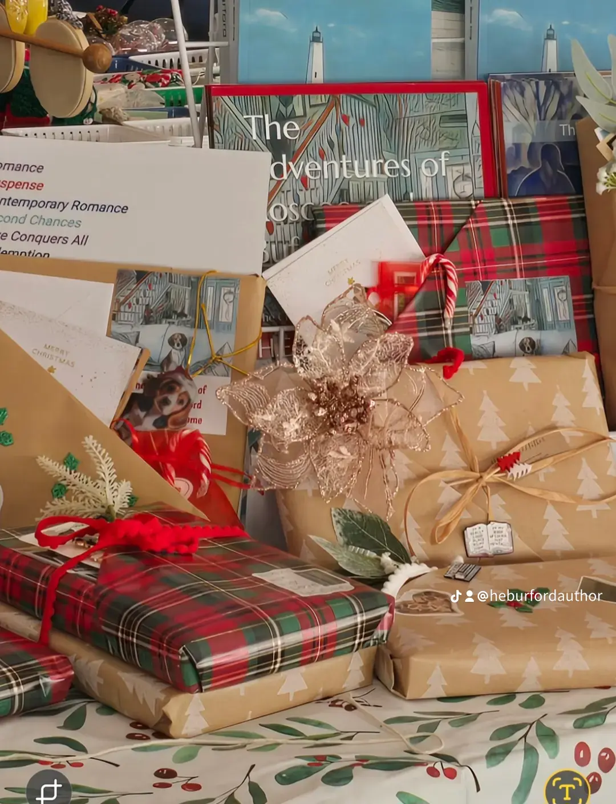

If you're looking for bookish gifts, I have book boxes to meet just every book lover's needs.

Box One includes Book One & Book Two in paperback & and gift certificate for a free download of Book Three when it releases in February 2025 as well as a book duck, bookmarks, bookish pins and stickers, and the option of a book mug or book necklace. Total Value is $70 but can be purchased for $55 shipped. Books will be wrapped and decorated as well as signed by the Author.

Box Two includes Book One and Two with all the swag (bookmarks and stickers) for $45 shipped.

Please click the **"Get Author Copies"** banner at the top of my website at [www.heatherburford.com](http://www.heatherburford.com)

Children's Books can be purchased wrapped with swag (2 for $20) and include the Farm Adventure and the Christmas Adventure. Shipping is $5.00.

🐾🐾♥️🎄🎁📚🐾🐾

# **Indie Author Spotlight**

Every month I highlight a few fellow Indie Authors. We depend on and support each other every chance we get, and we all respect that many of our friends and contacts appreciate different genres of writing.

# **The December Spotlight ⭐️⭐️⭐️⭐️⭐️**

***K.D. Sherrinford***

Visit-

<https://www.amazon.com/dp/B0BN16RPQY?fbclid=IwY2xjawG5vDtleHRuA2FlbQIxMQABHdAq9OOV84b5vNHCGfH8WSOIsGi84D4i2h5k20q4yKiKsSM71skKK_Vm3w_aem_3WvoYJywOMKaKL5IOvFQsA\>

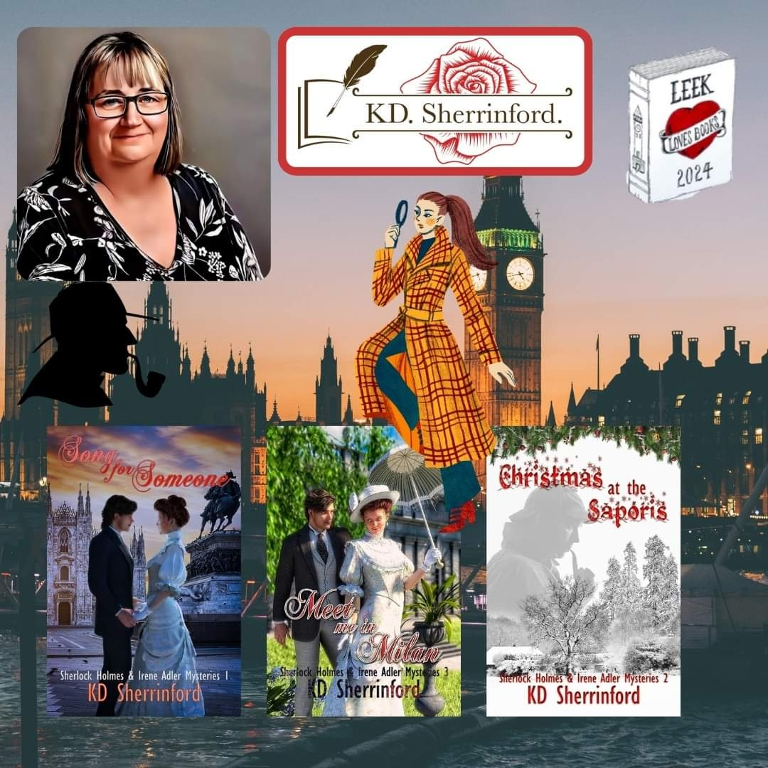

***C.J. Simone***

C.J. Simone writes dark and gritty psychological thrillers with romance, often centered on social issues and mental health themes. Her stories are intended for an upper YA through adult audience. She holds a BA in sociology and an MA in psychology. Widowed in 2023, she now resides with her children and a variety of pets on the East Coast.

Visit-

<https://www.amazon.com/Children-of-the-Mob/dp/B0CLKX66QW/?_encoding=UTF8&pd_rd_w=QVNud&content-id=amzn1.sym.0feea502-df19-477c-8654-d11baef80fe1&pf_rd_p=0feea502-df19-477c-8654-d11baef80fe1&pf_rd_r=141-0058973-7727610&pd_rd_wg=W5qju&pd_rd_r=cf215c41-8674-48ca-ab11-099ccb173610&ref_=kss_ap_sba>

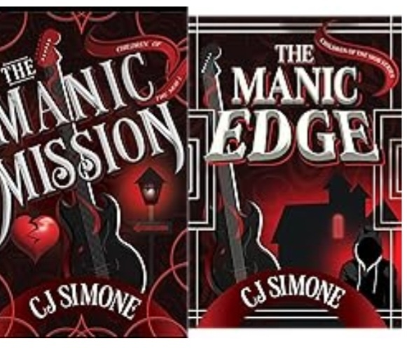

***Mark Aldrich***

Mark Aldrich was born in Massachusetts and raised in Virginia. Most of his adult life, he has made New York City his home while traveling extensively as an actor and singer. He has appeared in television, film, and theatre, including Broadway and many of the world’s most famous stages. However, some of his favorite performances were given in village pubs late at night on the wild West Coast of Ireland.

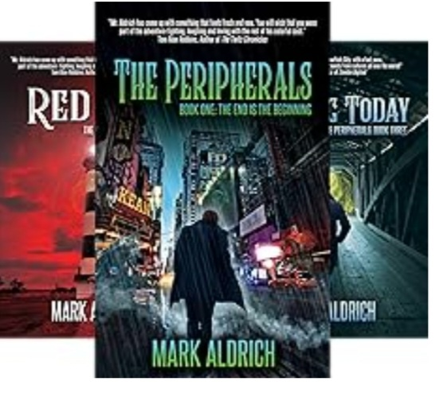Mark has written extensively for web publications, periodicals, and industry journals. After helping to tell others' stories on stage, he decided to commit some of his own to the page. The Peripherals marks his debut novel and combines his love of history, travel, folklore, music, and his decades-long knowledge of the inner workings of live theatre and the artists working there.

Stay up to date by visiting markaldrich.net or following me on Instagram and Twitter at @marktheginger

Or Visit-https://a.co/d/0ExENju

**Give these authors a look and find some new favorites to add to your TBR.**

***I hope everyone has a blessed holiday season. Thank you for following my writing journey and Keep Living In The Moment..***

H.E. Burford

