# Newsletter

**Email @heburford@heatherburford.com for your signed copy. In November the signed copies will be $20.00 Total (Includes Shipping).**

# October 2024

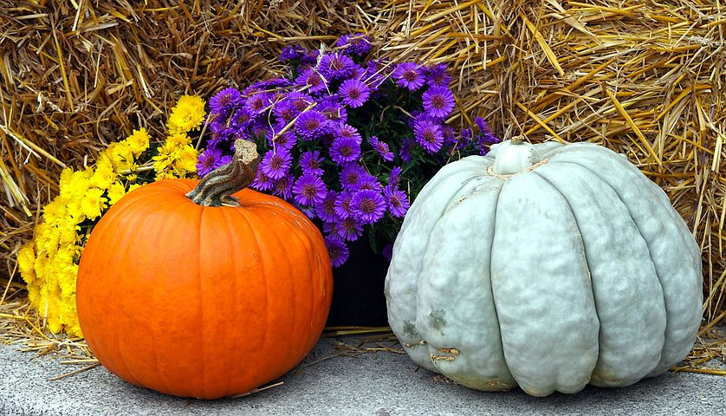

### November 8th is Quickly Approaching and so is the Release of the second book in The Moment Series: From This Moment On: Book Two.

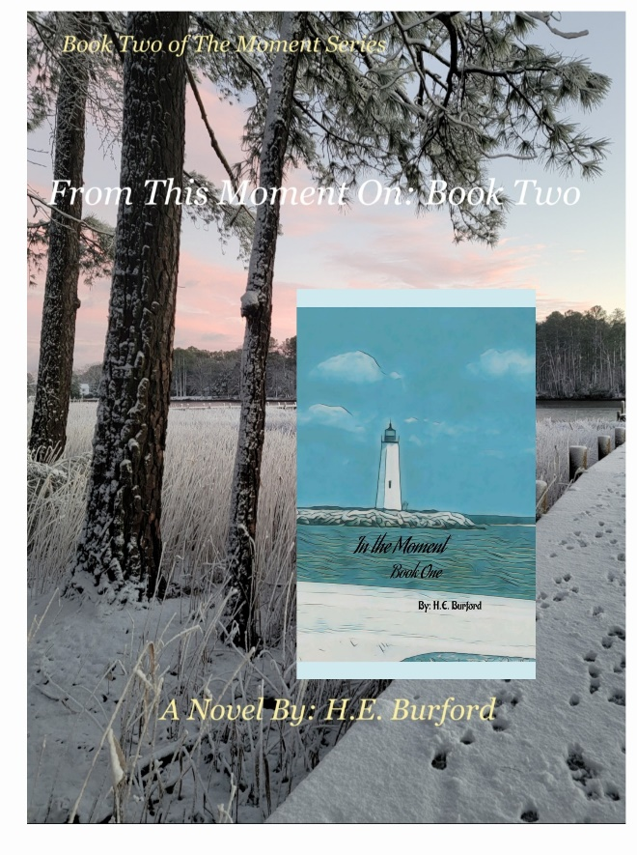

Author Events

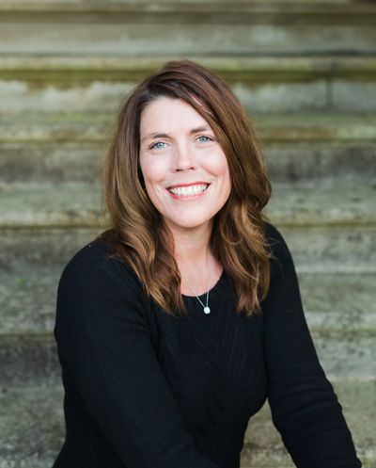

Fredericksburg Independent Book Festival

*Come see me at The Fredericksburg Independent Book Festival on Saturday October 12, 2024, from 10 to 4 at Riverfront Park in Fredericksburg, VA.

*Turn The Page Bookshop on Sunday November 17th from, Noon to Four. Get signed copies of Book One and Two of The Moment Series and check out Williamsburg's Only Independent Book Store!

5707 Richmond Road Suite 40 Williamsburg, VA 23188

*Gloucester Christmas Market

Come visit me at the first annual Gloucester Christmas Market on Saturday December 14th from 10 to 3 at The Historic Ware Church. Over 60 vendors will be present!

7825 John Clayton Memorial Highway in Gloucester Virginia.

*Festival or Book Signing Opportunities

If you have any opportunities for a budding author, please reach out to me at [heburford@heatherburford.com](mailto:heburford@heatherburford.com)

# Author Spotlights

As Indie Authors (Independently Published Authors), it’s important to support each other. Each month in my newsletter I will be featuring several authors for my readers to check out.

### Jess K. Chavez

<https://jesskchavez.com/>

You can purchase her books through the link on her site.

Synopsis

**The Flame of the White Horseman**

*Book One of Tales of the Four Horsemen*

It’s a YA romantasy

*An orphan girl trapped. A man destined for darkness. Can love be trusted to rescue?*

The world is not what it was. Light is but a tiny flickering flame in a blanket of darkness, struggling not to be snuffed out. Lucia, an orphan girl, is also a Core, a physical manifestation of Elohim’s pure love and part of an ancient prophecy that will prevent one of the Four Horsemen of the Apocalypse from being controlled by the darkness to destroy everything good. But Lucia’s not so sure she believes that anymore. Her upbringing by the Amilign monks has given her more questions than answers.

When the extent of the Amilign’s evil plans for her future is revealed, Lucia flees their mountain ashram, only to run into the mysterious Nicanor, who offers to take her to the prophets who possess the answers she seeks. Instinctively drawn to Nicanor and his white horse, Adira, the same horse who’s been haunting her dreams for years, Lucia wars with her growing feelings for her guide. But her years at the ashram have taught her not to trust anyone, and Nicanor hoards secrets like dragons their treasure.

When the truth about the nature of Lucia’s bond with the horseman comes to light and Lucia is unexpectedly recaptured by the enemy, Nicanor faces a hard decision. Will he continue to let fear rule his future—and Lucia’s—or will he unlock the heavenly power Elohim gifted before it’s too late for everyone?

# FOr the Holidays I will be offering

***Live in The Moment Gift Sets***

# More details will be updated on my website IN NOVEMBER.

# they WILL include GOODIES SUCH AS novel sets, Jeff’s BeARD oiL (THAT SMELLS OF cOCOA AND tEA tREE oIL), AND ALICIA’S sPA SET FEATURED IN bOOK tWO.

# A bottle of wine next to a glass of wine Description automatically generatedAnd a bottle of RED…

The Adventures of Roscoe and Buford is a children's book series sharing the fun adventures and daily experiences of two beagle brothers. Roscoe and Buford are avid travelers, but they also have momentous experiences that offer insight and understanding for children and adults alike. Through the eyes of these two brothers, children can learn and explore about matters such as anxiety, depression, health issues, life on the river, traveling to exciting, dog-friendly destinations and so much more. Dogs are family, and Roscoe and Buford share how their family has dealt with the fun moments, as well as the numerous obstacles that have come their way!

THan

# A heart with paw prints Description automatically generatedThe best way to support an author is by sharing their posts and book links and giving reviews. If you didn’t purchase from amazon, go to my profile on good Reads. it’s quick and easy and so very much appreciated!

**Thanks for your Support! Please go to my website and Subscribe.**

Keep Living in The Moment ~~

H.E. Burford

## More from H.E. Burford…

## In The works…

# COMIng in December of 2024: The Adventures of Roscoe and Buford

