- 2024 Volume 1 | Issue 1  2024 | 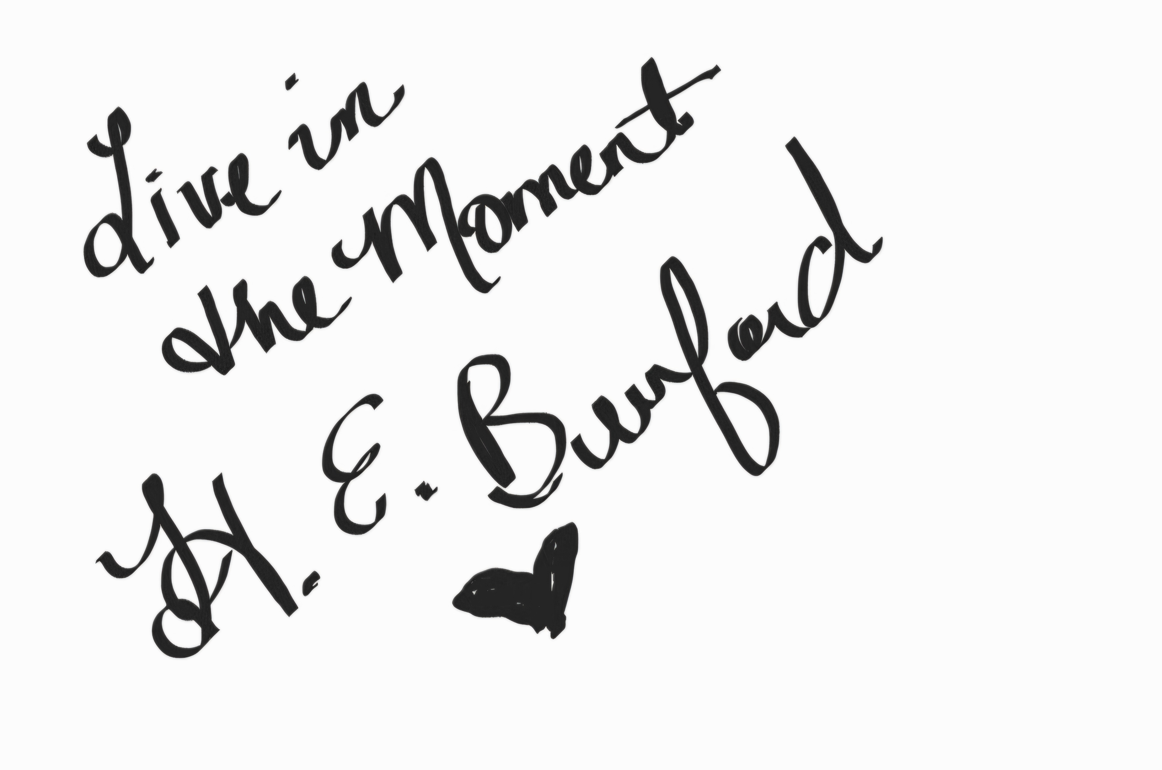  September Edition
Teaser | “For the first time in months, there was a shred of light at the end of the tunnel. The length of the tunnel was still uncertain, and I had no clue how deep we’d have to travel to reach the light, but we were on our way. Life was a collection of moments, and I didn’t want to let even one moment slip away without looking for the joy in it.” ~From This Moment On: Book Two  The Moment Series    Moments Like These: Book Three, The Final Chapter Available on February 14, 2025
Teaser | “These desires were not of the romantic variety, but rather a carnal variation. The details of this encounter were at his discretion, and his intent was clear. He was in charge, or rather, he needed to be, so I obeyed.” ~From This Moment On: Book Two  In the Works: Book Two of The Moment Series  From This Moment On: Book Two will be released on Thursday November 8th. Pre-orders for website subscribers will be shipped out on October 30th. These will be signed, author copies. To reserve yours, visit www.heatherburford.com Pre-orders must be received by Wednesday October 16th for October 30th shipping. Shipping is a flat rate of $5.00. Pre-orders will receive a $5.00 discount.  Pre-order Price: Paperback: $20 (includes shipping)  Hardback: $25 (includes shipping)  The link is live now on my website. It will instruct you to scan the Cash App Bar code. Once you have submitted payment, please send an email to heburford@heatherburford.com and include your full name and address. I will respond back in confirmation.  Signed copies will be available after the November 8th release at the original selling price:  Paperbacks are $20 ($25 with shipping), and Hardbacks are $25 ($30 with shipping).  Amazon link will be live for the regular purchase of Kindle version ($9.99), Paperback ($19.99), and Hardback ($24.99) on November 8th.  In the Works: 2025- Suspense Series  Once the series concludes in February 2025, a new series will commence.  If you’re a suspense fan, this series if for you! The first in the series of two novels is titled:  Struck At Dark: From Attack to Attraction  Release Information will be available soon! 2025 will be a year full of surprises.  “I saw her. I had her that night, and I’ve been chasing her ever since.”  Children’s Book Series (December 2025)  The Adventures of Roscoe and Buford is a children’s book series detailing the experiences of two beagle brothers. They have many fun adventures to share as well as some serious issues that they have had to overcome.  Fun adventures addressed in the series include a trip to the beach, a visit to grandma’s farm, camping, and living on the bay.  Serious topics addressed in the series include Sibling Rivalry, Anxiety, Epilepsy, Allergies, Fear of Storms, Surgery, and Welcoming New Family Members.  These are just a few of the many topics Roscoe and Buford plan to share with their human and animal friends.  Through the eyes of these two beagle brothers, young children can learn about how to deal with and accept issues that both humans and animals are confronted with, as well as follow along on some of the fun adventures these good boys have experienced.  The first three books in this series can be purchased as a set for $25.99 or individually for $10.00 each. Sets must be pre-ordered once the link goes live. More information on The Adventures of Roscoe and Buford will be available in the October Newsletter. The first boxed set will be available for Christmas delivery.  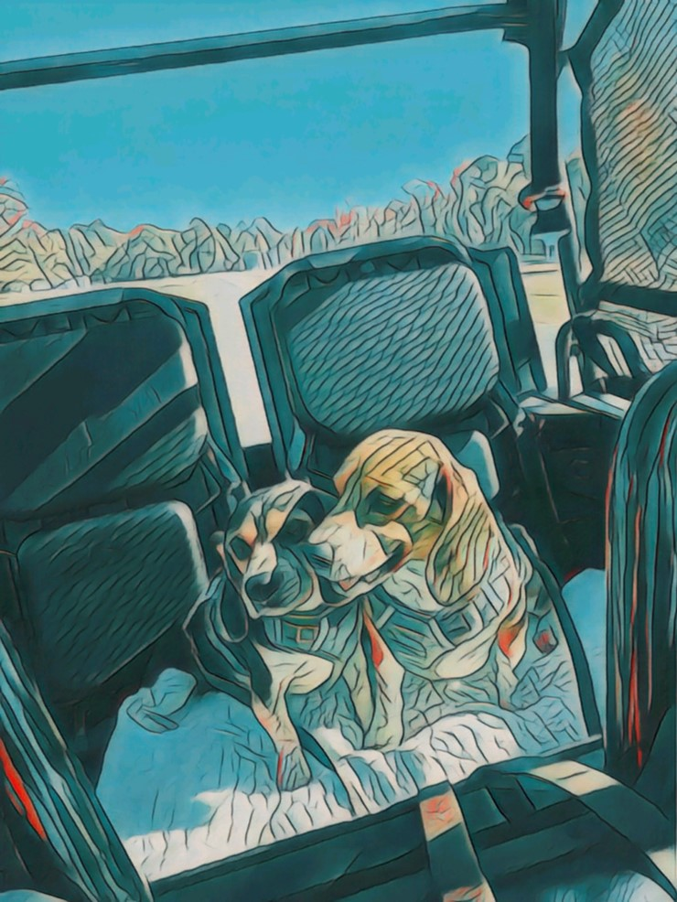  www.heatherburford.com ©  Blog  I will be adding weekly blog posts to my website beginning the first week of September. In addition to nonfiction and fiction segments, I will also be reviewing books that I have read or am currently reading. Please feel free to email me reviews you would like me to share on my website. Together, we can offer suggestions of other great author’s and books to my followers and grow a larger reading community.
  H.E. Burford  www.heatherburford.com | I can’t thank everyone enough for your support on this writing journey. The feedback has been wonderful!  Reviews are how I reach a larger reading audience. If you’ve read Book One and you enjoyed it, please visit my Good Reads profile and leave a review.  https://www.goodreads.com/heburfordauthor

