**The wait is finally over!**

**Here's a Recap of The Moment Series~**

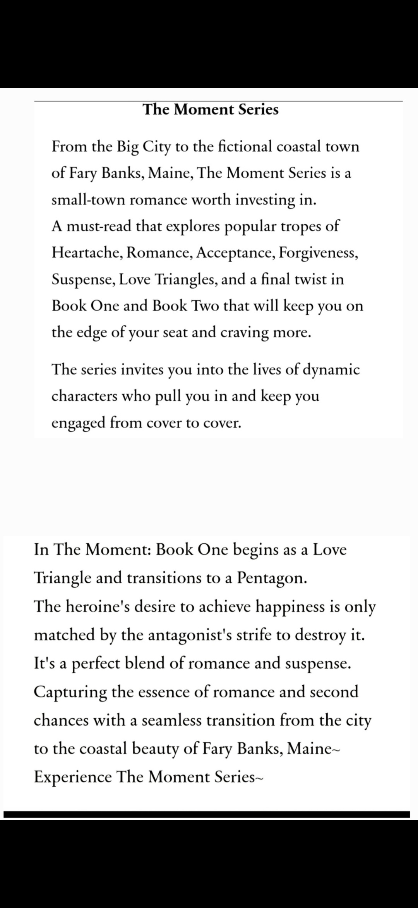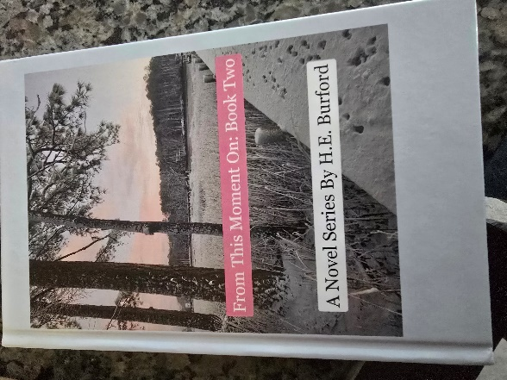**From This Moment On: Book Two Releases on Friday November 8th!**

I am so excited to share what's next for some of your new favorite characters: Alicia, Jeff, Max, Dominque, Jason, Beth, and, of course, Shelly. And Book Two introduces a few new characters too!

**If you're looking to give me the gift of reading, I have several wonderful options for you. For The Moment Series, you can purchase Book One and Two together (signed copies) for $32 and it will come wrapped with a few extra swag items. Shipping for the two is $7.**

***This deal is only available through me, and both copies will be signed copies. $40 total for wrapped, signed copies of Book One and Book Two.***

You can also purchase the books individually through Amazon.

\*\*\*\*\*\*\*\*\*\*\*\*\*\*\*\*\*\*\*\*\*\*\*\*\*\*\*\*\*\*\*\*\*\*\*\*\*\*\*\*\*\*\*\*\*\*\*\*\*\*\*\*\*\*\*\*\*\*\*\*\*\*\*\*\*\*\*

The Adventures of Roscoe and Buford, A Series of Beagle Adventures Releases with the First Adventures November 7th, with a 2nd Adventure Releasing on November 18th.

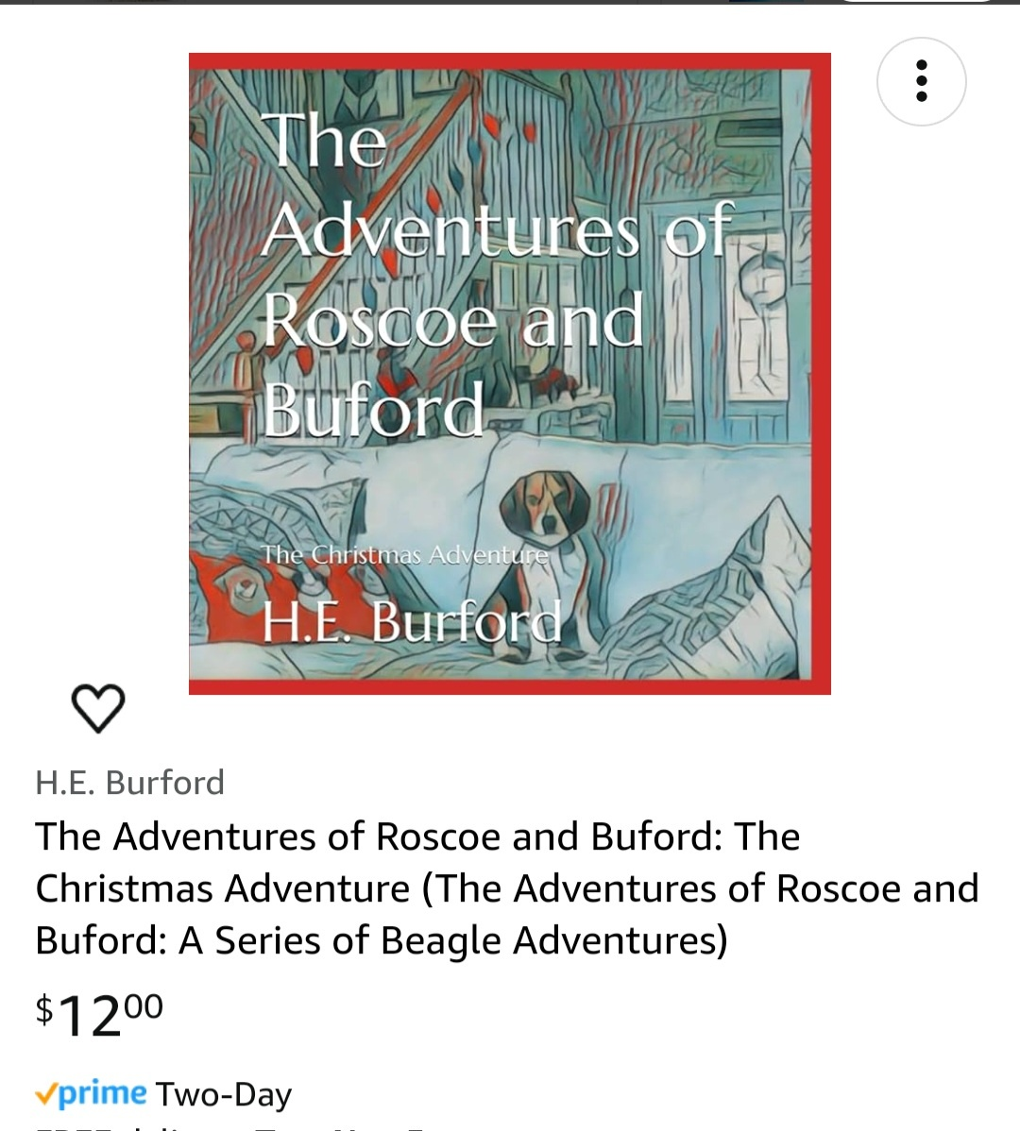Author copies come with bookmarks and stickers for the kids. Both books are also available to purchase on Amazon.

**Each book is $12. Shipping for author copies is $4.00 for one book and $6 for two or more.**

The new children’s book series is narrated by Buford, and it explores many of the experiences he has encountered while traveling and just living with his other animal siblings.

Be sure to get your copies of The Christmas Adventure on November 7th.

**Author Events:**

I will attend several events during the Holiday Season. All of my books will be available for purchase and will be offered as signed copies.

* **Sweet Mary’s, Dutton VA**

Saturday November 16th 8 to noon

* **Turn The Page Bookshop**

Sunday November 17th from, Noon to Four.

Get signed copies of Book One and Two of The Moment Series and check out Williamsburg's Only Independent Book Store!

5707 Richmond Road Suite 40 Williamsburg, VA 23188

* **The Vintage Pearl, Mathews, VA**

Saturday November 30th: 10-2

The Adventures of Roscoe and Buford Signing Event: 50% of the profits will be donated to local animal relief efforts.

* **Seaford Yacht Club 4th Annual Holiday Craft Fair**

Come see me at The Seaford Yacht Club on Saturday November 23rd from 9 to 2. Books One and Two will be available, Living in the Moment Swag, and holiday gift sets. Book Signing Available.

* **Gloucester Ware Christmas Market**

Come visit me at the first annual Gloucester Christmas Market on Saturday, December 14th from 10 to 3 at The Historic Ware Church. Over 60 vendors will be present!

7825 John Clayton Memorial Highway in Gloucester Virginia.

**Applause for The Moment Series~**

November 5, 2024

**Thought provoking and beautifully written.**

In the Moment by H.E. Burford is a unique exploration of self-discovery, healing, and the intricacies of human connection. Through a rich and nuanced narrative, Burford brings readers into a world where characters grapple with past traumas, personal growth, and the ever-elusive concept of living "in the moment."

Burford's writing is both lyrical and contemplative, painting vivid scenes that linger in the mind. The story follows protagonists who are deeply flawed yet incredibly relatable, and it’s through these imperfections that the book’s emotional weight is felt most powerfully. Each character's journey is meticulously crafted, revealing layers of vulnerability, resilience, and the often-complicated path toward self-acceptance.

What stands out about In the Moment is Burford's ability to delve into the themes of mindfulness and presence without feeling heavy-handed. The title itself is a reflection of the book’s core theme: the idea that true peace and understanding can only be found by engaging fully with each present moment. This message resonates deeply, especially in an era where distraction is a constant presence.

Burford’s prose is both elegant and grounded, managing to capture profound insights with simple yet powerful language. This is not just a book that tells a story—it’s an invitation to reflect on one’s own life, to consider the past and future but to ultimately ground oneself in the now.

In the Moment is an impactful read for anyone interested in character-driven stories that focus on the inner lives of individuals. Burford’s storytelling is as much about what is left unsaid as what is spoken, and this subtlety makes for a rewarding experience. It’s a reminder that our past may shape us, but it is in the present that we find our true selves.

In the Moment Book One is a great book to start the series. Author H.E. Burford so vividly creates the imaginary town of Fairy Banks that I found myself thinking about a visit to experience its small-town, ocean-front life.  
I hoped to meet Alicia in the small grocery or Jeff at the local coffee shop. I feel like I could identify either on site thanks to Burford, who does an excellent job of both physically describing the characters and revealing the complex emotions experienced as they undergo turn after unexpected turn in their complicated lives.  
The book literally leaves you guessing as to what will happen next without stretching the bounds of reality. It will be interesting to see what happens in Fairy Banks in the next book.

October 12, 2024, **Twists and Turns Galore** 

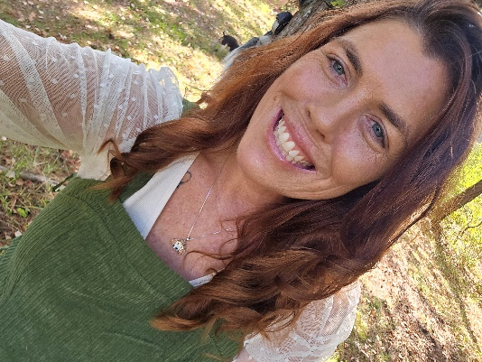

Independent Author success depends significantly on their friends, family, and followers sharing their work. Thank you to all of you for your support. If you love The Moment Series, please share it on social media and in conversations with your friends.



**Indie Author Spotlight**

If you’re looking for some new Indie Author reads, here are a couple of excellent choices:

**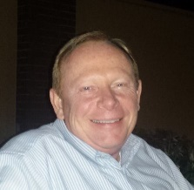Gary Bryant:** ~Writer residing in London, KY. Author of "Ace of Hearts," and upcoming sequel "Ace Johnson: Things Aren't What They Seem. **From Bryant’s description: “When a tragic crime shatters his quiet retirement, can a retired detective rediscover his purpose in the face of overwhelming darkness?”**

**On Amazon,** [**https://a.co/d/iWQ0RK3**](https://a.co/d/iWQ0RK3)

**Or Facebook:** <https://www.facebook.com/profile.php?id=61559336776465>

And

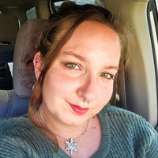**Tasia Timm**

**The first synopsis in Timm’s series from Amazon:**

{Tom and Mylie have been inseparable best friends all their lives. After graduating high school, they embark on a road trip and confess their love for each other, deciding to take the leap and become a couple. However, upon returning home, they are confronted with an unexpected surprise that challenges their faith and love, not only for each other but also within themselves. Will their bond withstand the test, or will this new chapter redefine their relationship forever?}

**On Facebook** [**https://www.facebook.com/profile.php?id=61559834406870**](https://www.facebook.com/profile.php?id=61559834406870)

**And on Amazon-**

**[amazon.com/-/e/B0D5S5PLGK](https://l.facebook.com/l.php?u=https%3A%2F%2Fwww.amazon.com%2F-%2Fe%2FB0D5S5PLGK%3Ffbclid%3DIwZXh0bgNhZW0CMTAAAR1Y9WXSog6CIi2JREpHHSsm8UjTb37T7MHLMq9UGiFuyP08ORY61zh-gOM_aem_OZrAUWq4bhjO9c-HLS6xGg&h=AT1Zqv-vg50giZT2pSfzd1oMZQLSnYamZNiMJqKiXUVQKwDey5_H6N6bMJOX5BqsbcsSLInY0wpSo95qmeE-PGc4641Oix5DEc_Rzmf3-w-2uT3sUrylfvpEzvmtDkUTA4YsdA" \t "_blank)**

***Keep Living in the Moment~***

***H.E. Burford***