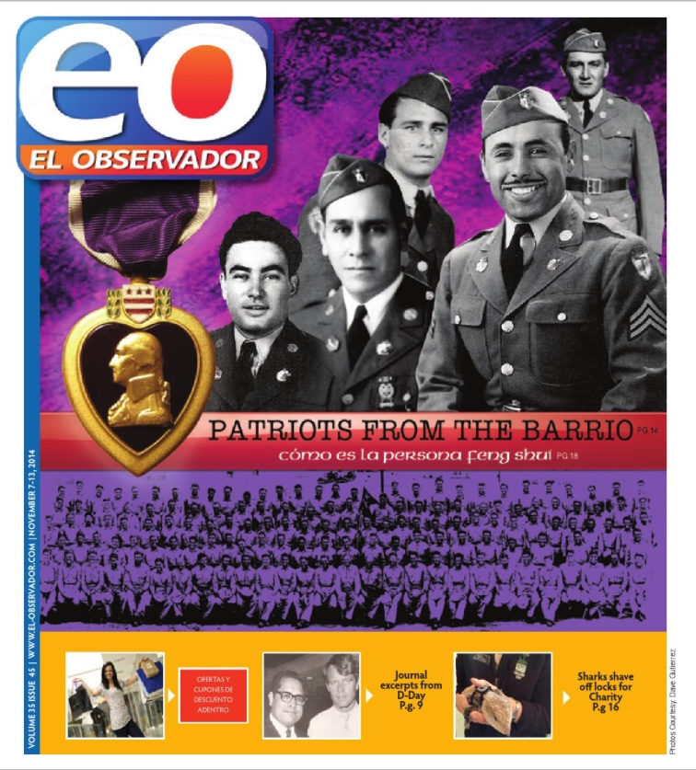

http://news.el-observador.com/2014/11/06/patriots-from-the-barrio/

PATRIOTS FROM THE BARRIO
Posted on admin on November 6, 2014 // Comments Off
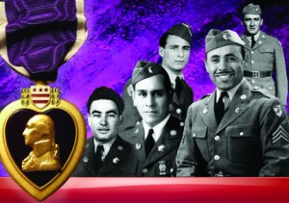
AUTHOR: DAVE GUTIERREZ / San Jose, CALIFORNIA
The true story of a WWII U.S. Army combat unit is documented by author Dave Gutierrez’s five year labor of love. commitment, and intense personal interest which began with the simple research of his family genetic tree using online sources of information. His family history led him to learn that his relative, Ramon G. Gutierrez, had served in Company E, Second Battaliion, 141st Regiment, 36th Division, U.S. Army. This unit was composed of more than 200 GI’s who were all Mexican American residents of the Del Rio and El Paso, Texas border area. All these Mexican Americans experienced the segregated military services of that 1940’s era. Company E served with valor, honor and distinction when participating in the Allied Forces campaign in North Africa, and spear-headed the invasion of the Italian mainland at Salerno. Company E would also make the landing at Anzio and the drive towards Rome. The first invasion of the European continent was not at Normandy Beach, France on June 6, 1944, rather it was when Salerno was assaulted and occupied many months earlier by U.S. Army forces which included Company E.
Over a five year period. author Dave Gutierrez traced survivors for interviews and commentary; or contacted surviving family members who shared photos, documents, dairies, and memories. A poignant landscape of personal and collective experiences is documented and communicated through anecdotes and descriptions which convey with unusual clarity the prejudicial, bigoted, and biased practices of their American society prevalent during that 1940’s WWII era.
Yet these Mexican American men served their nation with valor, honor and distinction during their entire military service period. DUTY, HONOR AND COUNTRY WAS THEIR MANTRA. A prior Department of Defense report documents that Mexican American combat service men earned/were awarded the most ‘Congressional Medals of Honor’ (more than 60 and more than any other ethnic group). This book, entitled PATRIOTS FROM THE BARRIO, conveys the personal stories of these AMERICAN CITIZENS, who. despite the pejorative attitudes and practices of their communities in Texas at that time (1940’s) chose to serve with verve, valor, honor, and distinction.
The ‘Patriot from the Barrio’ Ramon G. Gutierrez, of Del Rio, Texas, earned the Silver Star Medal, received three (3) Purple Heart medals, and was recognized by the Soviet Union, which awarded Ramon G. Gutierrez its Medal of Valor (He is listed along with General Dwight D. Eisenhauer, CIC, Allied Forces). Gutierrez was captured twice, escaped twice and returned to his unit. His true story is an example of Mexican-American men who served in the U.S. Army during WWII as members of this unique combat unit.
Company E is relevant today because it makes us all proud of our own. When the door of opportunity to serve this nation opened, these Americans of Mexican heritage, stepped up and performed very well.
This book needs to be read by all current Chicanos.Latinos, Hispanics and the American public. It needs to be available in all local school and college libraries because it fills a historical void not taught in American History classes, and read by our current generation of youth who are not aware ‘Why they belong’ in the current American society. Their personal situation today was earned by the valor and combat experiences of Mexican-Americans whose homes were in barrios; whose housing. education, and social status was considered ‘less than that of the Anglos.’ These ‘Americans of Mexican heritage came home to the biased practices which denied them their GI Bill of Rights entitlements (education, job training, home loans, ‘redlined for business loans’, etc.)….which led to the formation of the American GI Forum by Dr. Hector Garcia (1945). The local San Jose American GI Forum, Chapter No. One, addressed ;local social, education, economic, and public policy issues which this book describes with precision and clarity.
Dave Gutierrez and his family are residents of San Jose, CA. He and his family maintain their Tejano roots and Mexican-American heritage.
Publisher’s Note: Make plans to add this book, published by Xlibris, to your personal library. Order online at www.Xlibris.com, www.amazon.com or www.barnesandnoble.com. It is available in hard copy format ($29.99 + S&H), soft copy format, and digital Ebook format. ISBN 978-1-4990-5493-4; This reviewer strongly recommends purchasing two copies; keep one and present the second one to your local elementary or high school library to ensure its presence sooner rather than later. The Latino youth who read PATRIOTS FROM THE BARRIO will acquire historical knowledge that will swell their self esteem. We are beyond ‘Si se Puede’; today ‘Juntos racemes mas con exito’ (together we do more successfully).
Tags: DAVE GUTIERREZ, PATRIOTS FROM THE BARRIO

