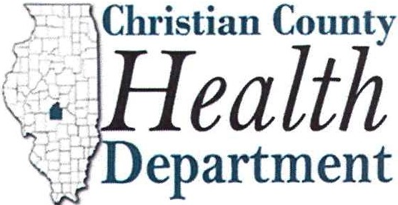730 N. Pawnee St, Taylorville, IL 62568 Phone: 217-824-4113 Fax: 217-824-5407

MEDIA RELEASE

Date: June 17, 2025

**CHRISTIAN COUNTY MOSQUITOS TEST POSITIVE FOR WEST NILE VIRUS**

**MOSQUITO VECTOR REPORT**

Taylorville, IL - Christian County has their first West Nile Virus (WNV) positive mosquito sample of the 2025 season. Mosquitoes collected on June 16th in Pana, Illinois were tested by Environmental Health staff in the laboratory at the Christian County Health Department, where the confirmatory analysis was conducted. According to the Illinois Department of Public Health (IDPH), a county is considered positive for WNV when a mosquito, bird, horse, or human tests positive for the virus.

According the weekly WNV report released by IDPH, there have been no human cases of WNV in the state in the 2025 season.

The recent warm, humid temperatures have created ideal conditions for mosquito populations in our area. According to Dr. Chad Anderson, Public Health Administrator, “It’s important to take simple steps to protect yourself and your family from West Nile Virus. Using insect repellent, removing any forms of standing water, and trying to avoid outdoor activity at peak mosquito hours can significantly reduce your risk.” He adds, “Public health is about prevention, and these actions truly make a difference.”

The Christian County Health Department will continue to monitor and test mosquitoes for WNV. Remember reducing mosquito breeding areas can help reduce your chance of contacting this virus. If you have any questions regarding West Nile Virus or any disease vectors, please contact your local health department or us at 217-824-4113.