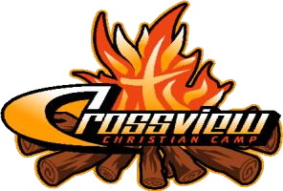
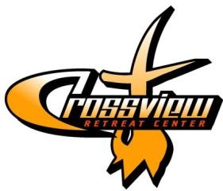
CrossView Christian
Camp P.O. Box 288
Dickens, TX 79229
Crossviewcamp.org

EVENT CONTRACT

This is a legal and binding contract between the Organization and CrossView Christian Camp &
Retreat Center. Please answer every question, obtain both required signatures, make and keep a copy for your records, and return the original to CrossView Camp along with your $300 deposit.

CONTACT INFORMATION
Name of Organization:

Address: City: State: Zip:
Name of Event Coordinator: |  | Title:
Business Phone: | Cell Phone: |  | E-mail Address:
EVENT INFORMATION Arrival Date: | Arrival Time:
Departure Date: | Departure Time:
# of Guests 18 & Older: | # of Males: | # of Females: | Group Description:
# of Guests under 18: | # of Males: | # of Females: | Group Description:

PAYMENT COMMITMENT
The Organization will pay CrossView Camp a deposit of $300 to reserve the dates of their event. The
Organization will pay their bill in its entirety (the deposit will NOT be applied) upon arrival at CrossView Camp. The $300 deposit will be refunded after the Organization’s departure from CrossView and the facilities have been inspected, if no property/facilities are damaged, extra cleaning is required, or other charges are incurred.
If the Organization must cancel their event for any reason, their $300 deposit is not refundable.
Fourteen days prior to the first day of the Organization’s event will be the cut-off for removing participants, activities, and/or facilities from the bill. The Organization may add participants, activities, and/or facilities after the cut-off date only by calling CrossView to see if these increases can be accommodated.
The Organization agrees to use all Camp facilities and equipment with care and agrees to cover the cost of any damage caused by careless, reckless, or negligent behavior on behalf of Guests. All facilities should be left reasonably clean and in order, or extra cleaning fees will be applied.

OTHER RESPONSIBILITIES OF ORGANIZATION
The Organization agrees to respect the beliefs of CrossView Camp as set forth in the Statement of Faith and to do nothing by word or deed that will in any way detract from the purpose or testimony of CrossView Camp.
The Organization agrees to collect from Guests and submit completed CrossView Release Forms upon arrival. The Organization agrees to go over CrossView’s Rules for Events with all their Guests and to enforce these rules. The minimum adult to child ratio is one adult per 10 children (under 18 years old). Adult leaders must be at least 18 years old, properly screened and trained, and able to be responsible for the safety of all children.
The Organization understands that alcohol and tobacco in any form are prohibited on Camp property.
Firearms, fireworks, airsoft guns, pets, and other destructive or damaging items are also prohibited.

OTHER RESPONSIBILITIES OF ORGANIZATION (CONT’D)
The Organization understands that use of the high ropes course, climbing wall, low ropes courses, paintball field, pond, and range requires prior notice, and these activities MUST be administered by certified CrossView Staff. A list of all event activities must be submitted and approved by the Camp Director before the event to ensure that none of the activities require the presence of Camp Staff and that none are prohibited by law, Camp policy, or the Camp’s insurance coverage.
The Organization is responsible for transportation of all Guests to and from CrossView Camp.

REQUIRED SIGNATURES
Event Coordinator:
Printed Name___________________Signature_________________Title_________________Date________

Board Member from Your Organization:
Printed Name___________________Signature_________________Title_________________Date________

